Public Tax Hearing Special Board Meeting Boone County Board of Education
August 26, 2021 6:30 PM
Ignite Institute
37 Atlantic Avenue
Erlanger, KY
(location change due to the construction at the normal board meetings of Ralph Rush Professional Development Center)
I. CALL TO ORDER
Dr. Maria Brown called the August 26, 2021 Public Forum to order at the Ignite Institute at 6:30 pm.

Attendance Taken at : 6:30 PM
Present Board Members:
Dr. Maria Brown
Ms. Karen Byrd
Mr. Keith Collins
Mr. Jesse Parks
Mrs. Julia Pile

Matthew Turner, Superintendent
Karen Evans, Board Secretary
II PLEDGE TO THE FLAG
A. The Pledge to the Flag was led by Dr. Maria Brown, Board Chair
III. INFORMATION ON TAX RATE LEVY (ATTACHMENTS ON WEBSITE UNDER EMEETING)
Mrs. Linda Schild, Finance Director presented to the board on the tax levy and the district finances with a PowerPoint presentation and handouts. The board discussed the challenge of the budget, bus purchases that are needed, the increase in cost of full day kindergarten being an unknown on what those expenses will look like in the next year. Discussion on ESSER funds, made clear these are only for designated items, not buses etc. 2025 we will need to cycle out over 40 buses from our fleet because at that time they will be costly to maintain. Discussion followed presentation.

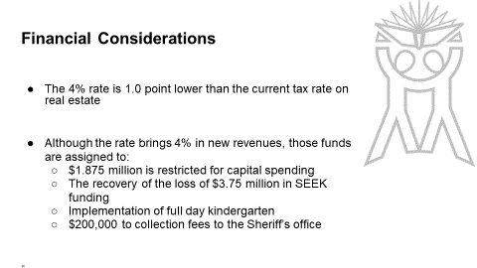
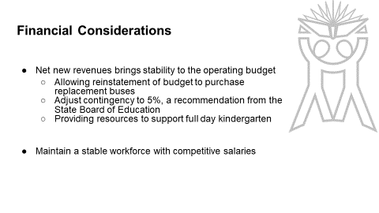
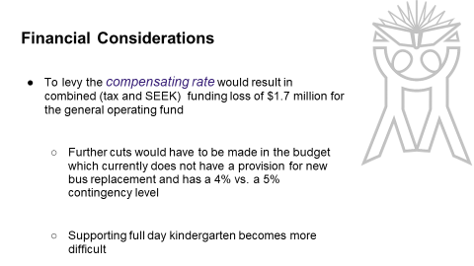
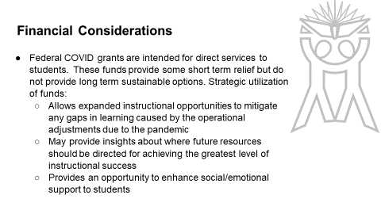

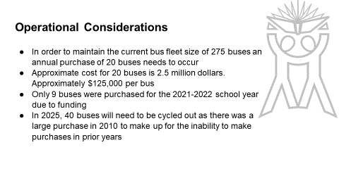

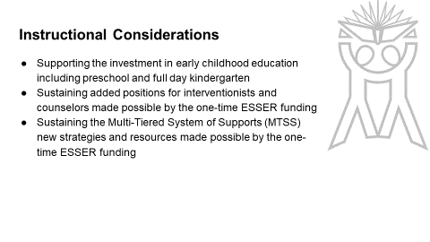
IV. PUBLIC HEARING
A. To hear comments from the public on the Tax Rate Levy
No one spoke.

V. ADJOURN
Order #1 - Motion Passed: Motion to adjourn at 6:43 pm, passed with a motion by Ms. Karen Byrd and a second by Mrs. Julia Pile.
5 Yeas - 0 Nays

Dr. Maria Brown | Yes
Ms. Karen Byrd | Yes
Mr. Keith Collins | Yes
Mr. Jesse Parks | Yes
Mrs. Julia Pile | Yes

________________________
Dr. Maria Brown, Board Chair

________________________
Karen Evans, Board Secretary

