BULLITT COUNTY PUBLIC SCHOOLS
1040 HIGHWAY 44 EAST
SHEPHERDSVILLE, KY 40165

REGULAR MEETING OF THE BULLITT COUNTY BOARD OF EDUCATION
December 11, 2023
5:00 PM
MINUTES OF RECORD
The Bullitt County Board of Education met at the Frank R. Hatfield Administrative Center, 1040 Highway 44 East, Shepherdsville, Kentucky, 40165, at 5:00 PM on December 11, 2023 with the following members present:
(1) Ms. Linda Belcher (2) Mrs. Nita Neal (3) Dr. Matt Mooney
(4) Mrs. Lisa Hodges (5) Mr. Darrell Coleman
CALL TO ORDER
The December 11, 2023 Regular Meeting of the Bullitt County Board of Education was called to order at
5:00 p.m. by the Board Chair Darrell Coleman.
ADOPT THE AGENDA
2023-195- Motion made by Ms. Linda Belcher and a second by Dr. Matt Mooney to adopt the agenda as presented. All members voted YES.

PRESENTATIONS
- Cate Noble Ward presented the Bullitt East Fine Arts Addition Bid Review and Re-issue Bid Package 3:Low Voltage and AV Systems package
Bid submissions have been reviewed and meet requirements of the Contract Documents.
Studio Kremer recommends the Board provide a Notice to Proceed for the submitted Bids and approve of the Design Team to formalizing contracts for :
· Bid Package 1: General Construction – Award to EH Construction
· Bid Package 2: Building Automation Controls – Award to Trane US
Re-Issue Bid Package 3: Low Voltage and AV Systems package due to a lack of bidder participation.
Schedule for Re-Bid:
Release for Bid - December 20, 2023
Bid Date - January 3, 2024
Provide Board Update and Request for Notice to Proceed - January 8, 2024
Request Board’s approval of the Contract - January 22, 2024
- School Resource Officer Discussion. Sarah Smith presented before the Board
c. Audience Comments (15 Minutes)
COMMUNICATIONS
Audience Comments
(none)
CONSENT ITEM
2023-196-Motion made by Ms. Linda Belcher and a second by Ms. Nita Neal to approve Consent Items as presented, noting that all items have been studied with individual recommendations and rationale being provided prior to the meeting in the report packed on December 5, 2023, which is available online. All Members voted YES.

a. Bullitt County Foundation for Excellence Grant Awards
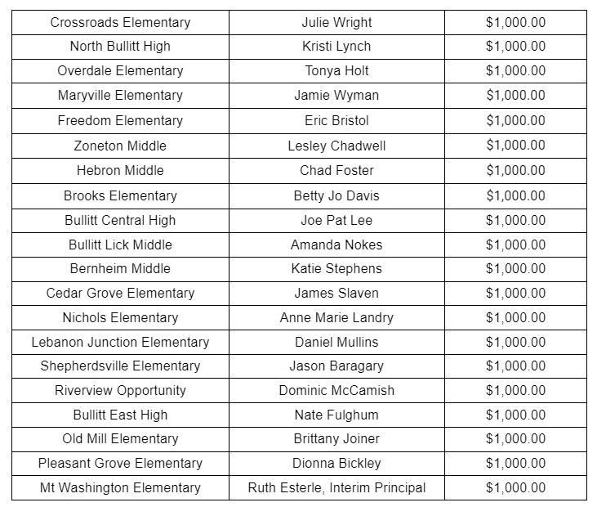
GENERAL DISCUSSION
a. School Calendar Year 2024-2025 The Calendar Committee presented the findings of the survey and recommended Calendar Option 2. It will be brought back to the Board Meeting on December 18, 2023 for Board approval.
ADJOURNMENT
2023-197- Motion by Mrs. Lisa Hodges and a second by Dr. Matt Mooney to adjourn at 6:01p.m. All members voted YES.

_____________________________ ______________________________
CHAIRPERSON SECRETARY

