BULLITT COUNTY PUBLIC SCHOOLS
1040 HIGHWAY 44 EAST
SHEPHERDSVILLE, KY 40165

Regular Meeting of the Bullitt County Board of Education
March 23, 2026
5:00 PM

MINUTES OF RECORD
The Bullitt County Board of Education met at the Frank R. Hatfield Administrative Center, 1040 Highway 44 East, Shepherdsville, Kentucky, 40165, at 5:00 PM on Monday, March 23, 2026, with the following members present:
Attendance Taken at 5:00 PM:
(1) Ms. Linda Belcher (2) Mrs. Nita Neal (3) Dr. Matt Mooney (4) Ms. Marci Hodges
(5) Mr. Dallas Harshfield
CALL TO ORDER
Board Chair, Dr. Matt Mooney, called the meeting to order at 5:00 pm
ADOPT THE AGENDA
Order #2026-201 - Motion Passed: Adopt the agenda as presented. passed with a motion by Ms. Nita Neal and
a second by Dallas Harshfield. All members voted YES.
PRESENTATIONS
Board Member, Marci Hodges led the audience in the Pledge of Allegiance and reviewed the Board Team Commitments. Stefanie Kleinholter gave the reminder to Address the Board.
Construction update by Mrs. Cate Noble Ward of Studio Kremer Architects

COMMUNICATIONS
Audience Comments
(NONE)
Superintendent's Report
Dr. Bacon asked for one of the Board Members to volunteer for the Bullitt County Code of Conduct Committee- Mrs. Nita Neal volunteered. Dr. Bacon also announced that on the Agenda were the 2026 BCPS Graduation Dates and Locations. NBHS requested to hold their graduation on their football field on Friday Night, May 29th at 7:00pm with a possible rain out scheduled for Saturday night, May 30th @ 7:00pm. Bullitt East graduation will be at Broadbent Arena at 11:00am on Saturday, May 30th at 11:00 am Bullitt Central graduation will follow at Broadbent Arena @ 2:00 pm on Saturday, May 30th.
Other Items from the Board

Linda Belcher thanked all schools for gifts, cards and food provided to them at last month’s Board Member Appreciation Celebration.
CONSENT ITEMS

Order #2026-201 - Motion Passed: Approve Consent Items as presented, noting that all items have been
studied with individual recommendations and rationale being provided prior to the meeting in the full Board
packet on Tuesday, March 17, 2026, which is available online. passed with a motion by Dallas Harshfield and
a second by Ms. Nita Neal. All members voted YES.
a. Financial Reports
1. Balance Sheets for All Funds
2. Monthly Summary Report for Period 8
3. AP Check Reconciliation Register
4. Paid Invoice Report
b. Bids
- Permission to Solicit Bids for Propane Fuel Accept bid renewals for Gasoline, Diesel, and
Motor Oil & Lubricants
We would like permission from the Board of Education to advertise and solicit bids for Propane Fuel,
the current bid with Amerigas Company is thru June 2026. The bid will be for the 2026-2027 fiscal
year with the option of an additional two-year renewable agreement. Also, we would like permission
to accept the renewable agreements with Key Oil Company and Apollo Oil Company for the Motor
Oil & Lubricants for the 2026-2027 fiscal year. In addition, we also would like permission to accept
the renewable agreement also with Valor Oil Company for Gasoline & Diesel fuel for the 2026-2027
fiscal year.
2. Permission to accept bid for Weapons Detection System
Following a thorough Request for Proposal (RFP) process that garnered six agency submissions,
the Safe Schools Department formally requests permission from the Bullitt County Board of
Education to purchase the Xonar weapons-detection system from Noble Technologies. No
other quote met every specification listed in the RFP, making this vendor the highest-scoring
vendor for the requirements. The proposal is attached.
These systems will be installed in each of our high schools and on the campus on High School
Drive (ATC, BAC, and ROC). BCHS, BEHS, and NBHS will have two access locations: one for
drop-off/car riders and one for bus drop-off. BAC/ROC/ATC will have one point-of-entry system
that all three programs will share. Therefore, we will purchase 13 walk-through scanners and 7
baggage scanners, along with support and warranty fees.
This decision aligns with the district's commitment to comprehensive safety efforts and
represents the most effective partnership for increasing another layer of security for Bullitt
County Public Schools.
The estimated price for this system is $1,277,850.00, plus additional requirements and licensing,
for a total of $1,375,788.71. We are seeking approval to move forward with this collaboration
and deployment.

c. Travel for March Brd Mtg
d. Minutes
e. Construction Items
1. Stormwater Management/BMP Facilities Agrmt North Bullitt Campus (BC Finance Corp)
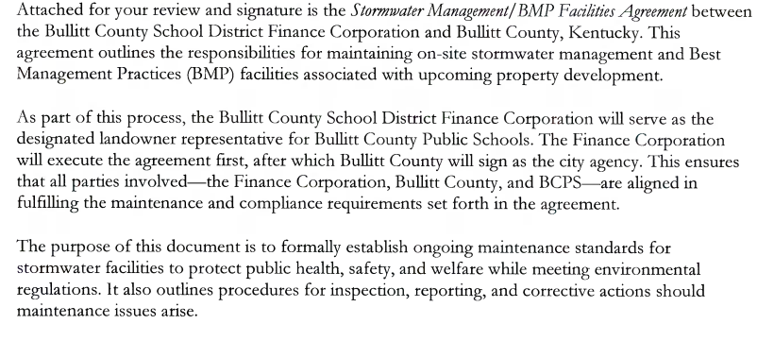
2. Revised BG -1 25-334 West Avenue Property
Attached please find the revised BG-1 for acquisition of the West Avenue property. I ask the revised
BG-1 for this project to be approved
Attachment:
- FACPAC Revised BG-1 Project 25-334
3. BG-1 LJES HVAC Upgrades 26-328 (#8138)
Attached please find the BG-1 for the Lebanon Junction Elementary HVAC Upgrades. I ask the BG-1
for this project to be approved.
Attachment:
- FACPAC BG-1 (Project 26-328)
4. Lebanon Junction HVAC Renovation - Equipment Procurement
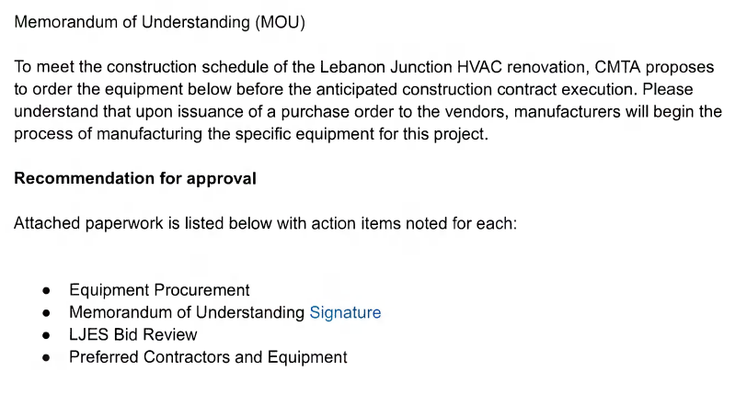
5. BEHS Fine Arts - BG 23-050 - Change Order 33 - Hot Water Piping Insulation
6. Bernheim Middle School - BG 23-051 - DPO 4 - Schiller - Change Order Credit Omit Sales
Tax on Administrative Request
7. North Bullitt PSC- BG 24-192 - Schiller DPO - Grab Bar Deduct
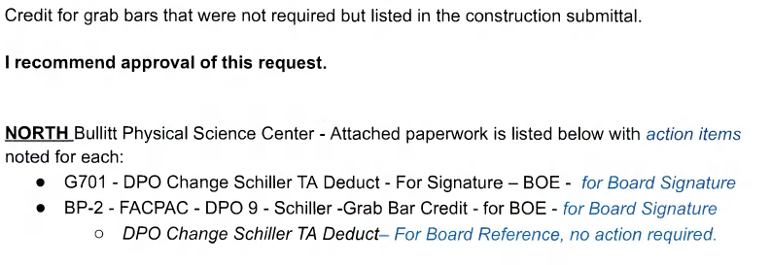
8. Correction to Change Order #29 for FACPAC
BG 24-192 Phase II Change Order #29 was approved and signed 8/25/25. The change order request
was increased in FACPAC and not deducted as requested. I recommend approval of this request.
Attacher paperwork is listed below with action items noted for each:
- FACPAC PO Change Order- Ferguson Material- for Board Signature
9. North Bullitt PSC- BG 24-192 Change Order 32 - Restroom Hardware Revisions
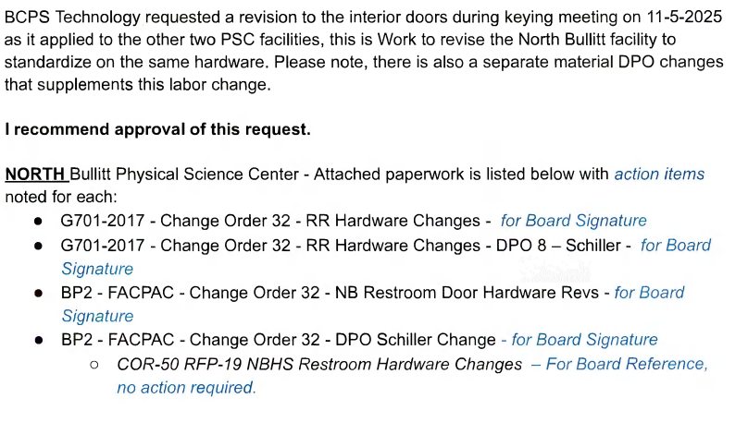
10. North Bullitt PSC - BG 24-192 - Change Order 33 - Site Revisions at Stadium Plaza
11. Bullitt Central PSC - BG 25-145 - B Sign DPO - Outdoor Back-Lit Light Credit
12. BCHS/BEHS PSC - BG 25-145 - Change Order 10 & 12 - Restroom Hardware Revisions
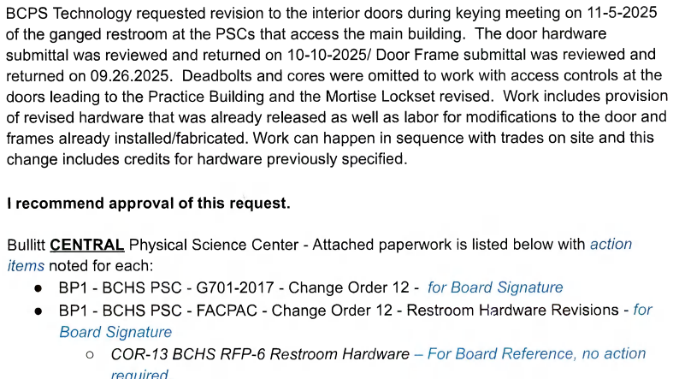
13. Bullitt Central PSC - BG 25-145 - Change Order 13 - Concrete Joint Installation
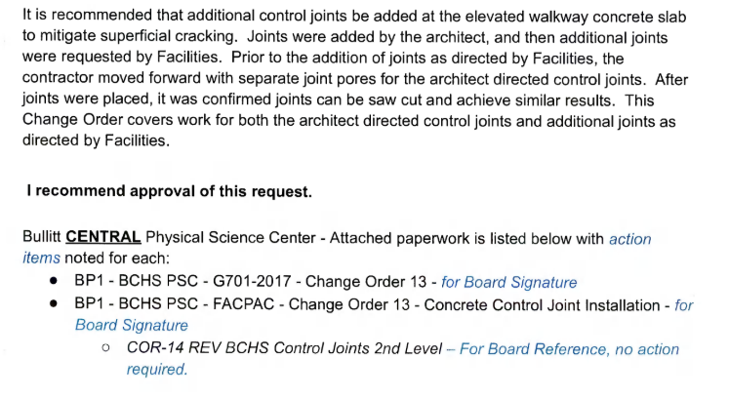
14. Bullitt Central PSC - BG 25-145 - Technology Bid Package No. 3 - Delta - Change Order 1 –
Projector Screen Credit
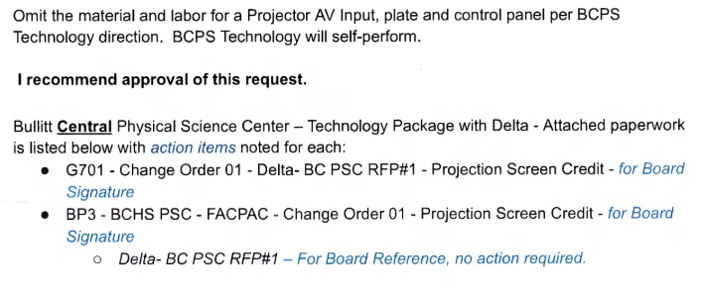
15. Bullitt East PSC - BG 25-145 - Change Order 11 - Added Endzone Netting Foundation
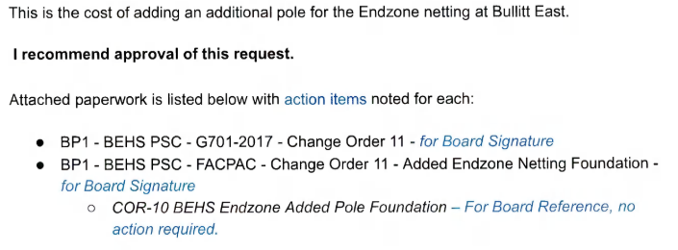
16. Bullitt East PSC - BG 25-145 - Change Order 12 - Concrete Control Joint Installation
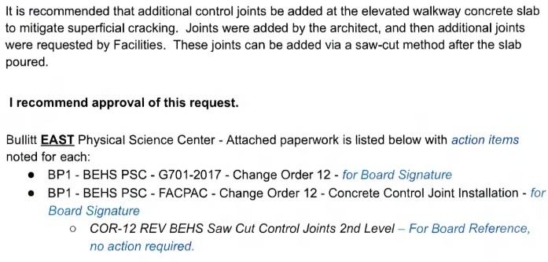
17. Bullitt East PSC - Technology Bid Package No. 3 - KES - Change Order 01 - Projector Screen
Credit
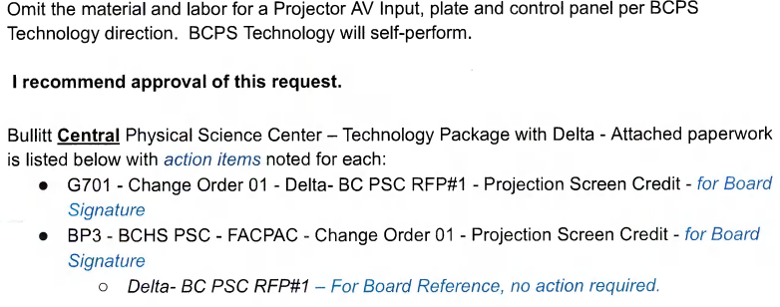
f. Human Resources
1. Leave of Absence Requests
Anastasia Lagowski-Teacher-Zoneton Middle School-Ms. Lagowski is requesting leave without
pay for the dates of 02/02/2026, 02/05/2026, 02/09/2026, 02/10/2026, 02/12/26 for a total of 5
Days without pay.

Tammy Coomes-Bus Monitor-Transportation-Ms. Coomes is requesting leave without pay for the
date of 02/03/2026 for a total of 30 minutes without pay.

Kelsey Richie-Lunchroom Monitor-Roby Elementary-Ms. Richie is requesting leave without pay
for the dates of 12/03/2025-02/06/2026, 02/09/26, 02/11/26 and 02/16/26 for a total of 39 days
without pay.

MacKenzie Green-Teacher-Shepherdsville Elementary-Ms. Green is requesting leave without pay
for the dates of 02/11/2026-03/02/2026 for a total of 13.50 days without pay.

Dona Crigger-Lunchroom Monitor-Maryville Elementary-Ms. Crigger is requesting leave without
pay for the dates of 02/03/2026, 02/05/2026 and 02/20/26 for a total of 3 hours without pay.

Stephanie Daniels-Lunchroom Monitor-Nichols Elementary-Ms. Daniels is requesting leave without
pay for the date of 01/29/2026 for a total of 1 hour without pay.

Jessica Embry-Monitor-Cedar Grove Elementary-Ms. Embry is requesting leave without pay for the
date of 02/06/2026 for a total of 1 hour without pay.

Kathy Howard-Lunchroom Monitor-Roby Elementary-Ms. Howard is requesting leave without pay
for the dates of 02/03/2026 for a total of 1.75 hours without pay.

Kellie Rausch-Monitor-Lebanon Junction Elementary-Ms. Rausch is requesting leave without pay
for the dates of 01/29/2026, 02/16/26 and 02/17/26 for a total of 3 days without pay.

Kayla Hass-Instructional Assistant-Maryville Elementary-Ms. Hass is requesting leave without pay
for the dates of 03/27/2026-05/29/2026 for a total of 38.53 days without pay.

Heather McDaniel-Instructional Assistant-North Bullitt High-Ms. McDaniel is requesting leave
without pay for the date of 02/10/2026 for a total of 22 minutes without pay.

Kendra Spencer-Teacher-Freedom Elementary-Ms. Spencer is requesting leave without pay for
the dates of 01/22/26 and 02/09/26 for a total of 15 hours without pay.

Elizabeth Norris-Secretary-Central Office-Ms. Norris is requesting leave without pay for the dates
of 02/05/26 and 02/06/26 for a total of 7 hours and 36 minutes without pay.

Jake Yoak-Bus Driver-Transportation-Mr. Yoak is requesting leave without pay for the date of
02/04/26 for a total of 1 hour and 2 minutes without pay.

Nichole Cavote-Secretary-Transportation-Ms. Cavote is requesting leave without pay for the date
of 01/29/26 for a total of 4 hours and 7 minutes without pay.

Terry Rowe-Teacher-Zoneton Middle School-Mr. Rowe is requesting leave without pay for the
dates of 02/02/26-03/06/26 for a total of 24.50 days without pay.

Clara Antle-Plant Manager-Nichols Elementary-Ms. Antle is requesting leave without pay for the
date of 02/16/2026 for a total of 8 hours without pay.

Keaghan Holland-Youth Service Center Assistant-Bullitt Lick Middle & Bernheim Middle-Ms.
Holland is requesting leave without pay for the date of 02/12/2026 for a total of 3.75 hours without
pay.

Shannon Flynn-Bus Driver-Transportation-Ms. Flynn is requesting leave without pay for the dates
of 02/03/26 and 02/04/26 for a total of 10.08 hours without pay.

Melissa Easley-Instruction Assistant-Bullitt East High-Ms. Easley is requesting leave without pay
for the date of 02/18/26 for a total of 3 hours without pay.

Ka’ren Weaver-Secretary 1-Central Office-Ms. Weaver is requesting leave without pay for the dates
of 02/06/26, 02/10/26, 02/17/26 and 02/23/26 for a total of 4 days without pay.

Ellen mast-Lunchroom Monitor-Brooks Elementary-Ms. Mast is requesting leave without pay for
the date of 02/20/26 for a total of 1.50 hours without pay.

Leslie Cook-Lunchroom Monitor-Crossroads Elementary-Ms. Cook is requesting leave without pay
for the dates of 02/09/26, 02/13/26, 02/17/26 and 02/19/26 for a total of 4.5 hours without pay.

Laura Buley-Lunchroom Monitor-Pleasant Grove Elementary-Ms. Buley is requesting leave without
pay for the dates of 02/11/26, 02/18/26 and 02/19/26 for a total of 4.5 hours without pay.

Christopher Miracle-Teacher-Zoneton Middle-Mr. Miracle is requesting leave without pay for the
dates of 05/14/26-05/29/26 for a total of 10 days without pay.

Kayla Broughton-Teacher-Crossroads Elementary-Ms. Broughton is requesting leave without pay
for the dates of 02/06/26-04/03/26 for a total of 39.88 days without pay.

2. Entry of the Employment Records in the Minutes of Record
Employment records for both the certified and classified personnel for the period of January 2026
through February 2026 are submitted for the Board’s information and inclusion in the minutes of this
meeting.
g. Contracts
1. Alpha-Lit Contract for Bullitt East High School Prom 2026
Please see the attached contracts between Bullitt East High School and Alpha-Lit for "PROM 2026"
lit letters for their Junior/Senior Prom on Saturday, March 21, 2026. This contract has been reviewed
by Dinsmore & Shohl LLP. Please approve this contract at the March Board Meeting.
2. PowerSchool Contract Renewal
Attached is the Annual Contract Renewal Agreement between PowerSchool Group LLC and the
Bullitt County Board of Education. PowerSchool Group LLC provides our electronic system for
maintaining employee evaluations (Unified Talent Perform), our electronic system for recruitment
and hiring (Unified Talent Applicant Tracking), and our electronic system for maintaining employee
records (TalentEd Records).
The renewal costs are:
Unified Talent Sync - $3,314.61 (Syncs all programs into one.)
TalentEd Records - Professional: $25,401.76
Total Cost: $30,494.49
Renewal:2026-2027 School Year

Unified Talent Perform (Evaluations)
Total Cost: $27,237.17
Renewal: 2026-2027 School Year
Unified Talent Applicant Tracking (Recruit and Hire)
Total Cost: $18.042.16
Renewal: 2026-2027 School Year
3. Vector Solutions Contract
Please present this contract between Vector Solutions and the Bullitt County Board of Education to
board members for consideration at the March 23, 2026 Board Meeting. A service agreement for
the 2026-2027 school year is needed to meet our district training needs. This contract was reviewed by
Lani Ceballos.
4. Rental of Broadbent Arena for 2026 Graduations
Provided is the Kentucky Venues Lease Agreement for rental of Broadbent Arena for graduation
ceremonies for all three high schools on Saturday, May 31, 2025. Rental of the facility is $5835.00.
The fee will be paid from the Superintendent's Office Budget, ORG-0011075, OBJ- 0891- Diplomas
and Graduation Expenses.
Graduations will be as follows:
Bullitt East High School May 30, 2025 @ 11:00 am
Bullitt Central High School May 30, 2025 @ 2:00 pm

North Bullitt High School will host their graduation at North Bullitt on Friday May 29, @ 7:00pm
with an alternate weather date of Saturday, May 30th @ 7:00pm

5. Pre-Employment Transition Services (Pre-ETS) Partnerships
The Bullitt County Public Schools Department of Special Education requests approval of the attached
Memorandums of Agreement to partner with the following agencies in providing Pre-ETS to students
with disabilities: Zoom Group, Inc., Mattingly Edge, Windrose Employment Services, and Options
Unlimited, Inc. These MOAs have been reviewed and approved by school board counsel. There is no
cost to the school district as funding for services from these agencies is provided from the Department
of Vocational Rehabilitation.
The implementation of Pre-Employment Transition Services (Pre-ETS) serves as a critical bridge
between secondary education and post-secondary success. Pre-ETS is a strategic pedagogical approach
designed to fulfill the mandates of IDEA. Under IDEA, the primary purpose of special education is
to ensure that students with disabilities are prepared for further education, employment, and
independent living. IDEA requires that the IEP include a "coordinated set of activities" designed
within a results-oriented process. Partnering with vendors to provide the Five Core Services directly
addresses these legal requirements by providing the instruction, community experiences, and
employment objectives necessary to satisfy the district's obligation to provide a Free Appropriate
Public Education (FAPE). Within Pre-ETS, there are five core services: Job Exploration Counseling,
Work-Based Learning Experiences, Counseling on Post-Secondary Opportunities, Workplace
Readiness Training, and Instruction in Self-Advocacy.
The implementation of Pre-ETS creates a vital bridge between IDEA and the Workforce Innovation
and Opportunity Act (WIOA). While IDEA mandates that schools lead the transition planning
process, WIOA requires vocational rehabilitation agencies to collaborate with schools to provide these
five specific categories of service. We are leveraging federal interagency requirements to provide
high-quality Work-Based Learning and Self-Advocacy training. This collaboration minimizes the
risk of service gaps, ensuring our district meets the IDEA standard of preparing students for
"competitive integrated employment" and successful post-secondary transitions. By partnering
with specialized vendors, the district gains access to expert resources and community networks
that extend beyond the traditional classroom. This collaboration ensures that every student receives
high-quality, specialized instruction that fulfills the district's obligation to provide a comprehensive
and effective education. Our goal in these partnerships is to move beyond compliance and toward
empowerment, ensuring every student graduates with a clear path toward a self-determined and
successful future.
6. Rumpke Solid Waste Removal, Disposal & Recycling Services Contract Renewal 2026-2027
Recommendation to request a one year extension for Rumpke Solid Waste Removal, Disposable
& Recycling Services Contract for the 2026-2027 school year. This will be the second extension
of a contract that was awarded for the 2024-2025 school year that has 3 extensions. Rumpke will
have a 5% increase of the original contract rate.
I recommend approval of this contract.
7. Grass Mowing and Trimming Services: Renewal 2026-2027
Recommendation to request a one year extension for HB Landscaping for Grass Mowing &
Trimming Services Contract for the 2026-2027 school year. This will be the first extension of a
contract that was awarded for the 2025-2026 school year that has 2 extensions. HB Landscaping
will have a 4% increase of the original contract rate.
I recommend approval of this request.
Attached paperwork is listed below with action items noted for each:
- HB Landscaping Contract Extension-For Board Signature
- HB Landscaping 2026-2027 Service Rates- For Board Reference
8. Data Protection for Tier 2 and 3 Character Strong
I am requesting approval of the attached document, the Data Protection Addendum
("Addendum") between the Bullitt County Public Schools and CharacterStrong LLC
("Contractor").
The Addendum outlines essential privacy and security provisions, beginning with definitions for
terms such as Personally Identifiable Information (PII), Student Data, and Education Records. It
establishes the Contractor as a School Official with a legitimate educational interest. Crucially,
the Contractor is strictly prohibited from using BCPS Data for its own commercial benefit,
including advertising, and is forbidden from selling, renting, or disclosing the data to any third
party without prior consent, except as required by law. Regarding security, the Contractor must
implement administrative, physical, and technical safeguards according to commercial best
practices, including encrypting electronic data both in transmission and at rest. In the event of a
Security Breach, the Contractor is required to notify the BCPS Designated Representative within
seventy-two (72) hours. Furthermore, the Contractor warrants compliance with all applicable
laws, including FERPA, COPPA, and HIPAA, and must securely destroy or return all BCPS Data
within thirty (30) calendar days upon receiving written notice of termination or expiration.
Please consider approving this request; this is crucial to effective Tier 2 and 3 implementation of
Character Strong, the district SEL programming that all schools utilize.
9. Chromebook Lease 26-27
We’ve chosen Dell as our Chromebook partner for another year. We worked to get quotes
from other vendors, but have been largely unsuccessful with the exception of
CDWG/Lenovo. Due to market volatility with RAM for data centers and increasing processor
chip costs, prices have increased significantly. Kindergarten through Second Grade will use
a 2-in-1 convertible Chromebook, while Grades 3 through 12 will continue to use a
non-touch clamshell device.
Our white-glove partner will be Encore, the official reseller for Dell.
The Kindergarten touchscreen devices will be a Dell 11, and the 3/6/9 grade non-touch
devices will be the Dell 11. We will lease the Kindergarten, 3rd, and 6th-grade devices for 3
years, with the incoming 9th grade at 4 years. The total amount to be paid over 3 and 4
years will be $1,607,138.39. Payments are detailed in the lease documents. We currently
have a large number of Chrome Upgrade licenses for the devices and will not need to
purchase those this year.
Insight Financial will remain our lease provider. The purchase and lease documents are
attached for your approval. These lease schedules have been reviewed by our district legal
counsel, Eric Farris. After board approval, we’ll send it off to the state for KDE’s legal
counsel approval. Thank you!
10. New PL Tracking System with Vector Solutions
For several years, we have relied on an internally developed system to track our professional
learning and EILA credits. After evaluating several alternatives, we have decided to move
forward with a new solution from Vector Solutions, a vendor with whom we already have a
successful relationship for our Safety and Compliance training.
This new PL tracking system offers capabilities that our current system lacks. Furthermore, by
securing a three-year agreement, we can obtain a favorable price point of $19,240 per year.
This represents a 10% annual savings compared to the single-year cost of $21,645.
A key benefit of this transition is that it will unify the tracking of both Safety & Compliance and
Professional Learning for all staff, both Classified and Certified, under a single Vector Solutions
platform. Please note that this is an additional cost to our existing agreement.
I respectfully request the approval of the attached three-year agreement for the Vector Solutions
PL tracking system. This was reviewed and approved by district legal counsel. Thank you for
your consideration.
h. Curriculum/Instructional Resources etc. Approval
i. Donations & Grants for Approval
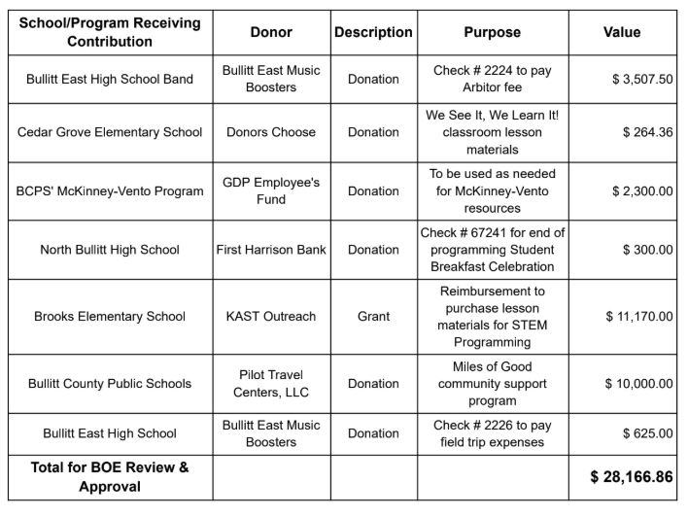
j. Shortened Day Request
The following information summarizes student cases for which the parents and medical
professionals have requested a modified attendance schedule for these students with disabilities.
The students are identified by number in order to maintain confidentiality. There is
documentation of medical necessity for the modified schedules, and the modified schedules have
been recommended for approval by the Admissions and Release Committees (ARCs). Full
documentation is on file in the office of Director of Special Education.
2526-04
This student has a diagnosis of Autism. A physician’s statement was submitted recommending
the implementation of a shortened school day/week schedule due to complications with the
child’s sleep patterns, negatively impacting their ability to attend and function in the school
setting; including physical fatigue and an inability to regulate emotions. An ARC meeting was
held on 10/27/25, during which the implementation of a shortened school day and week schedule
was approved: Wednesday through Friday, 12:00PM to 3:50PM. The modified schedule will be
approved for the 2025-2026 school year and will be reviewed during the spring of 2026.
2526-05
This student has a diagnosis of Down’s Syndrome as well as hypotonia resulting in
corresponding conditions of sleep apnea and circadian shift work disorder. A physician’s
statement was submitted recommending the implementation of a shortened school day schedule
to compensate for the physical effects associated with these conditions. An ARC meeting was
held on 9/16/2025, during which the implementation of a shortened school day schedule was
approved: Monday through Friday, 11:00AM to 3:30PM. The modified schedule will be
approved through the 2025-2026 school year and will be reviewed on or before the next IEP
annual review date.
2526-06
This student has a diagnosis of Anoxic brain damage, Congenital malformation of heart, and
muscle weakness. They suffered a brain injury following complications with open heart surgery
and underwent G-tube placement as a result of difficulty tolerating feeds. They have a complex
medical history of complex congenital heart disease with surgical interventions, cardiac arrest,
Extracorporeal membrane oxygenation (ECMO), and seizures. They also have a current
diagnosis of Hypoxic Ischemic Encephalopathy (HIE) and Mental Disorder. An ARC meeting
was held on 8/14/25, during which the implementation of a shortened school day schedule was
approved: Monday through Friday 9:00AM to 12:00PM. The modified schedule will be
approved through the 2025-2026 school year and will be reviewed on or before the next IEP
annual review date.
2526-07
This student has diagnoses of Autism Spectrum Disorder, Sensory Processing Disorder, and
Language Disorder which manifest in the form of maladaptive behaviors while the school day
progresses. A physician’s statement was submitted requesting this accommodation for the
student’s medical and mental health needs. An ARC was held on 9/4/25, during which the
implementation of a shortened school day schedule and transition plan was approved: September
4th through 12th, 9:00AM to 12:00PM; September 15th through 19th, 9:00AM to 12:30PM;
beginning September 22nd, 9:00AM to 1:00PM. When an updated physician’s statement is
available, the ARC will reconvene to discuss extending this student’s schedule to a full day.
2526-08
This student has a diagnosis of Autism. They enrolled in Bullitt County Public Schools on
2/22/26, with an out of state IEP stipulating the implementation of a shortened school day:
Monday through Friday, 8:00AM to 12:30PM. An ARC meeting was held in BCPS prior to
enrollment on 1/21/2026 to review the incoming IEP. The ARC agreed to continue the
implementation of the shortened school day, adjusted to coincide with hours of operation at the
receiving school: Monday through Friday, 9:00AM to 12:30PM. The student’s time in school
would be increased in 1 hour increments until they reach a full school day schedule. The student
was transitioned to a full day schedule on 2/23/26.
k. Use of District Property Requests
1. BCHS (Spark Athletics)- Community Use of School Facilities
Spark Athletics has submitted a facility use form seeking permission to use Bullitt Central HS on the following days: 03/28/2026 - 01/27/2026 All required documentation has been verified. I recommend approval of this request. Please reach out with any questions.
l. Permission to Apply for Sun Meals Program (aka Summer Feeding Service Program - SFSP)
The Department of School Nutrition Services (SNS) requests permission to apply for and participate in the Sun Meals Program, formerly known as the Summer Food Service Program (SFSP), during the summer weeks of 2026. Sun Meals ensures that children continue to receive nutritious meals when school is not in session. Breakfast and lunch meals are available at no cost to all children under the age of 19 years; these meals will be made available at approved Sun Meal sites in areas with significant concentrations of low-income children. Our department is planning to conduct non-congregate feeding, which will allow children to receive a weekly meal pack; meal packs will include daily breakfast and lunch meal offerings. This request for 2026 includes the need for, at maximum, fifteen (15) kitchen associates, three (3) kitchen managers and substitutes on an as-needed basis for no more than 40 days. Participation in Sun Meals benefits other community programs, such as Right at School of Bullitt County, by providing free meals, thus allowing other program funds to go towards education and enrichment activities.
m. Summer Camp Request for March Board Mtg
n. FIRST READING- Acceptable Use Policy Update
Due to the recent integration of emerging technologies, such as artificial intelligence, into the educational environment, a revision to the BCPS Acceptable Use Policy (AUP) is required to safeguard both students and staff.
We have also incorporated details regarding KRS 160.145 (also known as SB 181), which restricts staff from using messaging services not officially approved by the district for communication with students.
This revised policy has been reviewed and approved by our district's legal counsel. This constitutes the first reading, and we will request final approval at the next regular board meeting.
o. Request to declare BCPS 20023 Bucket Truck as Surplus
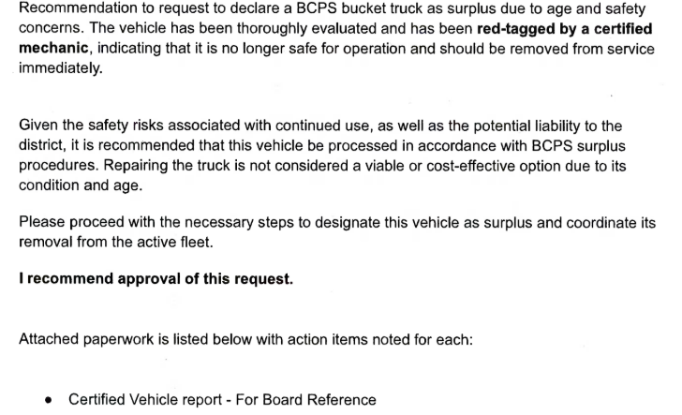
p. Recommendation to Utilize GovDeals for Surplus Property
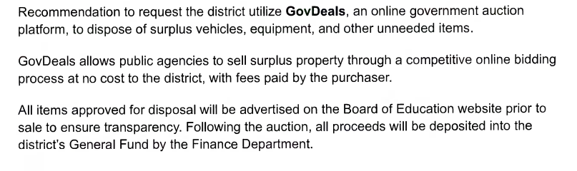
q. LPC Business Community Members
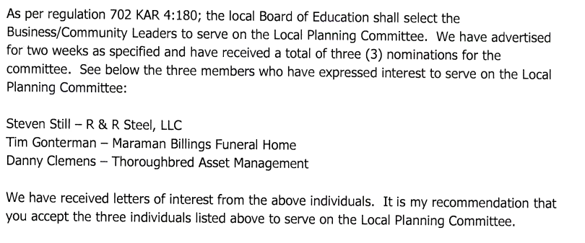
NEW BUSINESS
a. BEHS Request for 3 Assistant Baseball Coaches
Order #2026-201 - Motion Passed: Approve Request for 3 Assistant Baseball Coaches as requested. passed
with a motion by Dallas Harshfield and a second by Ms. Nita Neal. All members voted YES.
Attached is a request to add three (3) Assistant Baseball Coaches for the 2026 season to BEHS’s staffing.
Funding will come from Fund 22. Attachment: Memo from BEHS
b. MWMS MTSS Coach Extended Days - Change in Funding Source
Order #2026-201 - Motion Passed: Approve Change in Funding Source for MWMS Coaches Extended Days
passed with a motion by Ms. Linda Belcher and a second by Marci Hodges. All members voted YES.
Tim Ridley, principal at Mount Washington Middle School, requests to change the funding source for the
MTSS Coach's approved additional five extended days from Title I to SBDM (Section 6) funds. All other
details of the original Board approval remain unchanged.
Attached: Memo from Principal Ridley
c. Early Graduation Requests for March Board Mtg
Order #2026-201 - Motion Passed: Approve Early Graduation recommendations as requested. passed with a motion by Ms. Nita Neal and a second by Marci Hodges. All members voted YES.
Attached you will find an Early Graduation request for the following students:
SSID #2120169679 - senior at Bullitt Central High School
SSID #2120447950 - senior at Bullitt Central High School
SSID #2120435721 - senior at Bullitt East High School
SSID #2120224274 - senior at North Bullitt High School
SSID #2120173998 - senior at North Bullitt High School
These students meet the graduation requirements stated in our Graduation Policy 08.113. Please approve
the Early Graduation request for these students at the March Board meeting.

ADJOURNMENT

Order #2026-201 - Motion Passed: Adjourn at 5:19 p.m. passed with a motion by Ms. Nita Neal and a second
by Marci Hodges. All members voted YES.

_____________________________ ______________________________
CHAIRPERSON SECRETARY

