Curriculum, Instruction, and Assessment
Board Agenda
Wednesday, July 25, 2018
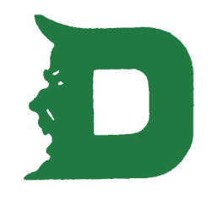
PROFESSIONAL DEVELOPMENT
- We have teachers attending a Junior Great Book/Shared Inquiry Training on July 30 and July 31.
- Many content areas and grade levels have been in over the summer for six hours of professional learning working on curriculum alignment and finalizing curriculum documents.
- We are in the middle of putting the final touches on the August 10 and August 13 professional learning day, along with planning many other items for the upcoming school year.

ASSESSMENT
- Schools are currently working on their Assessment Calendars for the 2017-2018 school year.

TEACHER EVALUATION
- District Evaluation Update training is on August 1 and August 2. District and Building Administrators will take a deeper dive into the Certified Evaluation Plan.

