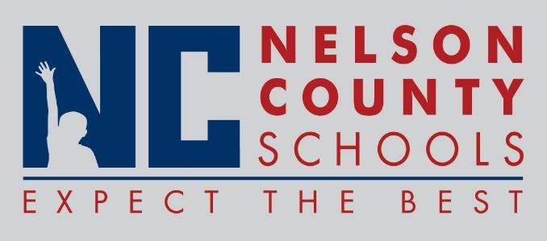

Information Paper

|  |  |
| --- | --- |
| To: | Nelson County Board of Education |
| From: | Bob Morris, Director of Student Support |
| cc: | Dr. Anthony Orr, Superintendent |
| Date: | October 25, 2016 |
| Re: | Personnel Notifications |
|  |  |

**Employment:**

**Transfers**:  None

**Reinstatements:**None

**One Year Certification:**None

**Classified Subs**:

**Certified Substitute:**

**Student Workers**:

**Non-Renewals**:  None

**Resignation**:  Shandy Seymour IAIII FHES

                       Andre Oei IAIII NCHS

Margie Kjera Coach NCHS

Amy Durbin Cook/Baker CCES

Margaret Woods Child Care CCES

Rebecca Mayes Sub District

Jackie Howell Sub District

Bonnie Girder Sub District

Cathy Mattingly Secretary CCES

Peggy Gaona Teacher OKH

Deja Jackson IAIII NCHS

Chassidy Hibbard IAI BOS

Cathy Matting Secretary CCES

**Retirements**:   None

**Reprimands/Terminations**:  Robert Kelty Bus driver Transportation

Lisa Anderson Bus monitor Transportation