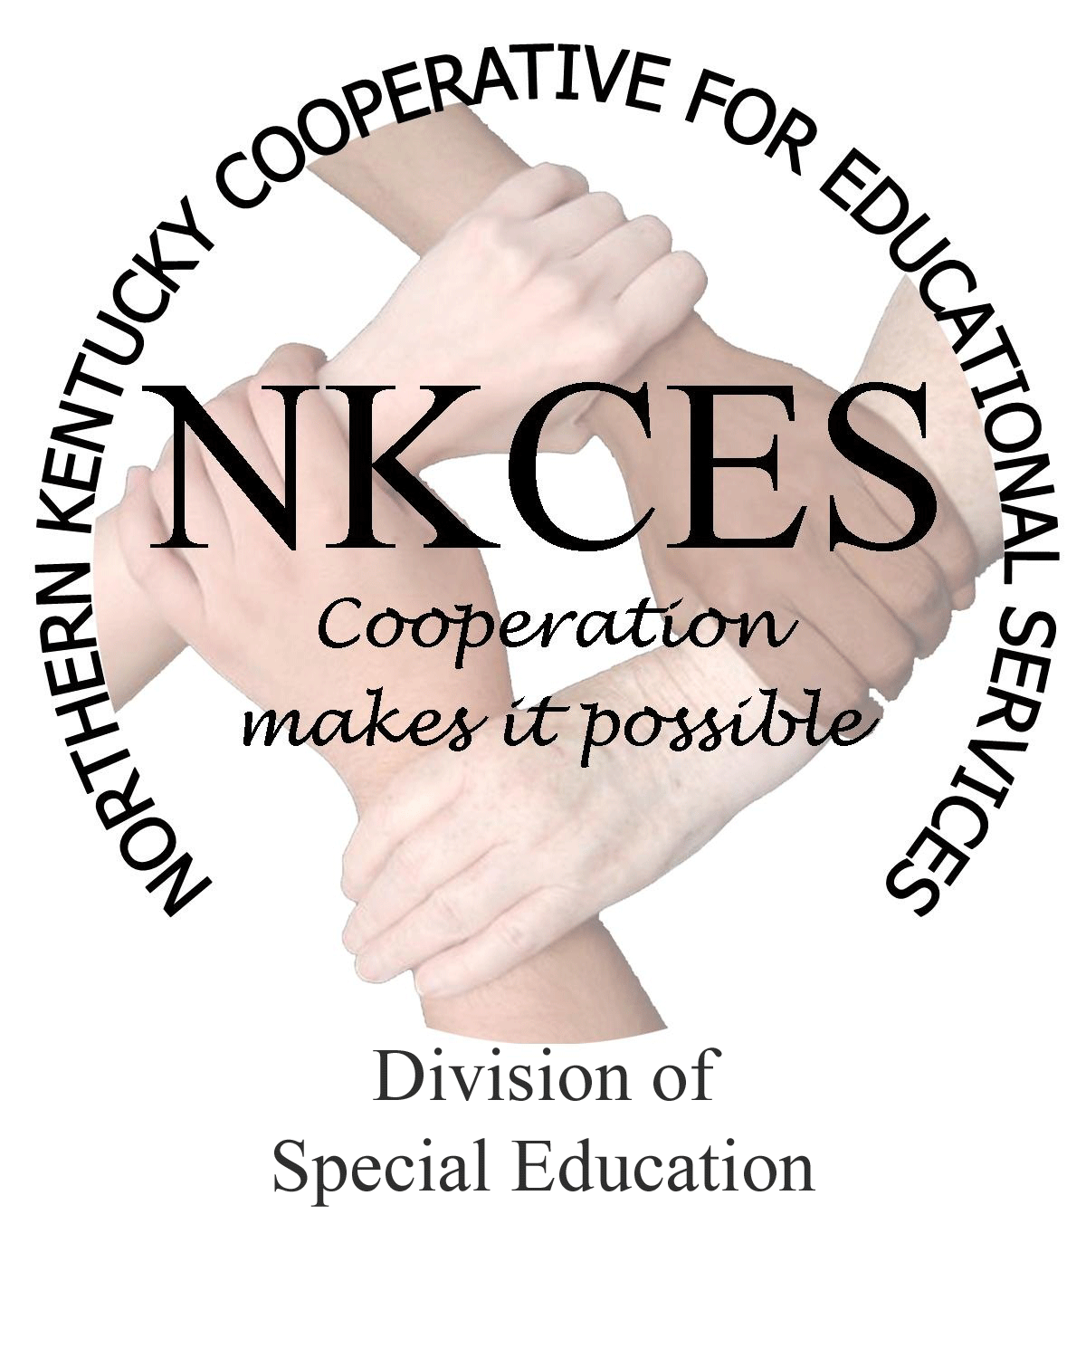
Northern Kentucky Cooperative for Educational Services, Inc.

Member Districts

Beechwood Independent • Bellevue Independent • Boone County • Campbell County

Covington Independent • Dayton Independent • Erlanger-Elsmere Independent

Ft. Thomas Independent • Kenton County • Ludlow Independent • Newport Independent

Pendleton County • Silver Grove Independent • Southgate Independent

Walton-Verona Independent • Williamstown Independent

May 5, 2014

Curtis Hall, Executive Director
NKCES
5516 E. Alexandria Dr.
Cold Spring, KY 4-176

Re: Superintendents Report

Dear Curtis:

Over the past couple of years the cooperatives across the state have developed logic plans. These plans in return evaluated our work through sample evaluations of districts attending and participating in different trainings and technical support. KDE has now informed us that this plan will be final at the end of the school year, and will no longer be utilized. We will begin to focus on a new plan called the Regional Systematic Improvement Plan (RSIP). The RSIP focuses on closing the gap for all children. This correspondence will provide an overview of the RSIP process and we will keep you informed as the process continues to unfold.

The KY Department of Education has been charged to focus on Results Driven Accountability (RDA), which will in return be developed into the State Systematic Improvement Plan (SSIP). The Cooperatives around the state will begin creating the Regional Systematic Improvement Plan (RSIP), which is due on March 2015 to the KDE. I have outlined the focus, components, and phases that will drive this work over the next months. The consultants and I will begin unfolding the process with the state-wide role groups on May 12th – 14th at the Annual State Directors and Consutlants meeting in Lexington. Our focus will be to learn more about the process, receive instructional coaching training, to begin meeting as a regional cooperative, and to continue identifying our work assisting districts in closing the gap. We recognize the process will be an ongoing and will require a consistent look at our regional data, strategies, interventions, trainings, coaching, and support throughout the school year. We will meet on a consistent basis to work on the plan and share it with the superintendent groups upon completion and approval from KDE.

Focusing on RDA – Results Driven Accountability
RDA is a new model designed to strengthen accountability for students with disabilities, and move away from a regulatory emphasis on procedural compliance to a results-driven accountability model improving educational results and functional outcomes for children and youth with disabilities.

Core Components for RDA –
- A system that is developed in partnership with our stakeholders
- A system that is transparent and understandable to states and the general public, especially individuals with disabilities and their families
- A system that drives improved outcomes for all children and youth with disabilities regardless of their age, disability, race/ethnicity, language, gender, socioeconomic status, or location
- A system that ensures the protection of the individual rights of each child or youth with a disability and their families, regardless of his/her age, disability, race/ethnicity, language, gender, socioeconomic status, or location
- A system that provides differentiated incentives, supports, and interventions based on each state’s unique strengths, progress, challenges, and needs
- A system that encourages states to direct their resources to wherethey can have the greatest positive impact on outcomes and the protection of individual rights for all children and youthwith disabilities and minimizes state burden and duplication of effort
- A system that is responsive to the needs and expectations of the ultimate consumers (i.e., children and youth with disabilities and their families) as they identify them.

SSIP – State Systematic Improvement Plan
The SISP is a multi-year plan that the State has developed a three phase role out.

Phase One -
- A detailed data and infrastructure analysis that will guide the development of strategies to increase the State’s capacity to structure and lead meaningful change in local educational agencies (LEA’s)
- States must assess the capacity of their current infrastructure systems; and, their ability to enhance this infrastructure; to, increase the capacity of LEA’s; to, implement, scale up, and sustain evidence-based practices that will result in improved outcomes for children with disabilities.
- The data and infrastructure analysis should use multiple data sources, including SPP/APR indicators and Section 618 data, to identify systemic approaches that will lead to improved results for students with disabilities across key measures: performance on assessment, graduation with a regular diploma, and post-school outcomes.

Phase Two – Implementation
Phase Three - Evaluation
- Details of phase two and phase three will be forthcoming.

As you can see, it is a complex process with several components that will measure our work and hold each cooperative to the highest degree of accountability. It is NKCES’ desire to fulfill and meet this expectation to the highest degree. We have already begun this year by using multiple data sources to identify the targeted areas that will asssist each district in closing the gap. This summer we will begin to do data retreats with schools to train them in a process that they can take back to their schools and focus on what the data says to identify the gap areas. We will also be offering instructional coaching training in the fall as well as curriculum cadres. As we partner with our districts, we are thinking outside the box to see the gap close in our region and assist teachers in making all students college and career ready.
Sincerely,

Linda Alford
Regional Director of Special Education
NKCES

