**CONSENT ITEM G**

**January 22, 2024**

**OLDHAM COUNTY BOARD OF EDUCATION**

**CONCERN**

Consider Approval of Additional ARC Chairs

**DISCUSSION**

The following ARC Chairs require approval by the Board.

Sarah Heitzman

Julie Sackella

Kendra Smith-Wehr

**RECOMMENDATION**

Approve ARC Chairs.

On a motion by _______________, seconded by _______________, the Board approved the ARC Chairs.

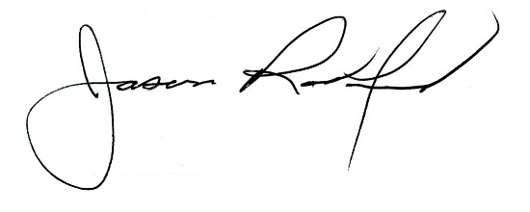

*Suzanne Hundley, Board Chair Jason Radford, Superintendent/Secretary*