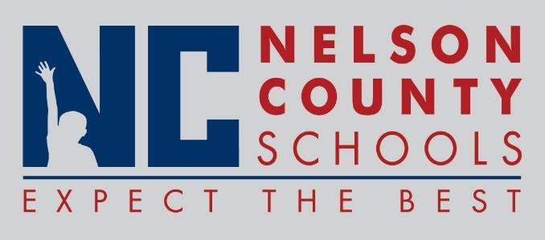

Information Paper
To: | Nelson County Board of Education
From: | Bob Morris, Director of Student Support
cc: | Tom Brown, Superintendent
Date: | February 20, 2018
Re: | Revised Policy and Procedures

09.423 Use of alcohol, Drugs and Other Prohibited Substances
09.423 AP 1 Student Drug Testing Procedures

