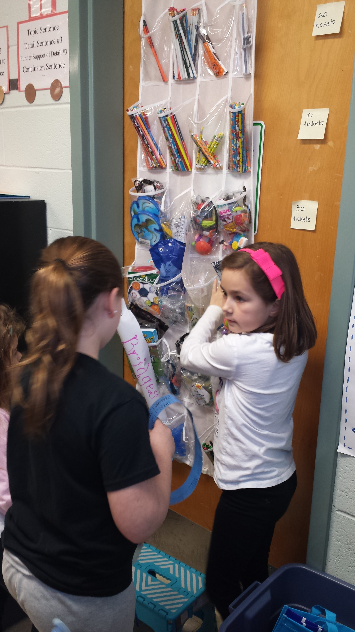  - mullins’  - market  positive behavior  management system  with real-world applications  How does it work?  Students earn tickets that can be used at Mullins’ Market, the classroom store. The store is open one day per week. Items in the store vary from pencils to jewelry to gift cards. Each section in the store has a value that range from 10 tickets to 100 tickets.  How do students earn tickets?  All students have classroom careers that earn various amounts of tickets per week. At the beginning of the year, students applied for 5 classroom careers using an application. Each classroom career has particular duties and pay (not all careers pay the same). I assigned each student a career for each grading period based on their application. On Fridays, students get paid tickets for their career. If they are absent, they do not get paid for the day they missed. If they do not do their responsibilities, they do not get paid.  Stud  Students also earn tickets for positive behavior in the classroom. Students can earn tickets for getting Tiger Paw Sheet signed every night, reading log completion, leadership in the classroom, helping a friend, and more. Again, Friday is pay day.  What are the Real-World Applications?  - Students earn salary for a job well-done! They know if they do not come to school,  they do not get paid.  - Students use economic skills as they purchase items from the store that vary in cost.  - Students are responsible for keeping track of their ticket balance and budgeting.  - Students learn that saving teaches patience and goal-setting.  - Students are expected to use the Dave Ramsey philosophy 50% spend, 40% save,  and 10% give. They can use their “give” to give to a friend or donate an article of clothing to the Family Resource Center (item purchase in Mullins’ Market). |  | “The store has things that you can make and give to someone for their birthday.” –B.N.  “If you have a job and you don’t do it, you don’t get paid. In real life, you don’t get your money.” –J.G.  “It teaches me to buy a good thing that you can actually use.” –J.S.  What Do Students Think About This?  “I like it because it is fun to get stuff from the store.” –M.W.  “It is not only fun but it helps us learn how to use money in real life.” --M.T.

