John Hardin SBDM Council
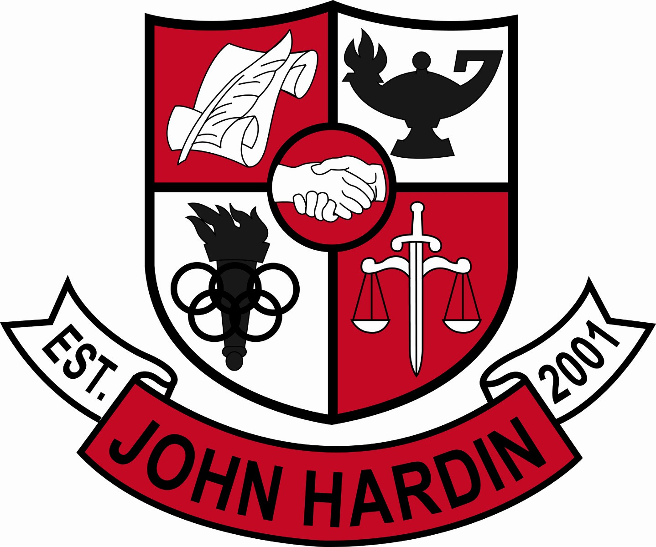
Meeting Minutes

May 8, 2014
4:00 p.m.

- Call to Order at 4:00 p.m.
Members present: Patrick Avery, Jana Haws, Stacey Moore, Pauline Crittenden, Alex Shearer, and Lynne Gibson.
Visitors present: None
- Approval of Agenda ORDER #13-14/0047
The council approved the agenda as written.
Motion: Crittenden Second: Moore
Avery - Yes
Crittenden – Yes
Gibson – Yes
Haws – Yes
Moore – Yes
Shearer - Yes
- Approval of Minutes ORDER #13-14/0048
The council approved the minutes as written.
Motion: Moore Second: Haws
Avery - Yes
Crittenden – Yes
Gibson – Yes
Haws – Yes
Moore – Yes
Shearer - Yes
- PLC Reports
None
- Principal’s Update
- Needs List – The Needs List was submitted. No extra monies that we are aware of except for Technology
- Title I/Title II Leftovers – Title I Part A has $15,705 in extra money. Ms. Gibson has contacted the four cores about using that money on supplemental equipment/needs. Math is looking into graphing calculators; science into microscopes and slides; social studies into reading materials and atlas; English into reading, writing, grammar and ACT/SAT supplements. Side Note: we will be getting some ($65/per student) textbook money next year (15-16 SY.) Title II extension money has paid for homework help; roughly $7,000 remains and must be spent by August 1st. Looking at offering a Reading and/or Math Boot Camp or an ACT Prep class for the summer.
- SBDM Elections – Ms. Gibson spoke with Jenny Brown. She will handle the teacher elections. Ms. Gibson will ask Jessica Forrest as a band parent to run the parent elections.
- Student Achievements - A lot or our students will be recognized for competing in Club events, (DECA, KUNA, etc) Chorus, and Band at the May HCS Board Meeting
- Financial Report ORDER #13-14/0049
The council reviewed and accepted the financial report for April.
Motion: Shearer Second: Avery
Avery - Yes
Crittenden – Yes
Gibson – Yes
Haws – Yes
Moore – Yes
Shearer – Yes
- Room Changes ORDER #13-14/0050
A change in the room assignments that were approved last month needs to occur. Special Ed is increasing the number of MMD students here and wants to use 121 as a Transition Room. The room will be set up like an efficiency apartment to help them better prepare for real life. The board is funding the changes. With that change occurring, Allan will move to 122; French to 123; Benmoussa to 120; Health to 124; and Carson to 229. The council approved the changes as submitted.
Motion: Avery Second: Shearer
Avery - Yes
Crittenden – Yes
Gibson – Yes
Haws – Yes
Moore – Yes
Shearer – Yes
- Personnel
Hired: Hired Jared McCurry for Head Boys Basketball and Kelly Luke for Asst. Volleyball
Vacancies: Golf Coach; Freshmen Volleyball Coach; 10% Baseball Coach; Freshmen Football Coach; Girls Cheer Coaches; Wrestling Coach; Girls Cross Country Coach; Girls Asst. Track Coach; Girls Asst. Soccer Coach; Asst. Wrestling Coach 50%
- Questions and Concerns from Council
None
- Agenda Items for Next Meeting
- No items were mentioned
- Final Meeting for 2013-14 is June 12th at 1:00 p.m.
- Adjourn
The meeting was adjourned at 4:40 p.m. The motion was made by Ms. Moore and seconded by Mr. Shearer

