Director of District Support Services
Board Report – February 2021
Submitted by Katrina Rechtin

District Assessment Coordinator
- The final round of our MAP assessments will take place in April. A specific timeline and schedule are being prepared.
- ACCESS testing is March 22nd – 26th. Specific schedules will be sent to schools within the next two weeks.
- K-PREP and other state assessments will follow the procedure as in the past. This could change, however we have not received notification of any testing waivers at this time. The tentative testing plan is listed below:
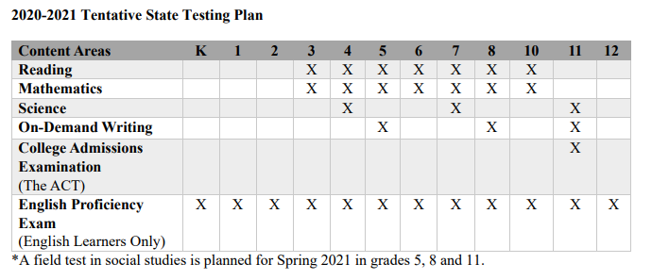
Director of Pupil Personnel
- This year, I have focused on reviewing the Kentucky Department of Education Pupil Attendance Manual to ensure we are following the required procedures. I am working with building leadership to evaluate the procedures we have in place and to improve and implement new procedures when needed.
- Attendance committees continue to collaborate to monitor attendance and participation.

BISD 2020-21 Enrollment Information
(Numbers pulled from Infinite Campus on February 17, 2021)
GES |  | BMS/BHS
Preschool | 38 | 6 | 45
K | 39 | 7 | 54
1 | 28 | 8 | 47
2 | 34 | 9 | 77
3 | 31 | 10 | 49
4 | 32 | 11 | 38
5 | 37 | 12 | 59
Total | 239 | Total | 369
BISD Total Enrollment Preschool – 12th Grade: 608

BISD Attendance Tracker
2020-21

Date | Temp/Cond | Notes | GES | BHS
10/12/20 | No School - Fall Break
10/13/20 | 72 - Sunny |  | 93% | B - 96%
10/14/20 | 77 - Sunny |  | 92% | Virtual
10/15/20 | 65 - Cloudy |  | 95% | A - 96%
10/16/20 | 58 - Sunny |  | 95% | B - 96%
10/19/20 | 59 - Rain |  | 90% | A - 97%
10/20/20 | 56 - Cloudy |  | 93% | B - 96%
10/21/20 | 71 - Partly Cloudy |  | 95% | Virtual
10/22/20 | 81 - Partly Cloudy |  | 98% | A - 96%
10/23/20 | 73 - Partly Cloudy |  | 98% | B - 95%
10/26/20 | 52 - Cloudy |  | 99% | A - 97%
10/27/20 | 52 - Rain |  | 95% | B - 97%
10/28/20 | 51 - Cloudy |  | 97% | Virtual
10/29/20 | 50 - Heavy Rain |  | 93% | A - 95%
10/30/20 | 43 - Cloudy |  | 95% | B -95%
11/2/20 | No School - Teacher Professional Development Day
11/3/20 | No School - Election Day
11/4/20 | 56 - Sunny |  | 94% | Virtual
11/5/20 | 60 - Sunny |  | 98% | A - 93%
11/6/20 | 61 - Sunny |  | 96% | B - 93%
11/9/20 | 70 - Sunny |  | 96% | A - 90%
11/10/20 | 68 - Sunny |  | 96% | B - 95%
11/11/20 | 60 - Cloudy |  | 96% | Virtual
11/12/20 | 37 - Sunny |  | 95% | A - 93%
11/13/20 | 42 - Sunny |  | 98% | B - 93%
11/16/20 | 45 - Sunny |  | 91% | A - 90%
11/17/20 | 42 - Sunny |  | 95% | B - 87%
11/18/20 - 1/29/21 | NTI - All Virtual
2/1/21 | 29 - Snow |  | 91% | A - 94%
2/2/21 | 30 - Cloudy |  | 92% | B - 95%
2/3/21 | 38 - Sunny |  | 97% | All Virtual
2/4/21 | 39 - Sunny |  | 97% | A - 96%
2/5/21 | 35 - Cloudy |  | 95% | B - 95%
2/8/21 | 32 - Cloudy |  | 96% | 94%
2/9/21 | 35 - Snow/Cloudy |  | No in-person instruction -  NTI - weather related
2/10/21 | 23 - Cloudy/Snow |  | 94% | All Virtual
2/11/21 | NO SCHOOL - SNOW DAY
2/12/21 | 34 - Partly Cloudy |  | 91% | 92%
2/15/21 | NO SCHOOL - Holiday
2/16/21 |  |  | No in-person instruction -  NTI - weather related

