Regular Meeting Boone County Board of Education
August 11, 2016 7:30 PM
Ralph Rush Professional Development Center
99 Center Street
Florence, Kentucky 41042

I. CALL TO ORDER

The Regular meeting of the Boone County Schools Board of Education August 11, 2016 was called to order by Chairperson Dr. Maria Brown at the Ralph Rush Staff Development Center.
Attendance Taken at 7:30 PM:

Present Board Members:
Dr. Maria Brown
Ms. Karen Byrd
Mr. Ed Massey
Ms. Bonnie Rickert
Mr. Steve Templeton

Gerry Dusing attended as Board Attorney
Karen Evans, Board Secretary, recorded the minutes.

II. PLEDGE TO THE FLAG
II.A. The Pledge to the Flag was led by Dr. Maria Brown, Chairperson.

III. GOOD NEWS
III.A. New Student Board Member Representative David "Bradley Rodriquez was sworn in by the Honorable Judge Schrand.
III.B. The board recognized the Ryle High School Brainy Bots First Tech Challenge Robotics Team (FTC) who were finalists for the Connect Award at the FTC World Tournament in St. Louis. This means that they were in the top 6 in the WORLD out of nearly 20,000 teams participating from 53 countries: only 3% of those teams qualified for the World tournament.
Congratulations for a successful season and representing Boone County Schools so well at the tournament!

Ken Ryumae
Mina Ryumae
Will Richards
Wyatt Richards
Tanner Schmidt
Alex Wilson
Zach St. Hilaire
Kate Grayson
Audrey Wilson

III.C. Brad Hughes and Dr. Hope McLaughlin from KSBA presented Dr. Poe the 2016 Celebrating Advocacy for Public Education Award - CAPE Award.

III.D. Introduction of Ms. Jennifer Patrick, new principal at Goodridge Elementary and Ms. Emily Green, new Expanded Learning Opportunities Coordinator.

- Dr. Poe and Steve Templeton thanked everyone that participated in the golf outing sponsored by the Business Association benefiting the Boone County Students. The outing was very successful and the monies will go to the Alternative School and winter wear for many of our students in need.
- Ed Massey spoke on the new program called My Life My Power, which Mike Puder is the founder. Ed Massey introduced Mr. Puder and associates and they introduced the program for the alternative school. Mr. Puder spoke on the recent administrator training and the Nationwide program of mentoring/motivating youth in schools . The program will begin on August 24 & 25th for Juniors and Seniors at the Alternative School.
- Brad Rodriquez, Student Board Representative, spoke to the board on the future platforms he will implement or continue from the last Student Board Representative: Health Choice Talk, Boone 4Health in the spring, and a new software that connects students with teachers after school to help with homework.

IV. AUDIENCE OF CITIZENS
No one spoke.

V. RECOMMENDED ACTION – CONSENT AGENDA
Dr. Randy Poe, Superintendent, recommended the board approve the consent agenda items A-U for board approval, as presented.

- A motion was made by Ed Massey, seconded by, Steve Templeton to approve the consent agenda items A-U, as presented. Ed Massey, Steve Templeton, Karen Byrd, Maria Brown, and Bonne Rickert voted, “aye” MOTION: The motion passed 5-0.

V.A. Minutes of the regular board meeting of July 21, 2016.
The board approved the minutes of the regular board meeting of July 21, 2016, as presented.
V.B. Bill List
V.C. Treasurer’s Report was given by Mrs. Linda Schild.
V.D. Leaves of Absence
The following persons submitted leaves of absence requests were approved:
Recommended by Principal/Supervisor for approval:
Blum-Ficke, Melanie, Teacher @ Boone County High, 8/15/3026 – 12/21/2016
Case, Stephanie, Teacher @ North Pointe Elem, 8/15/2016 – 9/5/2016
Ewing, Kristen, Teacher @ Collins Elem, 9/12/2016 – 12/21/2016
Frank-Nix, Kristina, Teacher @ Special Ed, 8/15/2016 – EOY
Gascon, Melissa, Bus Driver @ Transportation, 8/15/2016 – EOY
Hall, Roberta, Bus Driver @ Transportation, 8/15/2016 – 9/2/2016
Harvey, Sarah, Teacher @ Longbranch Elem, 10/17/2016 – 12/21/2016
Kim, Jesse, Teacher @ Alt Center, 9/8/2016 – 12/21/2016
Messmer, Kimberly, Teacher @ Ockerman Elem, 9/20/2016 – 10/21/2016
Ottesen-Price, Afton, Teacher @ Long Branch, 8/15/2016 – 9/23/2016
Payne, Samantha, Teacher @ Mann Elem, 8/15/2016 – 11/4/2016
Ratliff, Linda, Custodian @ Goodridge Elem, 6/22/2016 – 7/29/2016
Schnurr, Paula, Café Wkr @ RA Jones Middle, 8/12/2016 – 8/26/2016
Not Recommended by Principal/Supervisor for approval:
Nothing to Report
Amended Leaves:
Dickman, Randal, Custodian @ Goodridge Elem, 5/26/2016 – 8/5/2016
Cancelled Leaves:
Nothing to Report

V.E. Community Work Transition Program (CWTP)Memorandum of Understanding
The board approved the Community Work Transition Program (CWTP)
Memorandum of Understanding agreement, as presented.
V.F. Food Service Agreement with Head Start 2016-2017 School Year.
The board approved the Food Service Agreement with Head Start 2016-2017 School Year, as presented.
V.G. Sales Campaign
The board approved the Sales Campaigns, as presented.
V.H. Change Order #1 Conner Middle School HVAC Upgrades BG#16-087
The board approved the e Change Order #1 Conner Middle School HVAC Upgrades BG#16-087 with total change order to deduct $4166.00, as presented.
V.I. Change Order #2 Maintenance Building BG#15-219
The board approved the Change Order #2 Maintenance Building BG#15-219, total amount to change order addition of $21,809.00, as presented.
V.J. Change Order #1 Ryle High School Additions/Renovations BG#15-281
The board approved the Change Order #1 Ryle High School Additions/Renovations BG#15-281, as presented.
V.K. Change Order #1 New Haven Elementary Renovations BG#15-303
The board approved the Change Order #1 New Haven Elementary Renovations BG#15-303, as presented.
V.L. Cooper High School Track Refurbishment AIA Standard Form of Agreement
The board approved the Cooper High School Track Refurbishment AIA Standard Form of Agreement, as presented.
V.M. Surplus Equipment
The board approved the listed old equipment items as surplus and approve the disposal of, as presented.
V.N. NKYEC Membership Renewal 16-17
The board approved the NKYEC Membership 16-17 in the amount of $3450.00, as presented.
V.O. NSBA National Hispanic Caucus of School Board Members 2016-2017
The board approved the NSBA National Hispanic Caucus of School Board Members 2016-2017 membership in the amount of $75.00, as presented.
V.P. Field Trips
The board approved the Field Trips request, as presented.

School | Date Of Trip | Location | Reason
Florence Elementary | September 29, 2106 | Conner Prairie | Educational
Ryle High School | September 10, 2016 | Meade County | Soccer Games
Ryle High School | August 13, 2016 | Elizabethtown | Soccer Games
Cooper High School | September 23, 2016 | Lexington | Football Game

V.Q. Approval of Contract Closeout BG-5 Erpenbeck Elementary Controls Upgrade BG#15-065
The board approved the Contract Closeout BG-4 Erpenbeck Elementary Controls Upgrade BG#15-065, as presented.
V.R. 2016 KIP Memorandum of Understanding
The board approved the 2016 KIP Memorandum of Understanding, as presented.
V.S. Agreement for Consultation Services between the Boone County Schools and Jerome Bowles –Renewal
The board approved the Agreement for Consultation Services between The Boone County Schools and Jerome Bowles – Renewal Agreement, as presented.
V.T. Annual Memorandum of Agreement with NorthKey Community Care
The board approved the Annual Memorandum of Agreement with NorthKey Community Care, as presented.
V.U. Contract for 2016-2017 School Based Therapy Services with Catholic Charities
The board approved the contract for 2016-2017 School Based Therapy Services with Catholic Charities, as presented.

VI. RECOMMENDED ACTION – OLD BUSINESS
VI.A. Annual Board Policy Update Second Reading

Dr. Randy Poe, Superintendent, recommended the board approve the Annual Board Policy Update second reading, as presented.

- A motion was made by Karen Byrd, seconded by, Ed Massey to approve the Annual Board Policy Update second reading, as presented. Ed Massey, Steve Templeton, Karen Byrd, Maria Brown, and Bonne Rickert voted, “aye” MOTION: The motion passed 5-0.

VII. RECOMMENDED ACTION – NEW BUSINESS
VII.A. Tax Rate Levy and Property Assessment

Dr. Randy Poe, Superintendent, recommended the board approve the levy of the compensating rate: 63.5 cents per $100.00 valuation of real estate, 64.3 cents per $100.00 valuation of tangible property, 49.7 cents per $100.00 valuation of motor vehicles, as presented.

- A motion was made by Ed Massey, seconded by Steve Templeton to approve the levy of the compensating rate: 63.5 cents per $100.00 valuation of real estate, 64.3 cents per $100.00 valuation of tangible property, 49.7 cents per $100.00 valuation of motor vehicles, as presented.

- Dr. Poe discussed this rate is a decrease of the rate of valuation of real estate this year.

VIII. SUPERINTENDENT'S REPORT
VIII.A. Mrs. Krista Decker, LSS Director of Assessment – Reported to the board on the District Jr. ACT and AP data with the following powerpoint and handout presentation. Mrs. Decker explained the rising AP and ACT grading scores for the students in the district.

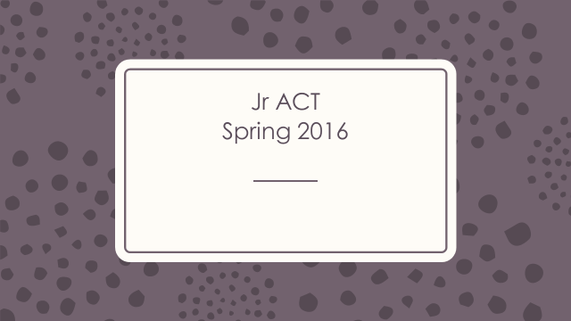

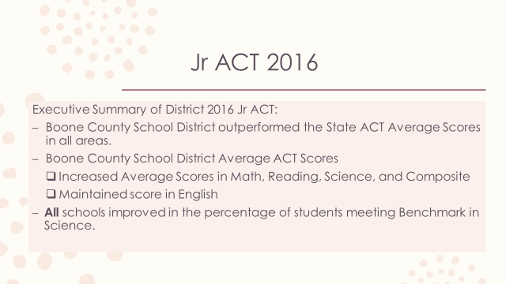

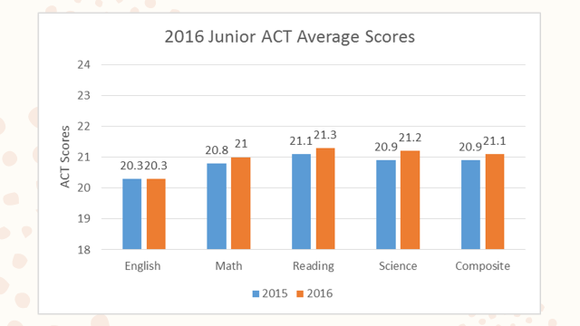

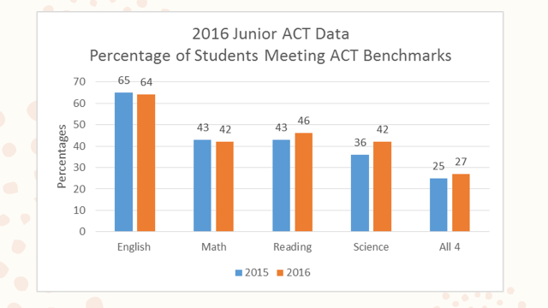

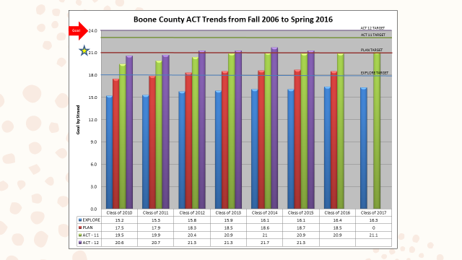

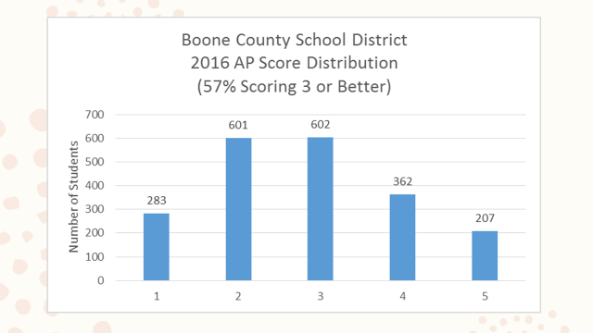

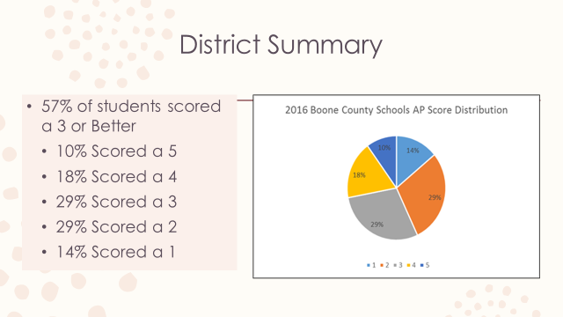

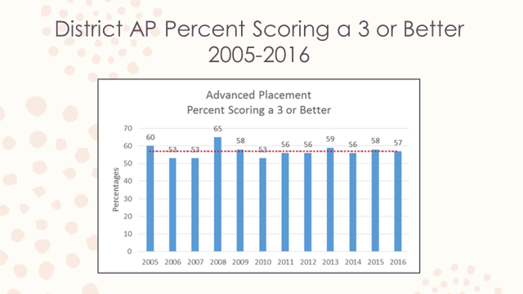

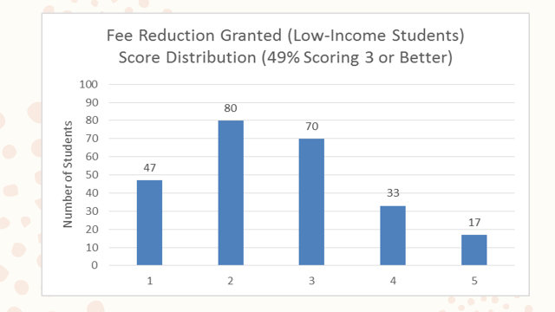

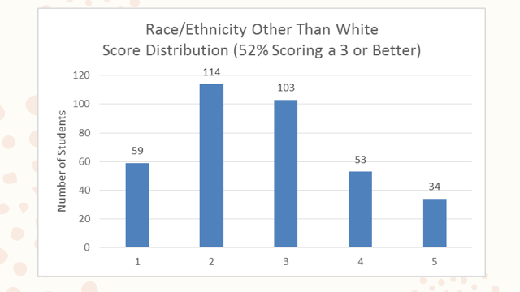

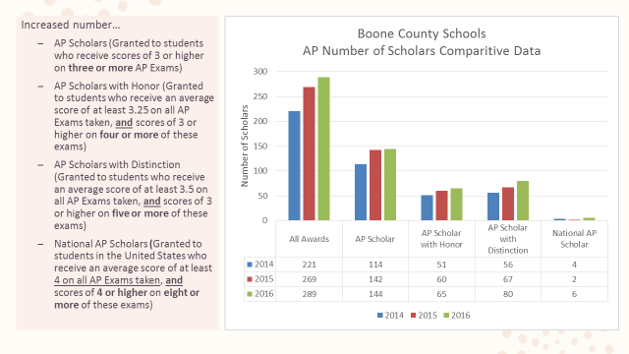

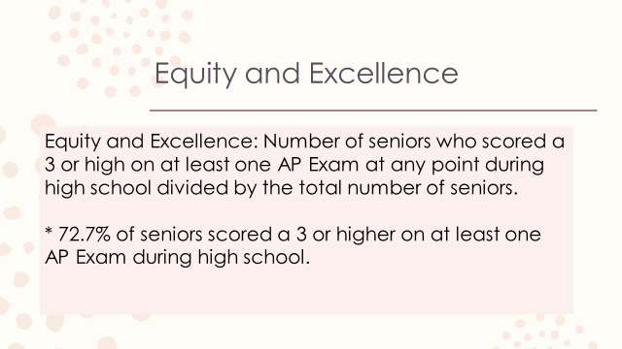

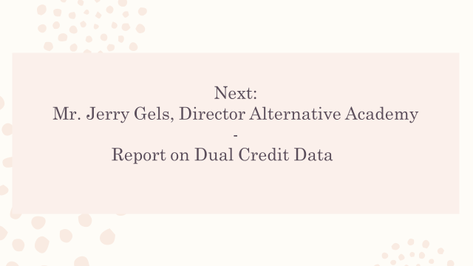

VIII.B. Mr. Jerry Gels, Director of Alternative Academy - Reported on Duel Credit Data. There was over 700 credit’s achieved in 15-16. With the number of juniors entering this year 20 will graduate with an associate degree. Mr. Gels spoke on the lower tuition price from the state which makes this program affordable and attainable. Dr. Poe reviewed the numbers and discussed the tremendous savings to a student that choose this path for college and could save the parents and student upwards of $30,000 in tuition.

IX. INFORMATION, PROPOSALS, COMMUNICATIONS
IX.A. Human Resource Actions
IX.B. Worker's Compensation Claims
IX.C. Overtime Report
IX.D. Construction Status Report
IX.E. Energy Management Report
IX.F. Boone County Schools Data Security Break Review 2016
IX.G. Kentucky Innovation Lab Network Letter of Commitment 2016-2017

X. AUDIENCE OF CITIZENS
Jonathon A. Clark introduced himself to the board as an education major at Gateway College.

XI. CLOSED EXECUTIVE SESSION PER KRS 61.810
XI.A. No closed session

XII. ADJOURN

- A motion was made by Ed Massey, seconded by Bonnie Ricert , to adjourn the meeting. Bonnie Rickert, Maria Brown, Karen Byrd, Ed Massey and Steve Templeton voted, “aye” MOTION: The motion passed 5-0.

Meeting was adjourned at approximately 8:31 pm

_____________________________________
Dr. Maria Brown /Chairperson

_____________________________________
Karen Evans/Secretary

