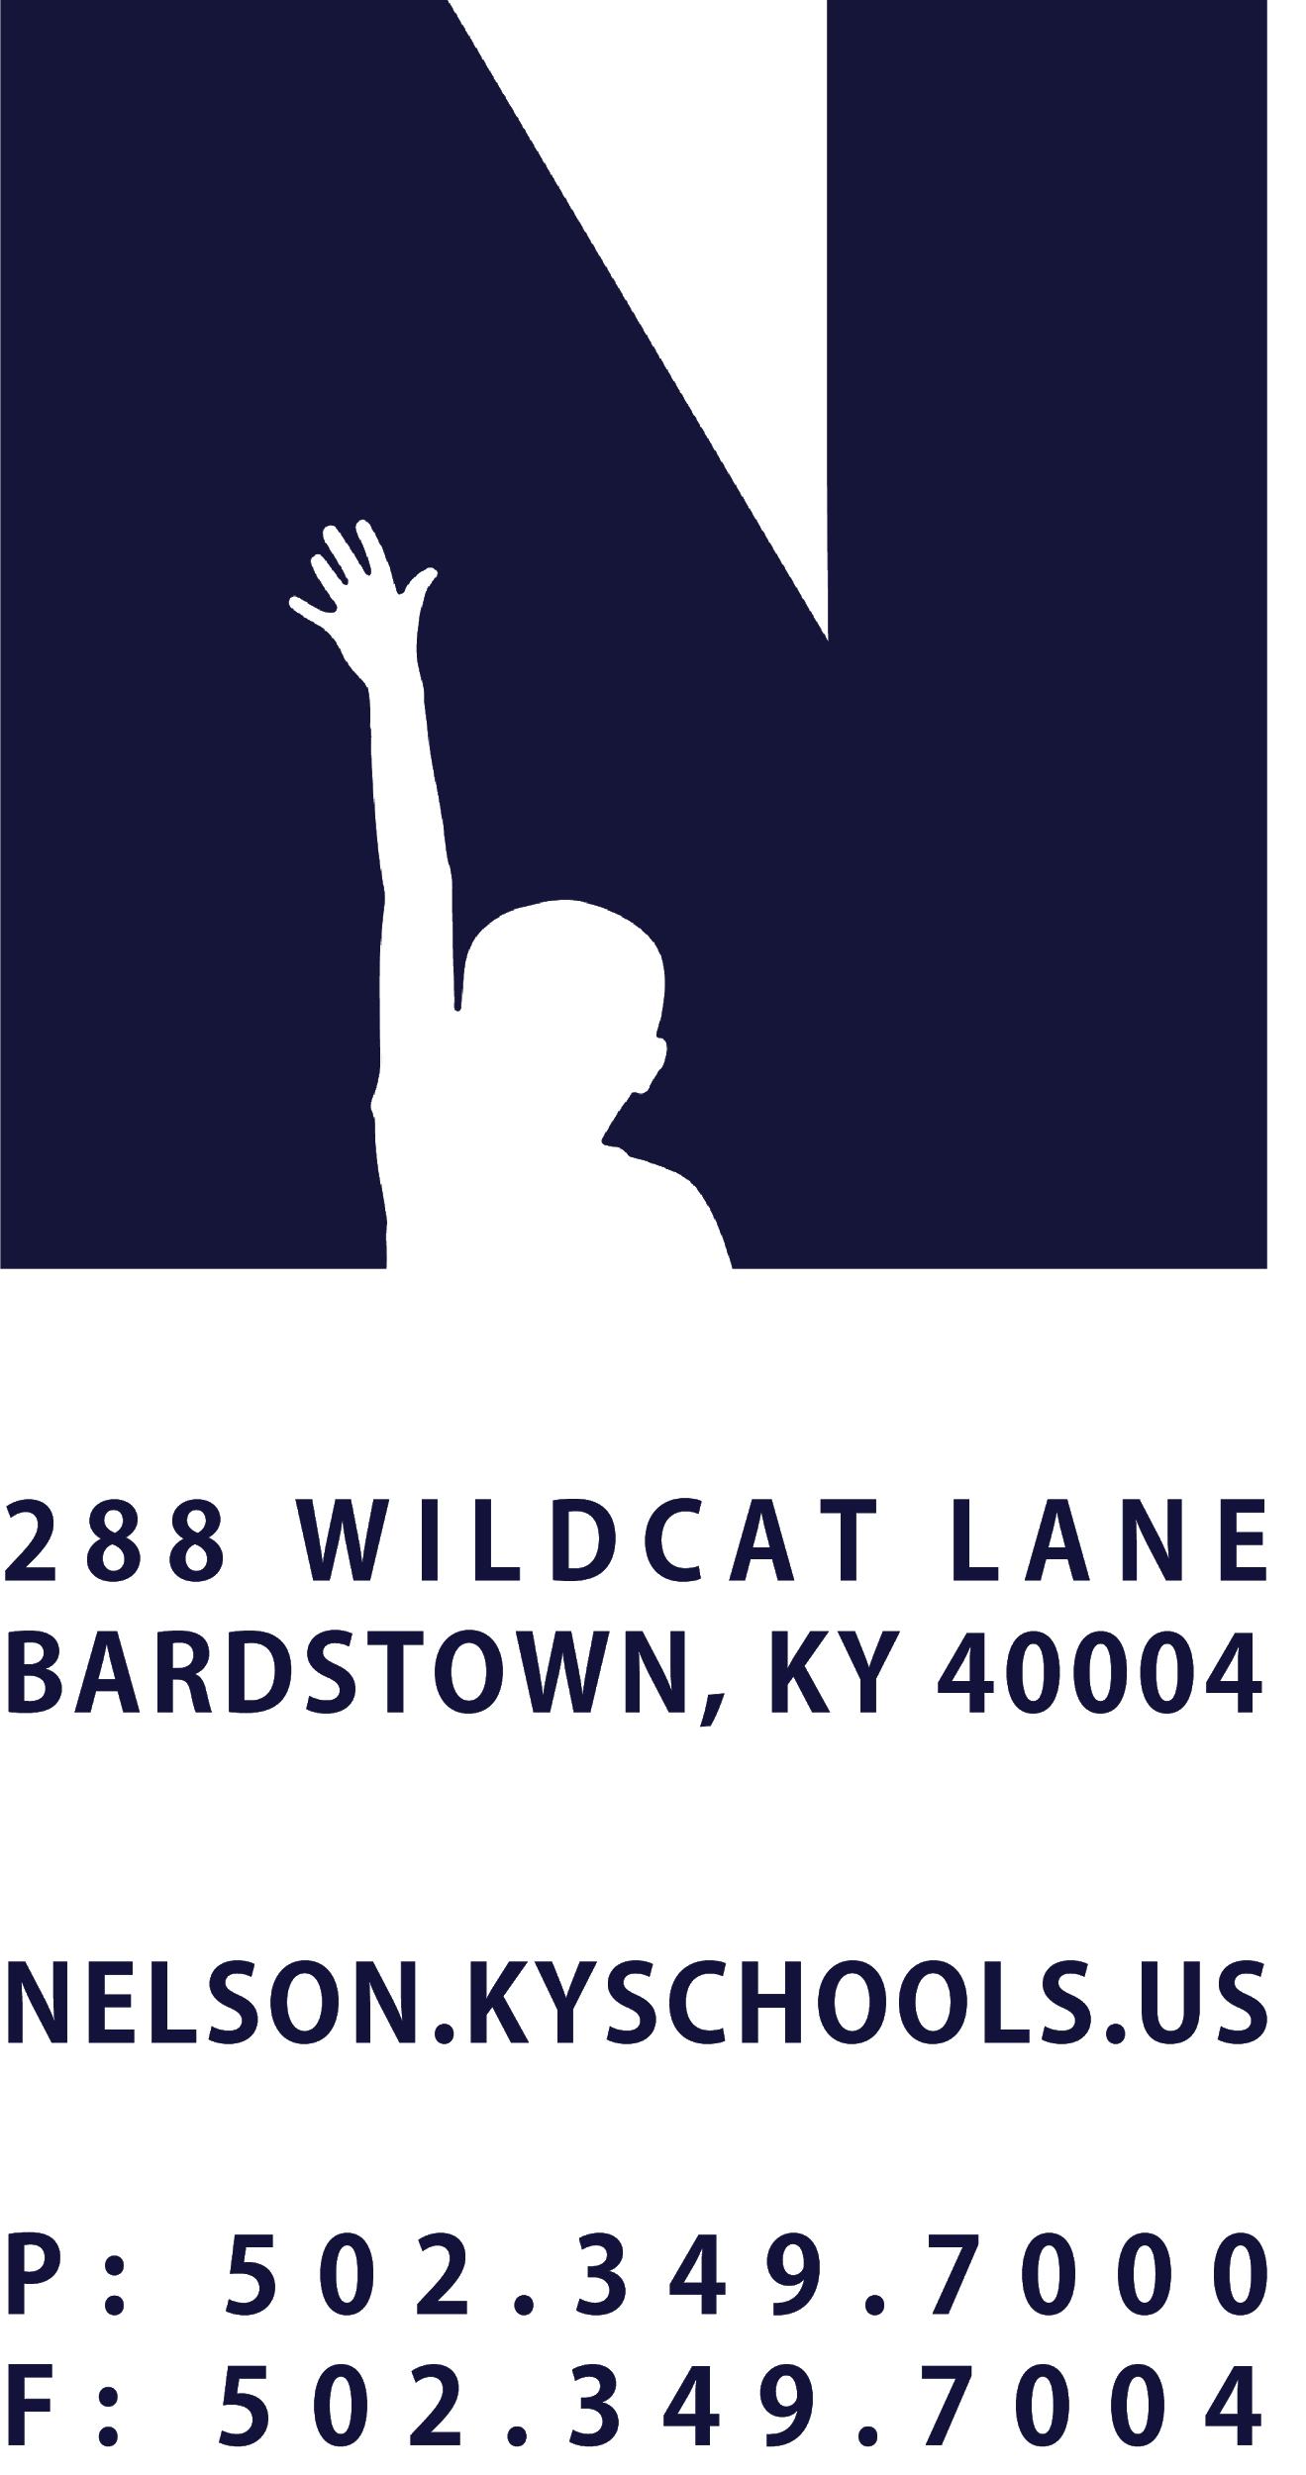 | JOB TITLE | WORKFORCE COLLABORATOR
 | REPORTS TO | WORKFORCE DEVELOPMENT DIRECTOR
 | SALARY SCHEDULE/GRADE | $15.00/HOUR
 | CONTRACTED DAYS AND/OR HOURS | AS NEEDED
 | EXEMPT STATUS | NOT EXEMPT
 | JOB CLASS CODE | 7342
 | POSITION CLASSIFICATION | CLASSIFIED PROFESSIONAL
 | DATE APPROVED

QUALIFICATIONS
Bachelor’s Degree with experience and knowledge of the community and experience in collaborating with a variety of community partners and postsecondary institutions. Pursuit of a Master’s Degree is desired.

POSITION SUMMARY
The Workforce Development Collaborator will partner with the Nelson County Schools workforce development team and counselors to connect upcoming graduates to work based experiences. The position will partner with the Lincoln Trail Workforce Board and community partners to create work experiences for students.

DISTRICT AND SCHOOL PRIORITY ALIGNMENT
Align actions with district and school values and core priorities.
Evaluated based on the efficacy of aligned actions.

PERFORMANCE RESPONSIBILITIES
Collaborate with NCS workforce leaders and Bardstown City Schools to identify students for the summer works program.
Provide advising & support to students & families.
Facilitates application process for summer works program.
Connect qualifying students to appropriate postsecondary options.
Connect students to employers.
Assist students in preparing applications & resumes for students when applying for positions.
Mentor students during the summer works program.
Coordinate marketing efforts as needed in correlation with Chamber & Lincoln Trail Workforce Board.
Recruit employers for the program.
Provide support to employers during the recruitment & application process.
Process timesheets & payments for students.
Conduct site visits to employers during the summer program.
Demonstrate effective positive interpersonal and communication skills, with students, parents and staff.
Demonstrate a commitment to professional growth.
Demonstrate punctuality and regular attendance.
Maintain appropriate professional appearance.
Adhere to the appropriate code of ethics.
Perform other duties as assigned by Superintendent or designee.

KNOWLEDGE AND ABILITIES
To perform the responsibilities as previously outlined.
Perform as a leader such that student achievement is maximized.

PHYSICAL DEMANDS
Work is performed while standing, sitting, or walking.
Requires the ability to communicate effectively using speech, vision, and hearing.
Requires the use of hands for simple grasping and fine manipulations.
Requires bending, squatting, crawling, climbing, reaching.
Requires the ability to lift, carry, push, or pull light weights.

