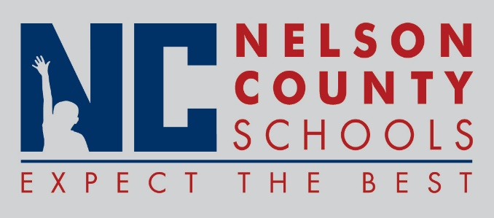

Decision Paper
To: | Nelson County Board of Education
From: | Ann Marie Williams

cc:
Date: | March 20, 2018
Re: | 18-19 FRYSC Continuation Plans

RECOMMENDATION: Approve the 18-19 FRYSC Continuation Plans. These plan provide a template for the Family Resource and Youth Service Centers in regard to site needs, program services, and budgeting. Each plan includes a needs assessment and action plan for each center and have been approved by FRYSC councils and local SBDMs.

RECOMMENDED MOTION: I move that the Nelson County Board of Education approve the 18-19 FRYSC Continuation Plans.

