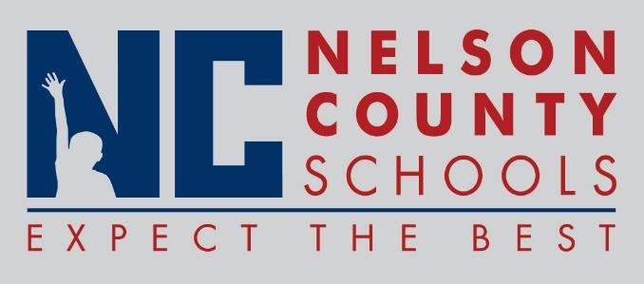

Information Paper
To: | Nelson County Board of Education
From: | Bob Morris, Director of Student Support
cc: | Dr. Anthony Orr, Superintendent
Date: | September 20, 2016
Re: | Personnel Notifications

Employment: Karla Kunze Teacher Horizons
Jessica Hutchins Teacher FHES
Anna Reynolds Speech Path District
Kurtis Howland FRYSC Assist BOS/NH
Amanda Skees IAI BOS
Chassidy Hibbard IAI BOS
Andre Oei IAIII NCHS
Rachel Coleman IAIII NCHS
Belinda Keys Custodian CCES
Jamie Mallard Cook/Baker TNHS
Jessica Barnes Childcare District
Jared Hickman Childcare District
Robin Akridge Bus Driver Trans
Paula Calvert Bus Monitor Trans
Dan Handloser Energy Manager District
Margaret Woods Childcare CCES

Reinstatements: None

One Year Certification: None

Classified Subs:

Certified Substitute: Don Bradley, Amanda Mooney, Kelsey Shryock
Student Workers: Cami Ballard, Mackenzie Summers

Non-Renewals: None

Resignation: Deja Jackson IAIII NCHS, Reece Grubbs Teacher Horizons, Kelly Fields IA CCES

Retirements: None

Reprimands/Terminations: None

