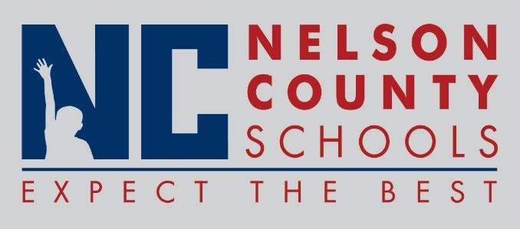

Decision Paper
To: | Nelson County Board of Education
From: | Tim Beck, Director of Student Support
cc: | Dr. Anthony Orr, Superintendent
Date: | April 26, 2016
Re: | Nelson County Certified Evaluation Plan for 2016-2017

RECOMMENDATION: Approve the updated Nelson County Certified Evaluation Plan. The updated plan for 2016-2017 includes the following changes:
- Reduced pages through graphic redesigns
- Removed individual sign offs throughout multiple sections
- Specifically defined mini vs full observations
- Dropping the proficiency component of the student growth goal
- Addition of tabs on the TPGES Toolboxes for school specific components

RECOMMENDED MOTION: I move that the Nelson County Board of Education approve the updated Nelson County Evaluation Plan.

