Regular Meeting Boone County Board of Education
January 12, 2017 7:30 PM
Ralph Rush Professional Development Center
99 Center Street
Florence, Kentucky 41042

I. CALL TO ORDER

The Regular meeting of the Boone County Schools Board of Education January 12, 2017 was called to order by Chairperson Maria Brown at the Ralph Rush Staff Development Center.
Attendance Taken at 7:30 PM:

Present Board Members:
Dr. Maria Brown
Ms. Karen Byrd
Mr. Ed Massey
Mr. Matt McIntire
Ms. Bonnie Rickert

Gerry Dusing attended as Board Attorney
Karen Evans, Board Secretary, recorded the minutes.

II. NATIONAL ANTHEM
II.A. The National Anthem was presented by students from Camp Ernst Middle School.

III. PLEDGE TO THE FLAG
III.A. The Pledge to the Flag was led by students from Collins Elementary.

IV. STUDENT BOARD MEMBER REPRESENTATIVE REPORT
Bradley Rodriguez gave the Student Board Member Representative report. Bradley introduced a fellow student council member to the meeting, Ms. Cary Sebree. Bradley discussed the plan for scheduling the speaking engagements for the elementary schools on the Healthy Choices campaign and discussed the guest speakers talk, Mr. Todd Novak, Principal at Gray Middle School, to the students.

V. GOOD NEWS
V.A. January was School Board Member Recognition Month. Karen Byrd, Matt McIntire, Ed Massey, Bonnie Rickert, Dr. Maria Brown and Bradley Rodriguez were acknowledged for their commitment and positive contributions to our students and schools. In recognition a proclamation was presented by Judge Executive Gary Moore.
V.B. The board recognized Dr. Maria Brown for her service as the 2016 Boone County Board Chairperson.
V.C. The board recognized the following 2017 January Parent Power Award recipients:

Cooper High School Bill Tinch
Longbranch Elementary Sonya Besson
Thornwilde Elementary Amy Taylor
Maureen Zachary
Karen Brandstetter
Erpenbeck Elementary Kellie Aulick
Asako Yamaguchi

The board recognized Mr. Ed Massey for his 20+ years of service as a board member. Conner High School Band played a special performance of a few songs in honor of Mr. Massey.

VI. AUDIENCE OF CITIZENS
No one spoke.

VII. BOONE COUNTY BOARD OF EDUCATION ELECTION OF OFFICERS 2017
VII.A. Election of Boone County Board Chairperson for 2017

Nominations were open for the Office of Chairperson by Superintendent Dr. Randy Poe.

- A motion was made by Karen Byrd, seconded by Bonnie Rickert, to nominate Ed Massey as Chairperson for the year 2017 by acclamation and to close nominations. Karen Byrd, Dr. Maria Brown, Matt McIntire, Ed Massey and Bonne Rickert voted, “aye” MOTION: The motion passed 5-0.
Dr. Maria Brown passed the gavel to Ed Massey the new board chair for the 2017 year.

VII. B. Election of Vice Chairperson for 2017
Nominations were open for Vice-Chairperson by Chairperson Ed Massey.

- A motion was made by Karen Byrd, seconded by Dr. Maria Brown, to nominate Bonnie Rickert as Vice-Chairperson for the year 2017by acclamation and to close nominations. Karen Byrd, Maria Brown, Matt McIntire, Ed Massey and Bonne Rickert voted, “aye” MOTION: The motion passed 5-0.

VIII. RECOMMENDED ACTION - CONSENT AGENDA
Dr. Poe, Superintendent, recommended the following Consent Agenda items A-P for Board approval, as presented.

- A motion was made by Karen Byrd, seconded by Maria Brown , to approve the consent agenda items A-P as presented. Karen Byrd, Maria Brown, Matt McIntire, Ed Massey and Bonne Rickert voted, “aye” MOTION: The motion passed 5-0.

VIII.A. Minutes of the regular board meeting of December 8, 2016
The board approved the minutes of the regular board meeting of December 8, 2016, as presented.
VIII.B. Bill List
VIII.C. Treasurer's Report was given by Mrs. Linda Schild.
VIII.D. Leaves of Absence
The following persons submitted leaves of absence requests were approved as presented.
Recommended by Principal/Supervisor for approval:
Ballard, Brice, Custodian @ Ryle High School, 12/2/2016 – 12/30/2016
Casson, Sarah, Teacher @ Gray Middle School, 1/24/2017 – 2/24/2017
Drake, Regina, Café Aide @ Yealey Elem, 11/28/2016 – 1/31/2017
Elbert, MeKenzie, Teacher @ Camp Ernst Middle, 1/19/2016 – 2/10/2017
Embry, Brittany, Teacher @ RA Jones Middle, 1/20/2017 0 2/17/2017
Embry-Walker, Nedra, Bus Driver @ Transportation, 11.30.2016 – 12/13/2016
Maynard, Diane, Bus Driver @ Transportation, 1/10/2017 – 1/31/2017
Woodruff, Debora, Staff Support @ Ockerman Middle, 12/5/2016 – 1/31/2017
Not Recommended by Principal/Supervisor for approval:
Nothing to Report
Amended Leaves:
Cobb, David, Bus Driver @ Transportation, 11/2/2016 – 12/21/2016
Haubner, Michelle, Teacher @ Cooper High School, 12/8/2016 – 1/17/2017
Jackson, Erin, Café Wkr @ Florence Elem, 11/1/2016 – 1/20/2017
Kay, Shannon, Teacher @ New Haven Elem, 12/1/2016 – 1/20/2017
Kelly, Kari, Teacher @ Camp Ernst Middle, 12/7/2016 – 12/21/2016
Leistner, Michael, Bus Driver @ Transportation, 11/11/2016 – 12/2/2016
Ritchie, Jonathan, Custodian @ Conner Middle School, 1/11/2017 – 3/17/2017
Cancelled Leaves:
None

VIII.E. Duke Energy Powershare Agreement
The board approved the Duke Energy Powershare Agreement for the 2017 year, as presented.
VIII.F. Reappointment of Board Secretary for 2017
The board approved the reappointment of Karen Evans to the position of Board Secretary for 2017, as presented.
VIII.G. Reappointment of Board Treasure for 2017
The board approved the reappointment of Linda Schild as Board Treasure for 2017, as presented.
VIII.H. Surplus Technology
The board approved and declared the Surplus Technology as surplus and approved the disposal of old and outdated technology items listed, as presented.
VIII.I. Annual Commissioning Services
The board approved the Annual Commissioning Services with bid award to ZH Commissioning, as presented.
VIII.J. Field Trips
The board approved the Field Trips, as presented.

School | Date Of Trip | Location | Reason
Camp Ernst Middle School | February 8-13, 2017 | Orlando, FL | National Cheerleading Competition
Conner High School | March 16, 2017 | Louisville | Orchestra Assessment Event
Ryle High School | March 15-19, 2017 | Lexington | State Boys Basketball Game

VIII.K. Salt Storage Use Agreement
The board approved the use of property at Ryle High School for the joint use and cost sharing of salt storage, as presented.
VIII.L. BG-1 for Conner Middle School HVAC Phase 2 Project BG#17-061
The board approved the BG-1 for Conner Middle School HVAC Phase 2 Project BG#17-061, as presented.
VIII.M. Change Order #5 New Maintenance Building BG#15-219
The board approved the Change Order #5 New Maintenance Building BG#15-219 with the total addition on $ 6074.00, as presented.
VIII.N. Change Order #3 Ryle High School Addition BG# 15-281
The board approved the Change Order #3 Ryle High School Addition BG# 15-281 with the total addition on $82,866.00, as presented.
VIII.O. KSBA Conference 2017
The board approved the board members and Superintendent to attend the Annual KSBA 2017 Conference Feb. 24-26, 2017, as presented.
VIII.P. Gray Middle School MEP Improvements BG#17-121 AIA Standard Form of Agreement
The board approved the Gray Middle School MEP Improvements BG#17-121 AIA Standard Form of Agreement, as presented.

IX. RECOMMENDED ACTION - OLD BUSINESS
IX.A. No Old Business

X. RECOMMENDED ACTION - NEW BUSINESS
X.A. Draft Budget for 2018 Fiscal Year
Dr. Poe, Superintended recommended the board approve the Draft Budget for the 2018 Fiscal Year, as presented.

- A motion was made by Karen Byrd, seconded by Maria Brown, to approve the Draft Budget for the 2018 Fiscal Yaer, as presented. Karen Byrd, Maria Brown, Matt McIntire, Ed Massey and Bonne Rickert voted, “aye” MOTION: The motion passed 5-0.

X.B. 2016-2017 District Improvement Plan Revised
Dr. Poe, Superintendent, recommended the board approve the 2016-2017 Boone County Schools District Improvement Plan revised as required by the Kentucky Department of Education, as presented.

- A motion was made by Bonnie Rickert, seconded by Maria Brown, to approve the 2016-2017 Boone County Schools District Improvement Plan revised as required by the Kentucky Department of Education, as presented. Karen Byrd, Maria Brown, Matt McIntire, Ed Massey and Bonne Rickert voted, “aye” MOTION: The motion passed 5-0.

X.C. Change of Assignment 03.2311 Revision
Dr. Poe, Superintendent, recommended the board approve the revisions to the Change of Assignment Policy 03.2311, as presented.

- A motion was made by Karen Byrd, seconded by Maria Brown, to approve the revisions to the Change of Assignment Policy 03.2311, as presented. Karen Byrd, Maria Brown, Matt McIntire, Ed Massey and Bonne Rickert voted, “aye” MOTION: The motion passed 5-0.

Dr. Poe discussed this is changing the time frame on classified transfers in the school year.

X.D. Turf Field at Conner High School Fund Raiser
Dr. Poe, Superintendent, recommended the board to approve the request from Conner High School to explore the possibility of raising money to install an artificial turf field, as presented.

Justin Bailey, committee member for fundraising, explained the Conner High School Turf Campaign to the board. Mr. Bailey presented the board with a handout of the Executive Summary, Purpose and Goals, Turf Field Committee, and various fundraising campaigns. The fundraising goal is $750,000.00.

Dr. Poe explained to the board this approval is giving this group permission to form a committee to fundraise for the Conner Turf Field. As a board no funding will be given and in the future the maintenance and upgrades would be the responsibility of the fundraising committee. Dr. Poe requested that Eric McArtor, COO, contact Ehmit Hayes & Associates Architects, to advising for the project of codes and all procedures are followed.

- A motion was made by Karen Byrd, seconded by Maria Brown, to approve the request from Conner High School to explore the possibility of raising money to install an artificial turf field, as presented. Karen Byrd, Maria Brown, Matt McIntire, Ed Massey and Bonne Rickert voted, “aye” MOTION: The motion passed 5-0.

XI. SUPERINTENDENT'S REPORT
XI.A. NKIP Boone County NaviGo Enhanced Operators Pipeline Cohort presentation will be moved to the February 9, 2017 board meeting.
XI.B. Nutrition and Wellness Power Point Presentation by Barbara Kincaid, Director of Food Service. Boone County schools participate in the National School Lunch, National School Breakfast, Afterschool Snacks and Summer Feeding programs. For school year 2015-16 the district met all required regulations in regards to nutrition standards and physical required physical activity minutes. Mrs. Kincaid reported in detail on the School Food Service Nutrition Program of communication, quality nutrition choices for the students, nutrition training that is provided to all food service employees at levels above the USDA requirements, nutrition certification programs, nutrition education, and special dietary needs assistance for our students. Mrs. Kincaid reported our district has a wide wellness policy that is utilized by the majority of the schools, several have developed school specific policies. The report stated that all schools reporting met the requirements for the total minutes of physical activity on a weekly bases. Mrs. Kincaid reported in detail on the staff incorporating Nutrition Education in health classes, club activities, etc and the wide variety of programs and planned activity involving physical movement in schools. Assessing the Wellness/Physical Activity environment was discussed. In order to assess the wellness environment, schools were asked to respond to a series of questions regarding Wellness and Physical activities in their school. The responses are being placed in a spreadsheet for review/posting on the website. A new online survey facilitated by the Kentucky Department of Education may be utilized next year to certify that information from every school is captured. Any required area can then be directly reported and the assessment can be made more comprehensive.
This report as well as the responses from the schools will be posted on the Boone County Website for review and response by the general public.
XI.C. 2016-2017 Comprehensive District Improvement Plan (CDIP) Revisions Update by Dr. Karen Cheser, Deputy Superintendent, CAO. Dr. Cheser gave the following power point presentation to the board. Dr. Cheser reviewed and discussed the 5 CDIP Goals, Strategy, Activity and Opportunities in detail.

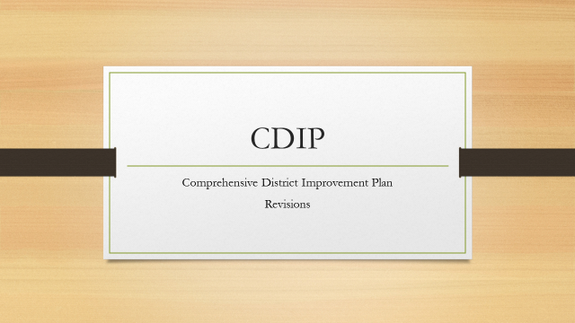

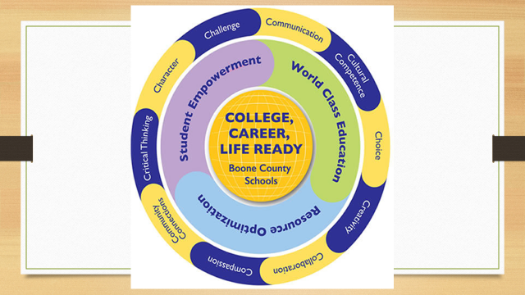
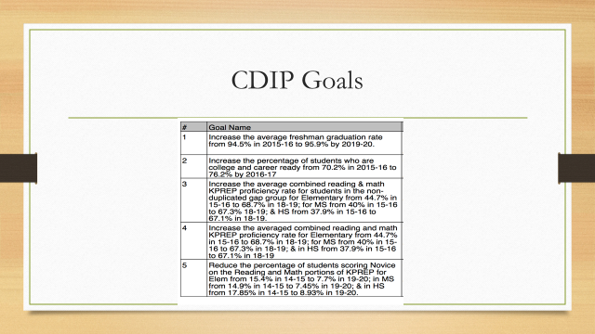
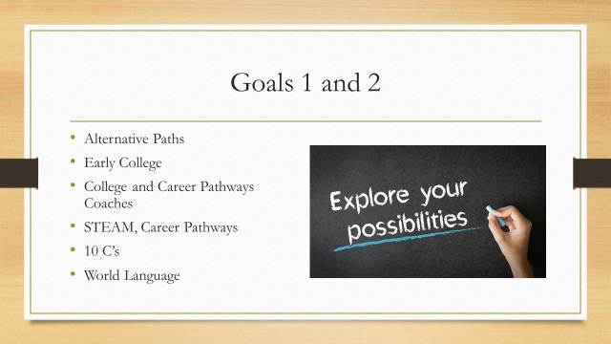
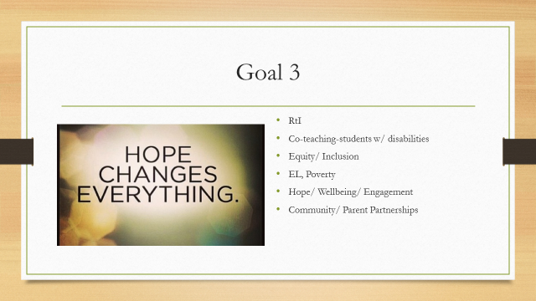
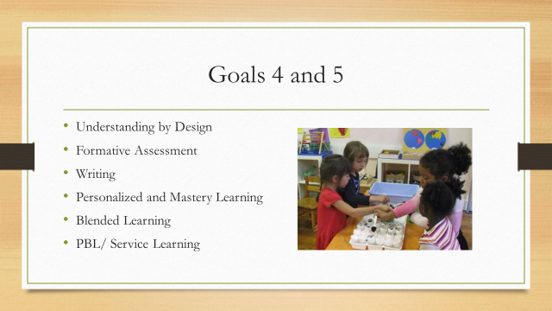

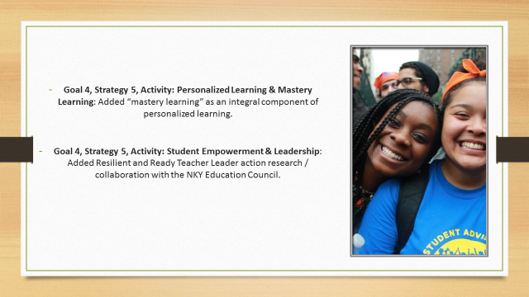

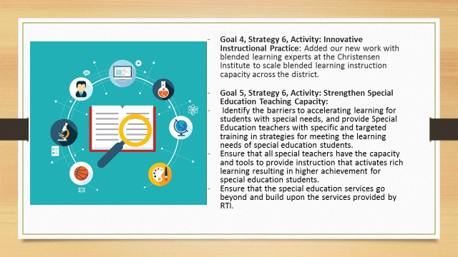

XII. INFORMATION, PROPOSALS, COMMUNICATIONS
XII.A. Human Resource Actions
XII.B. Worker's Compensation Claims
XII.C. Overtime Report
XII.D. Construction Status Report
XII.E. Energy Management Report
XII.F. Gerry Dusing, Board Attorney - Board Member Code of Ethics and Review of Board Polices, all board members signed the document as receipt that have been given and reviewed.

Dr. Poe, Superintendent discussed options for a time and date for an upcoming Special Board Workshop on the Districts Grade Point Scale. The date was set for March 21, 2017 at 6:30 pm at the Ralph Rush Professional Development Center. All board members agreed on this date.

Dr. Poe announced the upcoming Special Workshop on the Strategic Plan Organizational Structure on January 26, 2017 at 6:30 pm at the Ralph Rush Development Center.

Ed Massey reported he will be attending the NSBA Equity and Advocacy Symposium later in the month.
Ed Massey reported on the meeting at St. Paul’s in Newport regarding Charter schools the coming Saturday at 9:30 for those that our interested.

XIII. AUDIENCE OF CITIZENS
The following college students in the education field were in attendance introduced themselves to the board: Abigail Schlagel, NKU, Lexi Ulerilk, NKU, and Courtney Revell, NKU.

XIV. CLOSED EXECUTIVE SESSION PER KRS 61.810
XIV.A. Closed Session per KRS 61.810(1)(b) Acquisition of Real Property

- A motion was made by Karen Byrd, seconded by Maria Brown to adjourn for the closed session pursuant to KRS 61.810 (1) (b), meeting s specified by law to be conducted in private which is pursuant to KRS 156.557, Section 4 for discussions of acquisition of real property, as presented. Karen Byrd, Maria Brown, Matt McIntire, Ed Massey and Bonne Rickert voted, “aye” MOTION: The motion passed 5-0.

Adjourned to closed session at 8:55 pm
Returned from closed session at 10:15 pm.

- A motion was made by Karen Byrd, seconded by Maria Brown, to return from closed session pursuant to KRS 61.810 (1) (b), meeting s specified by law to be conducted in private which is pursuant to KRS 156.557, Section 4 for discussions of acquisition of real property with no action taken, as presented. Karen Byrd, Maria Brown, Matt McIntire, Ed Massey and Bonne Rickert voted, “aye” MOTION: The motion passed 5-0.

XV. ADJOURN

- A motion was made by Karen Byrd, seconded by Maria Brown, to adjourn the meeting. Bonnie Rickert, Maria Brown, Karen Byrd, Ed Massey and Matt McIntire voted, “aye” MOTION: The motion passed 5-0.

Meeting was adjourned at approximately 10:18 pm.

_____________________________________
Ed Massey/Chairperson

_____________________________________
Karen Evans/Secretary

