Regular Meeting Boone County Board of Education
March 13, 2014 7:30 PM
Ralph Rush Staff Development Center, Florence, Kentucky

I. CALL TO ORDER

The Regular Board Meeting of the Boone County Schools of March 13, 2014 was called to order by Chairperson Karen Byrd at the Ralph Rush Staff Development Center.
Attendance was taken at 7:30 pm.

Present Board Members:
Dr. Maria Brown
Ms. Karen Byrd
Mr. Ed Massey
Ms. Bonnie Rickert
Mr. Steve Templeton

Gerry Dusing attended as Board Attorney
Karen Evans, Board Secretary, recorded the minutes.

II. NATIONAL ANTHEM
The National Anthem was presented by Camp Ernst Middle School students and led by Andrea Leffler.

III. PLEDGE TO THE FLAG
The Pledge to the Flag was led by the Thornwilde Elementary School Student Council Members.

IV. GOOD NEWS
IV.A. The board recognized The March 2014 Break the Mold Award recipient, Mr. Paul Goodridge, Bus Driver to North Pointe Elementary School Students. Mr. Goodridge was honored for his dedication and commitment to our Boone County students and staff.

IV.B. The board recognized the March 2014 Parent Power Awards as follows.
Goodridge Elementary Amie Humphrey
Dwayne Humphrey
Gail Tanner
Kelly Elementary Jolene Benedict
Longbranch Elementary Jodi Garuccio
Mann Elementary Emily Boomershine
Beth McIntire
New Haven Elementary Shawn Murdock
Elaine Stitch
Stephens Elementary Paula McPeake
Leslie Keyes
Celena Fraider
Thornwilde Elementary Laura Dover
Kathy Super
Patti Ottino
Mary Eloise Baynum
Michelle Reeder
Conner Middle School Brooke Burcham-Hurst
Boone County High School Karen Sherman
Jean Edwards
Conner High School William Michels
Bridgette Michels

IV.C. The board recognized Mrs. Victoria Yoemanson, Cooper High School teacher, 3C Outstanding Educator Award winner.
IV.D. The board recognized the Ockerman Middle School FIRST Lego League team for teaming up with the Boone County Emergency Management Agency in creating a website and data base for BCEMA’s use. The teams created a website for legitimate charities in Boone County and they donated their fobot filed mat and Lego kit to the BCEMA.
IV.E. The board recognized Mrs. Tricia Shelton, Distinguished Teaching Award Recipient from the National Science Teaching Association (NTSA).
IV.F. The board recognized Mrs. Karen Cheser, Deputy Superintendent, for receiving the Education Administration Scholarship award from AASA. This award was one of only four given by the AASA.
IV.G. The board recognized Mr. Doug Logan, Ockerman Elementary teacher, for being named the Tom and Betty Lawrence American History Teacher of the Year by the Simon Kenton Chapter of the Sons of the American Revolution.
IV.H. Lori Schlarman, board member of the Boone County Foundation, recognized the KONA Ice company for the donation of $5,000.00 for a Robotics grant.

Ms. Karen Byrd spoke on her recent visit to the Erpenbeck Project Based Learning Event. Ms. Byrd spoke on the successful event with a multitude of projects with more than 1300 in attendance. She congratulated Principal Brown and the staff for organizing such a meaningful event for students, parents and the community.

V. STUDENT BOARD MEMBER REPRESENTATIVE REPORT
There was no student board member representative report, Ms. . Heyra "Ada" Avila was unable to make the meeting due to a speech competition event.

VI. AUDIENCE OF CITIZENS
Brief summaries:

Carrie Cox, of Burlington, spoke to the board concerning parents need to be involved and continue to work together for a safe environment for our students. Ms. Cox spoke on the safety committee meeting. She stated she and others were disappointed after the Safety Committee Recommendation meeting last week and did not feel they had a chance to be heard at the meeting. Ms. Cox discussed the need to keep our kids as the primary focus and keep an open dialogue and share ideas to find a common ground on the issue of school safety and our kids. She stated we must change the corporate culture where parents aren’t coming to board meetings and don’t know what’s going on. She said the parents assume they are giving the board the care of our children and after the meeting she felt the board was not doing this job. Ms. Cox asked the school board members to be more open minded about listening to the citizens and the parents. Ms. Cox spoke to what she feels is silencing the teachers. She asked that teachers say what they need to say and get all the ideas on the table, because there might be some middle ground that is being missed. She asked that everyone work to together to find common ground on safety.

Tom Haddock, BCEA President and resident of Florence. Thanked the board on behalf of the Teachers. Thank you for listening to the teachers, as a representative of the teachers I have been in most of the building within the last few weeks. He assured the board, 100%, that the majority of the teachers do not support a program such as the POST program.t The decision you had to make was difficult and I realize everyone is not happy with the decision is made. However, I want to thank you on behalf of the teachers, I also heard some feedback. I wanted to say that I invited the KEA Executive Director to the safety meeting and I also asked to be put on the agenda and was not invited by any board member or the Dr. Poe. I choose to come and speak out on behalf of my members and the teachers that I represent. Thank you again for the decision that you made.

Jeff Dwyer, of Florence, asked the board to look at the potential benefit for the staff and students of arming and is for the POST program.

VII. RECOMMENDED ACTION - CONSENT AGENDA
The Superintendent, Dr. Poe, recommended the following Consent Agenda items A – DD for board approval, as presented.

- A motion was made by Ed Massey, seconded by Bonnie Rickert to approve the consent agenda items A-DD, a presented. With board members disqualifying from the minutes under vendor # 49478- Bonnie Rickert, #20340 –Karen Byrd, # 43041- Ed Massey, # 45951-Steve Templeton, # 52109 –Dr. Maria Brown. Bonnie Rickert, Maria Brown, Ed Massey, Steve Templeton and Karen Byrd voted, “aye” MOTION: The motion passed 5-0.

VII.A. Minutes of the regular board meeting of February 6, 2014.
The Board approved the minutes of the regular board meeting of February 6, 2014, as presented.
VII.B. Minutes of the Special Board Workshop Strategic Planning: Leadership, Innovation and Process Management on January 28th, 2014.
The board approved the Minutes of the Special Board Workshop Strategic Planning: Leadership, Innovation and Process Management on January 28th, 2014, as presented.
VII.C. Bill List
VII.D. Treasurer's Report
Treasurer’s Report was given by Linda Schild.
VII.E. Leaves of Absence
The board approved the following persons submitted unpaid leave of absence, as presented.
Recommended by Principal/Supervisor for approval:
Alcock, Alissa, ELL Teacher @ Erpenbeck & Long Branch Elem, 4/22/2014 – 5/9/2014
Grimme, Ellen, Teacher @ Goodridge Elem, 3/5/2014 – 3/27/2014
Hall, Lindsey, Teacher @ Ockerman Elem, 4/22/2014 – EOY
Martin, Deborah, Transportation Aide @ Transportation, 3/4/2014 (1/2 day) – 5/2/2014
McQuade, Bridget, Teacher @Ryle High, 3/31/2014 – 5/2/2014
Mohrstadt, Nancy, Transportation Aide @ Transportation, 2/12/2014 – 2/28/2014
Muse, Crystal, Teacher @ Collins Elem, 3/7/2014 – 5/9/2014
Raines, Ken, Carpenter @ Maintenance, 2/14/2014 – 5/30/2014
Rowland, James “Lee”, Maintenance Wkr @ Warehouse, 2/4/2014 – 3/28/2014
Schwamb, Dawn, Café Manager @ Thornwilde Elem, 2/19/2014 – 2/26/2014
Smith, Kristina, Teacher @ New Haven Elem, 3/24/2014 – 5/16/2014
Steltenkamp, Kayla, Teacher @ Mann Elem, 5/1/2014 – 6/6/2014
Wilde, Dana, Teacher @ Ockerman Elem, 4/14/2014 (1/2 day) – 4/25/2014

Not Recommended by Principal/Supervisor for approval:
None

Amended Leaves:
Ballou, Selena, Teacher @ Ryle High, 1/30/2014 (1/2 day) – EOY
Barber, Margaret, Transportation Aide @ Transportation, 12/9/2013 – 4/14/2014
Barnes, Shavanah, Teacher @ Gray Middle School, 12/19/2013 – 3/28/2014
Bricking, Amanda, Teacher @ Boone County High, 2/21/2014 – 3/28/2014
Collins, Angela, Custodian @ Long Branch Elem, 12/18/2013 – 3/7/2014
Dailey, Landon “Mackenzie”, Teacher @ Ockerman Elem, 3/14/2014 – 4/25/2014
Dragan, Elaine, Café Aide @ Cooper High School, 11/19/2013 – 1/28/2014
Hagedorn, Patricia, Teacher @ Goodridge Elem, 3/17/2014 – 4/4/2014
Hammond, Amy, Bus Driver @ Transportation, 1/14/2014 – 3/3/2014
Mallicoat, Denise, Para-Educator @ Gray Middle, 11/21/2013 – 2/24/2014
Pope, Deborah, Custodian @ Cooper High School & Café Wkr @ Gray Middle School, 10/15/2014 – 5/30/2014
Smith, Kathleen, Bus Driver @ Transportation, 2/20/2014 – EOY
Yazell, Jan, Bus Driver @ Transportation, 11/1/2013 (1/2 day) – 3/4/2014

Cancelled Leaves:
Steffen, Jessica, Job Coach @ Special Ed, 1/28/2014 – 2/10/2014
VII.F. Bus Request- City of Florence
The board approved the bus request from the City of Florence, as presented.
VII.G. Bus Request- Boone County Parks
The board approved the Bus Request from the Boone County Parks, as presented.
VII.H. Camp Ernst Middle School Drama Club Agreement for Storage Space Rental
The board approved the Camp Ernst Middle School Drama Club Agreement for Storage Space Rental, as presented.
VII.I. Camp Invention at Erpenbeck Elementary
The board approved the Camp Invention Program at Erpenbeck Elementary on June 9, 2014, as presented.
VII.J. Boone County Parks Summer Program
The board approved the Boone County Parks Summer Program at Yealey and Erpenbeck Elementary, as presented.
VII.K. KISTA Surplus Bus Sale
The board approved the KISTA Surplus Bus sale, as presented.
VII.L. Sales Campaign Approvals
The board approved the School Sales Campaigns, as presented.
VII.M. Change Order #4- Longbranch/Cooper Additions BG#13-027
The board approved the Change Order #4- Longbranch/Cooper Additions BG#13-027 to add $7136.00, as presented.
VII.N. Continuation of Agreement with Cincinnati Bell for T1 Line at Maplewood for 2014 through 2016.
The board approved the Continuation of Agreement with Cincinnati Bell for T1 Line at Maplewood for 2014 through 2016, as presented.
VII.O. Bids for Local and Long Distance Telephone Services for 2014-2015
The board approved the Bids for Local and Long Distance Telephone Services for 2014-2015 for Cincinnati Bell to be our provider for this service, as presented.
VII.P. Bids for Web Hosting for 2014 through 2019
The board approved the Bids for Web Hosting for 2014 through 2019 and award Web Hosting Service to School Pointe DBS: Index Blue, Inc, as presented.
VII.Q. Depository Services- Bid Renewal
The board approved the bid be renewed for the period of July 1, 2014 through June 30, 2015 with First Financial Bank utilizing the second renewal option, as presented.
VII.R. Treasurer's Bond
The board approved the Treasurer's Bond renewal for 2014-2015 fiscal year, as presented
VII.S. Surplus Items
The board approved and declared the items presented as surplus and to approve the disposal of items documented, as presented.
VII.T. Continuation of Agreement with Cincinnati Bell Telephone for Managed Fiber for 2014 through 2016
The board approved the Continuation of Agreement with Cincinnati Bell Telephone for Managed Fiber for 2014 through 2016, as presented. (Corrected typo on agenda to 2014 instead of 2015 – the memo is correct)
VII.U. Bids for Cellular/Data Service for 2014-2015
The board approved the bid to AT&T for cellular/data services for 2104-2015, as presented.
VII.V. Bond of Depository
The board approved the execution of the bond depository for the 2014-2015 school year, as presented.
VII.W. Bid Invitations-Annual Commissioning Services
The board approved the bid be renewed for the period of July 1, 2014 through June 30, 2015 with Facility Commissioning Group utilizing the first renewal option, as presented.
VII.X. School Resource Officer cost to reimburse Sheriff's Department
The board approved the cost to reimburse the Sherriff's Department for 2 resource officers for the 2014-2015 year, as presented.
VII.Y. Instructional Time for 2014-2015 School Year 702 KAR 7:125 Pupil Attendance
The board approved the Instructional Time for the 2014-2015 School Year, 702 KAR 7:125 Pupil Attendance, as presented.
VII.Z. Declaration Statement
The board approved the Declaration Statement authorizing the Superintendent to employ teachers or substitute teachers with emergency or adjunct instructor certification when no qualified teachers have applied for vacant positions, as presented.
VII.AA. Project Closeout-BG-5 Burlington Geothermal Heat Pump and Glycol Charge BG#13-040
The board approved the Project Closeout-BG-5 Burlington Geothermal Heat Pump and Glycol Charge BG#13-040, as presented.
VII.BB. Field Trips
The board approved the Field Trip request, as presented.

School | Date Of Trip | Location | Reason
Burlington Elementary | April 23, 2014 | Columbus, OH | COSI
Camp Ernst Middle School | April 3, 2014 | Fishers, IN | Educational
Conner Middle School | April 3, 2014 | Conner Prairie | Educational
Conner Middle School | April 3, 2014 | Perryville | Educational
Conner Middle School | April 2, 2014 | Conner Prairie | Educational
Conner High School | May 7, 2014 | Louisville | KMEA State Choir Assessment
Conner High School | May 5 or 6, 2014 | Louisville | Symphonic Band Festival
Conner High School | February 27, 2014 | Frankfort | Jazz Band invited to play at State Capital
Erpenbeck Elementary | April 3, 2014 | Frankfort | Educational
Florence Elementary | March 17, 2014 | Cincinnati | Educational
Kelly Elementary | April 15, 2014 | Frankfort | Educational
Ryle High School | April 29-May 3, 2014 | Washington, DC | Band
Thornwilde Elementary | April 25, 2014 | Frankfort | Educational

VII.CC. BG-1 Application for HVAC Upgrades
The board approved the BG-1 for the HVAC Controls Upgrade Project, as presented.
VII.DD. KDE Disclosure of Free and Reduced Price Information Agreement
The board approved the KDE Disclosure of Free and Reduced Price Information Agreement, as presented.

VIII. RECOMMENDED ACTION - OLD BUSINESS
VIII.A. Revisions to Board Policies-Affordable Care Act 2nd Reading
The Superintendent, Dr. Poe recommended the board approve the second reading of the revisions to Board Policies -Affordable Care Act, as presented.

2. A motion was made by Steve Templeton, seconded by Ed Massey to approve the second reading of the revisions to Board Policies -Affordable Care Act, as presented. Karen Byrd, Maria Brown, Ed Massey, Steve Templeton and Bonnie Rickert voted, “aye” MOTION: The motion passed 5-0.

IX. RECOMMENDED ACTION - NEW BUSINESS
IX.A. No New Business

X. SUPERINTENDENT'S REPORT
Alissa Ayres, Assistant Superintendent of Learning Support, along with Ben Lusk and Charlene Ball presented to the board an update on the Explore and Plan results and the Kindergarten Screener. The report detailed the Kindergarten Screener which the purpose of the data provides support for parents, improvement in the program and strengthening the learning continuum for cradle to career. Charlene Ball spoke to the board concerning the Action Steps for Improving Kindergarten Readiness. Alissa and Ben discussed the 2013-2014 BCS Kindergarten Readiness Results and making the most of the data, District EXPLORE Mean Scores 7 Year Trends, District Rankings EXPLORE 2006-2014, District Plan Mean Scores 7 Year Trends, along with the District Rankings PLAN 2006-2014. Ben discussed our districts standing in detail and how to move the PLAN and EXPLORE in a positive direction. The detailed power point follows:

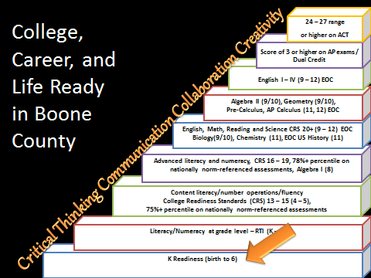

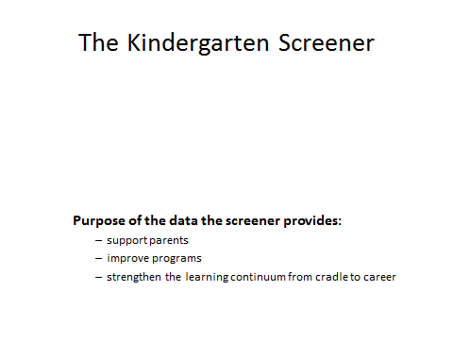

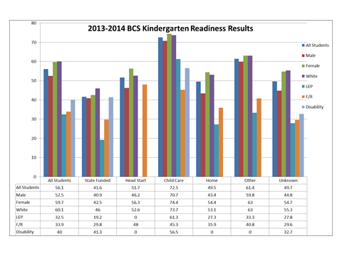
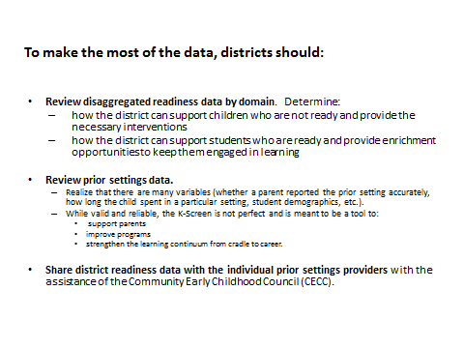

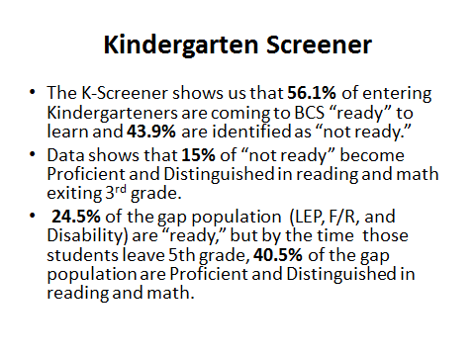

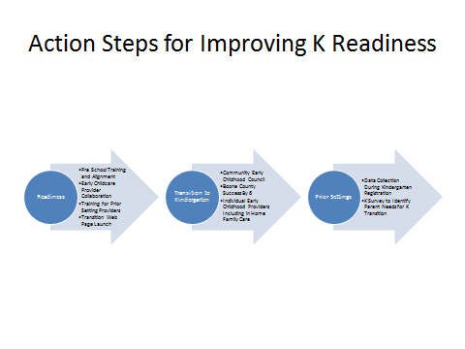

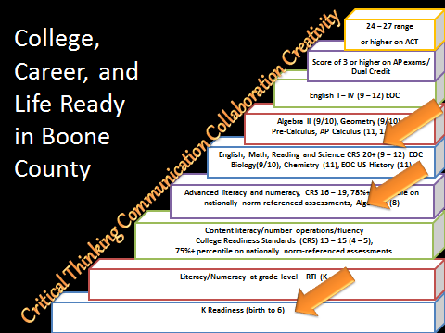
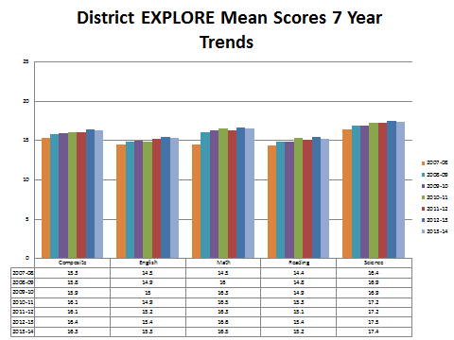

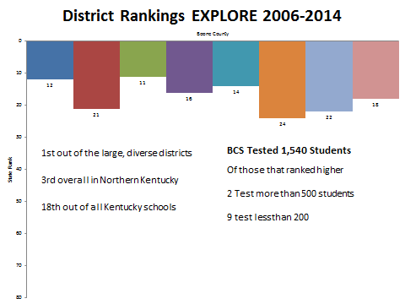

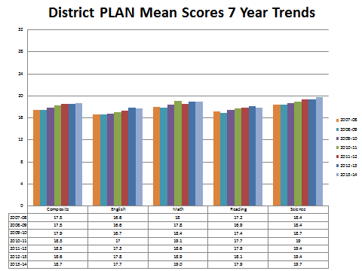

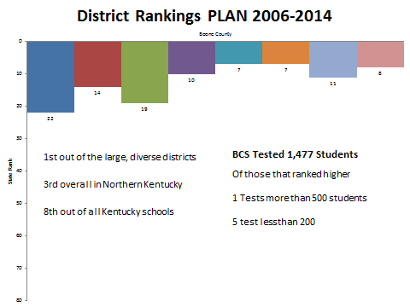

XI. INFORMATION, PROPOSALS, COMMUNICATIONS
XI.A. Human Resource Actions
XI.B. Worker's Compensation Claims
XI.C. Overtime Report
XI.D. Construction Status Report
XI.E. Monarch Construction Order of Joint Stipulation of Dismissal
XI.F. KSBIT Funds Assets- Kentucky League of Cities
XI.G. Memorandum KY Dept. of Insurance Summary of Recent Events
XI.H. Memorandum Feb 11, 2014 KSBIT Information Summary of Feb. 10, 2014 Hearing
XI.I. Statement of Position Boone County School District - KY League of Cities

- Karen Byrd reminded the board of the Education in Excellence Dinner on March 27th, which recognizes are outstanding teachers with the Golden Apple Award.
- Dr. Poe stated there will be a Special Board Workshop on March 24, 2014 at 6:30 pm to 8:00 pm at Ralph Rush. The Special Workshop will be on Transportation Reorganization.
- Ed Massey spoke on the repealing the Common Core legislation that is being presented at this time would be another unfunded mandate from the state. This legislation would not be in the best interest of our children. Dr. Poe stated this mandate would be an estimated 2 million dollar cost to the district to redesign if the common core repels passes. Discussion followed.

XII. AUDIENCE OF CITIZENS
Ashley Cooke , student from NKU studying Education introduced herself to the board.
Joseph Kempf, student from Gateway studying Math Education introduced himself to the board and asked the board a few questions on substitutes and the alternative school.

XIII. CLOSED EXECUTIVE SESSION PER KRS 61.810
XIII.A. No closed session

XIV. ADJOURN

- A motion was made by Ed Massey, seconded by Steve Templeton, to adjourn the meeting. Bonnie Rickert, Karen Byrd, Maria Brown, Steve Templeton and Ed Massey voted, “aye” MOTION: The motion passed 5-0.

Meeting was adjourned at approximately 9:14p.m.

_____________________________________
Karen Byrd/Chairperson

_____________________________________
Karen Evans/Secretary

