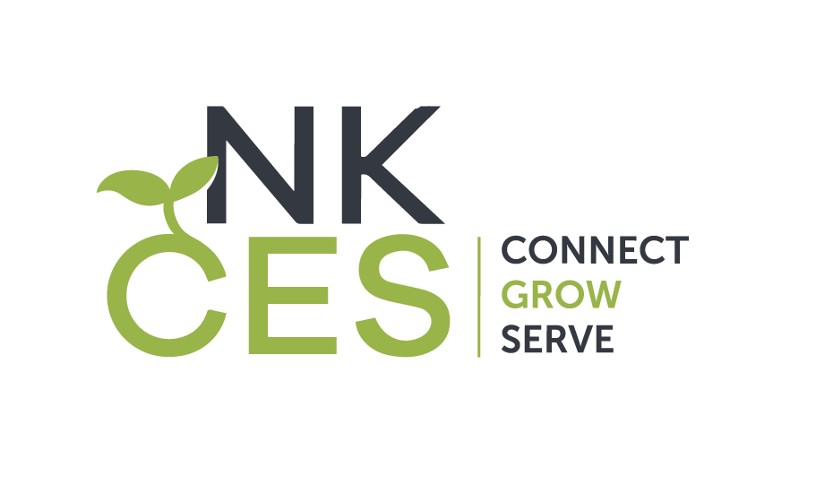
Northern Kentucky Cooperative
for Educational Services

NKCES Board of Directors Meeting
Location: NKCES, Synergy Room (PD Room)
5516 East Alexandria Pike
Cold Spring, KY 41076 Time: 8:30 - 10:00 AM

July 2022 - NO MEETING
August 24, 2022
September 14, 2022
October 19, 2022
November 9, 2022
December 2022 NO MEETING
January 11, 2023
February 8, 2023
March 8, 2023
April 19, 2023
May 10, 2023
June 2023 (Louisville, KY)

