John Hardin SBDM Council
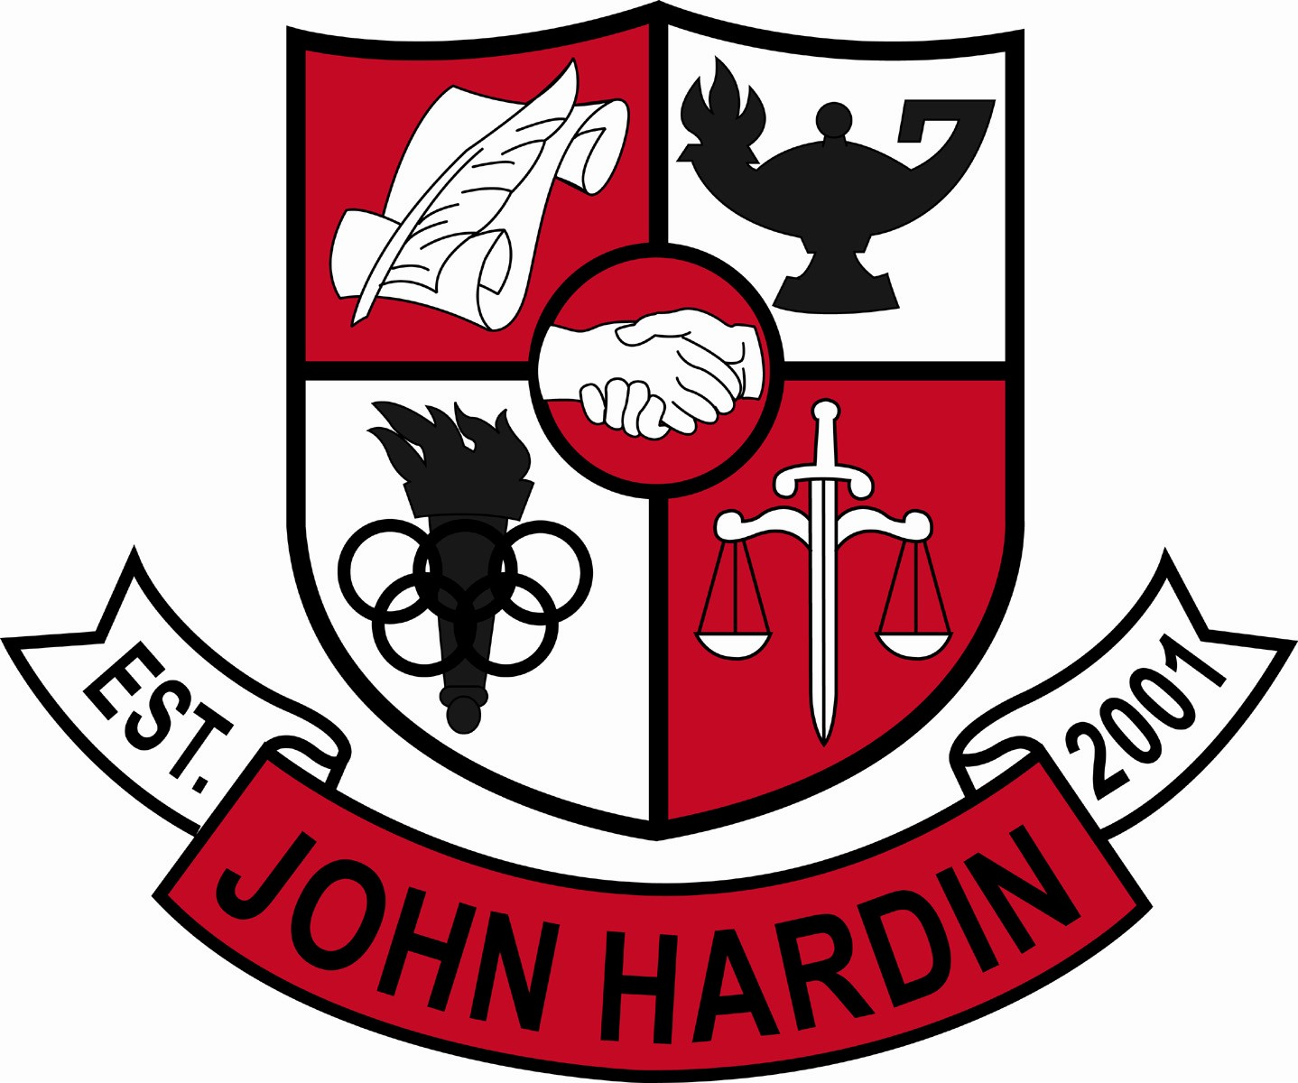
Meeting Minutes

November 14, 2013
4:00 p.m.

- Call to Order at 4:01 p.m.
Members present: Patrick Avery, Jana Haws, Stacey Moore, Alex Shearer, Pauline Crittenden and Lynne Gibson
Visitors present: Heather Brown, Shelby Bilbrey, Mike McCune, Jeremy Hall, Melissa Curtsinger, Kim Case and Bobby Lewis
- Approval of Agenda ORDER #13-14/0019
The council approved the agenda with the addition of World Language Department.
Motion: Moore Second: Avery
Avery - Yes
Crittenden – Yes
Gibson – Yes
Haws – Yes
Moore – Yes
Shearer - Yes
- Approval of Minutes ORDER #13-14/0020
The council approved the minutes as written.
Motion: Shearer Second: Moore
Avery - Yes
Crittenden – Yes
Gibson – Yes
Haws – Yes
Moore – Yes
Shearer - Yes
- PLC Reports
Science (Bilbrey) – working on commons assessments; teaching same concepts; learning new technology
Math (Shearer) – the entire department is working on Alg II alignment for EOC; working on standards based teaching
- Principal’s Update
- CTE – Mr. McCune and Mr. Hall presented a proposal concerning the CTE classes and how they can improve our standings. They need more students to be completers in order to improve our scores. They have so many choices that many do not follow through to “complete” their career pathways. CTEs are asking that no new electives be approved in the core departments to help streamline those completers. Mr. Shearer spoke for the council saying the council didn’t want to limit electives offered by anyone; let the students choose which classes make. He did recommend that if there was a scheduling conflict with singletons, the completers would win. Mr. McCune stated we need to be more definitive on the classes students can sign up for so we can guide the students to be career ready as well as college ready. If we can narrow the focus and still help students, it’s a win-win. Putting this proposal in place will help move JHHS to the 97-99 percentiles. He also said that it will improve each year because of the Early College and Career Center. Freshmen will need to decide on a pathway and will be able to obtain 1 credit per year in the pathway and reach the goal of completion.
- World Language - Ms. Heather Brown presented to the council a proposal that would allow an Arts and Humanities credit to be awarded after a student successfully completes and passes level 3 and 4 World Language classes (WL 3b, 4a, 4b or PB3/4.) The A/H curriculum is already embedded in the upper level World Language curriculum.
World Language-A/H Credit ORDER #13-14/0021
The council approves granting Arts and Humanities credit to students who successfully complete the upper level World Language Classes as outlined.
Motion: Shearer Second: Moore
Avery - Yes
Crittenden – Yes
Gibson – Yes
Haws – Yes
Moore – Yes
Shearer - Yes
- Course Offerings – The guidance counselors presented a list of course offerings the different departments would like to offer for 2014-15
Course Offerings ORDER #13-14/0022
The council approved the offerings presented by Science, Social Studies, Fine Arts, Family Consumer Science, Ag and Business with the understanding that if a class doesn’t “make” it will not be scheduled. The PE recommendation is a concern as the “standards” are not being taught in varsity sports or band like they are in PE or JROTC. The PE recommendation was tabled until next month.
Motion: Shearer Second: Moore
Avery - Yes
Crittenden – Yes
Gibson – Yes
Haws – Yes
Moore – Yes
Shearer – Yes

The council went in to closed session to discuss curriculum issues.

The council came out of closed session to continue the agenda

- Student Achievements – The council was provided a print out of the accomplishments of our students for the first three months of the school year.

- Financial Report ORDER #13-14/0023
The council reviewed and accepted the financial report for October.
Motion: Shearer Second: Avery
Avery - Yes
Crittenden – Yes
Gibson – Yes
Haws – Yes
Moore – Yes
Shearer - Yes
- Personnel
Vacancies: Asst. Tennis Coach; Freshmen Volleyball Coach; Girls Soccer Head Coach; Asst. Swim Coach; 90% Freshmen Baseball Coach; 10% Asst. Baseball/10% Freshmen Baseball Coach
Hired: Mark Thompson for Asst Softball; Maurice Green for .5 Middle School Wrestling; Levi Hardin for 90% Asst. Baseball
- Questions and Concerns from Council
- None
- Agenda Items for Next Meeting
- .5 PE Credit
- Conflict with current handbook and suspensions
- Adjourn
The meeting was adjourned at 6:04 p.m. The motion was made by Mr. Shearer and seconded by Mr. Avery

