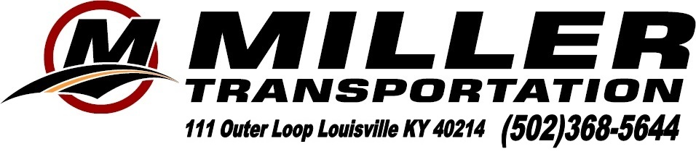
Pg. 1 or 2
Boone County Schools
Rocket City Regional -Huntsville, Alabama Charter # 152909
1 – 55
Teacher in charge: Elizabeth Koch 24 students, 6 adults = 30 Requested - Wifi
cell: 859-620-0087 2019. Driver: Ben Flanagan

April 6, 2022 - Wednesday
4:30 AM EDT (105 mi) Coach arrives at 37 Atlantic Ave., Erlanger, KY 41018.
Driver: Group will need to load their equipment and Robot under the coach.
5:00 AM EDT Board coach and depart
Fast food breakfast stop will be made enroute. Everyone pay on their own.
** Time change ** CDT time is one hour behind EDT time **
11:00 AM CDT (382 mi) Arrive at the U.S. Space and Rocket Center - One Tranquility Base, Huntsville, AL 35805. Ph: (256) 837-3400 Upon arrival , please go to the Davidson Center for Space Exploration to Check-in. Driver: Please pull around the parking lot and park in front of the open black gates for unloading..
U.S. Space & Rocket Center includes access to historic Shuttle Park, Rocket Park and all indoor exhibit areas such as the main museum atrium and the Davidson Center for Space Exploration. With each ticket purchase, enjoy daily guided tours of the Saturn V Hall, featured traveling exhibitions, hands-on demonstrations and presentations, museum simulators and a behind-the-scenes tour of Space Camp. Everyone will enjoy lunch on their own at the Space Center. Note: Docents are usually available in Saturn V Hall until 4 PM. Resv. #
4:00 PM CDT Depart (closes at 4 pm)
4:15 PM CDT (5 mi) Arrive at the Von Braun Center - 700 Monroe St SW, Huntsville, AL 35801. Ph: (256) 533-1953. Must drop off the Robot before going to the hotel. May take a while to unload the Robotics
equipment.
8:30 PM CDT (1 mi) Arrive at Embassy Suites – 800 Monroe St SW, Huntsville, AL 35801
Ph: (256) 539-7373. (Very conveniently attached to Convention Center)
Check in & Check on Breakfast Location.
Group will be on their own for Dinner. (Teacher has already made reservations and will
Pay the hotel directly) The teacher did include a room for the driver. – Make sure next year
Hotel Security will be provided by Southern Jamm Security –3077 Leeman Ferry Rd SW #H, Huntsville, AL 35801 Ph: (256) 880-5266 Officer – TBD Cell –
TBD
10 PM – 6 AM (officer may change) Miller will be billed for Security Service
April 7, 2022 – Thursday
Enjoy breakfast at the hotel.
Group will be participating in the Rocket City Regional - Robotics Competition. Group will walk to the Von Braun Center - 700 Monroe St SW, Huntsville, AL 35801. Ph: (256) 533-1953.
Hotel Security will be provided by Southern Jamm Security – Officer - - Cell –
10 PM – 6 AM. (officer may change) Driver will be off duty.
April 8. 2022 – Friday
Enjoy breakfast at the hotel.
Group will be participating in the Rocket City Regional - Robotics Competition. Group will walk to the Von Braun Center - 700 Monroe St SW, Huntsville, AL 35801. Ph: (256) 533-1953.
Hotel Security will be provided by Southern Jamm Security – Officer - - Cell –
10 PM – 6 AM. (officer may change) Driver will be off duty.

April 9, 2022– Saturday
Enjoy breakfast at the hotel.
12:00 PM or 3:00PM or 6:00 PM CDT - Departure from Huntsville, AL. will depend on whether or not the group qualifies for semi-finals or finals in the competition.
Fast food stop enroute home. Everyone will pay on their own.
**Time Change** EDT time is one hour ahead of CDT time**
8:30 PM or 11:30 PM or 3:30 AM- next morning EDT (381 mi) -Arrival time back home will depend on departure time.

Pg. 2 of 2

Tour Includes: U.S. Space and Rocket Center, Security at the hotel, and deluxe motorcoach transportation.

Teacher will make the hotel reservatons and include a room for the driver.

Tour Cost: Based on a minimum of 40 paying passengers per coach is $185.00 per person

Tour Cost: Based on a minimum of 35 paying passengers per coach is $204.00 per person

Tour Cost: Based on a minimum of 30 paying passengers per coach is $228.00 per person

Tour Cost: Based on a minimum of 25 paying passengers per coach is $285.00 per person

The Teacher will be taking care of the hotel reservations including the Driver’s room, room list & hotel payment.

Final Balance due 3/11/22

Prices are subject to change based on availability at the time of booking.

Cancellation Policy:
- There are no cancelations or refunds after 3/11/22

Complimentary Tour Policy and Minimum Paying Passenger Requirement:
- A minimum of [25] paying passengers is required for your tour. If for some reason this minimum is not met, a price increase will be necessary. Please contact Miller Transportation as soon as possible to make adjustment.
- There is a maximum of 55 passengers per motorcoach

I have read the above information and agree to the terms and conditions of this contract as stated.

__________________________________ ___________________
Authorized School Official (Print) Date

__________________________________
Authorized School Official (Sign)

