John Hardin SBDM Council
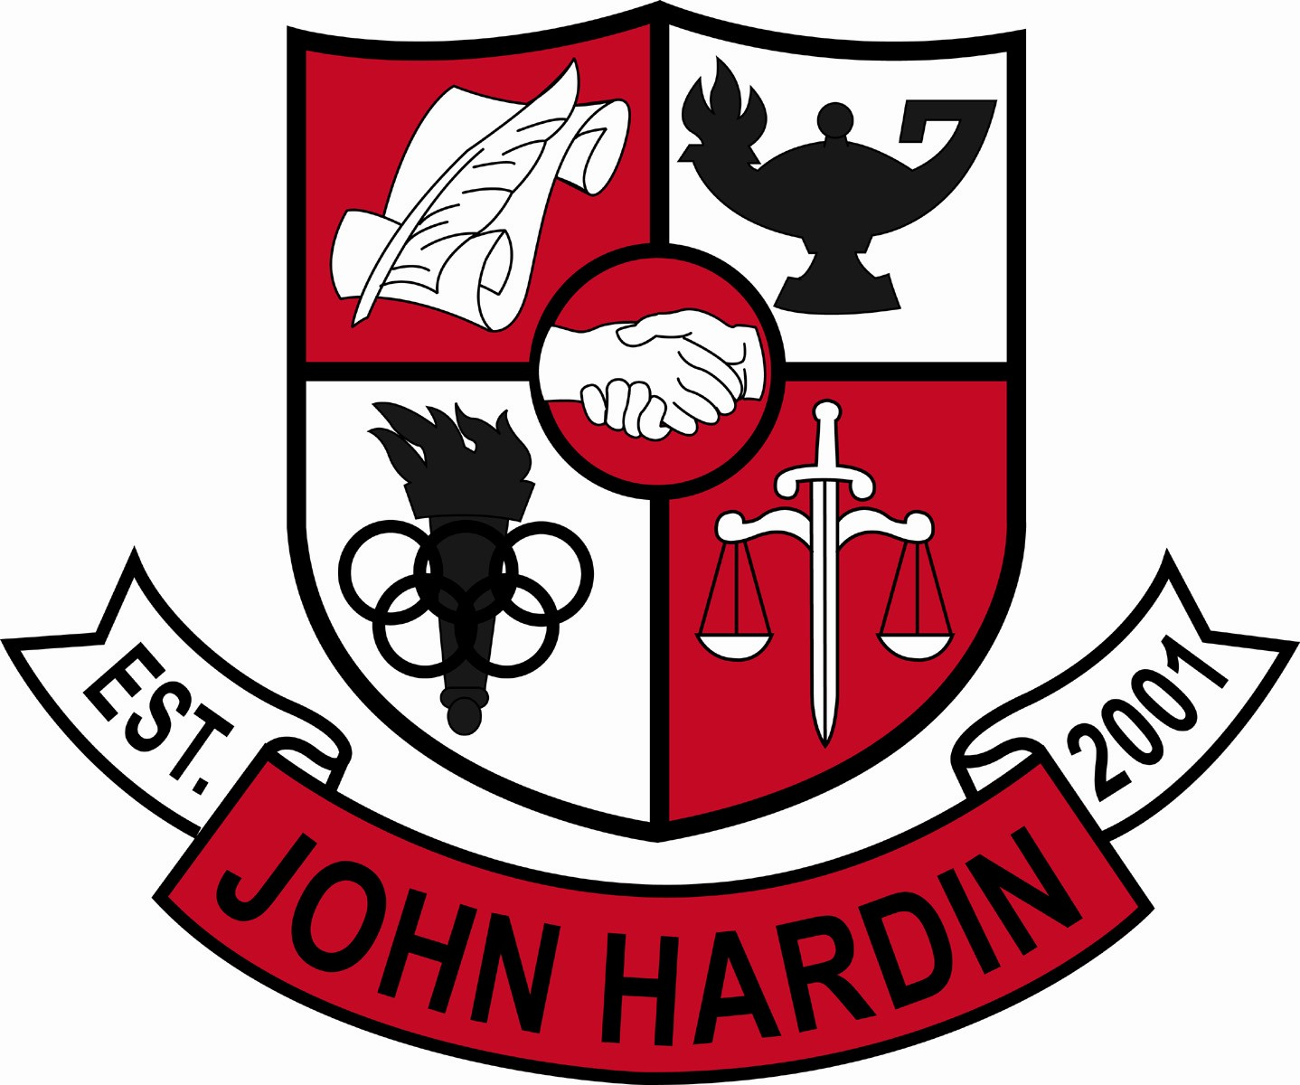
Meeting Minutes

February 9, 2017
4:00 p.m.

- Call to Order at 4:03
Members present: Jan O’Daniel, Alex Shearer, Aurora Selbe, Kelly Smith and Mark Wells.
Members absent: Mike Moritz
Guest: Chris Reed
- Approval of Agenda ORDER #16-17/0034
The council approved the agenda as written.
Motion: O’Daniel Second: Selbe
Selbe – Yes
O’Daniel – Yes
Shearer– Yes
Wells – Yes
Smith - Yes
- Approval of Minutes ORDER #16-17/0035
The council approved the minutes as written.
Motion: Selbe Second: O’Daniel
O’Daniel – Yes
Selbe– Yes
Wells – Yes
Shearer – Yes
Smith - Yes
- Good News Report –
  - Archery – Featured in KY NASP Region 5 Newsletter
  - FCCLA – Teachers and students donated money to purchase gifts for the Angel Tree.
  - BETA – Food was collected and delivered by John Hardin staff members to John Hardin families in need.
  - FCCLA – The following students will attend state competitions in March
    - Chapter in Review Portfolio: Reyna Shelby and Rebecca Smith
    - Chapter Service Project Display: Kait Humphrey and Madison Smith
    - Focus on Children: Katie King and Patrick Amulong
- Academic Team – District Champions and will compete in Regions at Nelson County High School on February 18th.
- BETA – John Hardin’s first year attending. The following awards were received by students attending.
- Public Comment – No comments
- Principal’s Update
  - Staffing Allocations – Allocations will be received on Monday, February 13th.
- Financial Report ORDER #16-17/0036
The Financial Report for December was approved as written.
Motion: Shearer Second: O’Daniel
O’Daniel – Yes
Selbe– Yes
Wells – Yes
Shearer – Yes
Smith - Yes
- Financial Report ORDER #16-17/0037
The financial report for January was approved as written.
Motion: Smith Second: Selbe
O’Daniel – Yes
Selbe– Yes
Wells – Yes
Shearer – Yes
Smith - Yes
- Governor’s Scholar Committee Report
A committee of teachers was formed to encourage and assist students in the application process. John Hardin has 14 students advancing to the next step.
- Personnel
Hired: Darrel Singleton for Freshmen Baseball Coach; Christopher Appelman for Asst. Baseball Coach; Andrew Hairston for Asst Wrestling Coach - 35% Stipend; Christopher Engstrand for Special Ed teacher; Adrianne House for EXCEL Instructional Assistant.
Vacancies: Assistant Girls Track Coach
- Agenda Items for Next Meeting
- Staffing Allocations
- Adjourn
The meeting was adjourned at 4:25 p.m. The motion was made by Ms. Selbe and seconded by Mr. Shearer

