Regular Meeting Boone County Board of Education
October 12, 2017 7:30 PM
Ralph Rush Professional Development Center
99 Center Street
Florence, Kentucky 41042

I. CALL TO ORDER

The Regular meeting of the Boone County Schools Board of Education October 12, 2017 was called to order by Chairperson Ed Massey at the Ralph Rush Staff Development Center.
Attendance Taken at 7:30 PM:

Present Board Members:
Dr. Maria Brown
Ms. Karen Byrd
Mr. Ed Massey
Mr. Matt McIntire
Ms. Bonnie Rickert

Gerry Dusing attended as Board Attorney
Karen Evans, Board Secretary, recorded the minutes.

II. NATIONAL ANTHEM
The National Anthem was presented by students from the Gray Middle School Quartet.

III. PLEDGE TO THE FLAG
The Pledge to the Flag was led by students from Mann Elementary School.

ADDENDUM TO AGENDA
Karen Byrd recommended the board approve the addition to the New Business Agenda and add the item of Boone County Board Resolution calling on the General Assembly to consider the roles and responsibilities of school councils as they relate to student achievement, and the best possible operation of schools and districts of October 12, 2017, as presented.

- A motion was made by Maria Brown, seconded by Matt McIntire, on the General Assembly to consider the roles and responsibilities of school councils as they relate to student achievement, and the best possible operation of schools and districts, October 12, 2017, as presented.
Maria Brown, Matt McIntire, Karen Byrd, Bonnie Rickert and Ed Massey voted, “aye” MOTION: The motion passed 5-0.

IV. STUDENT BOARD MEMBER REPRESENTATIVE REPORT
Bryan Padilla gave the Student Board Member Representative report and discussed the Drug Free Program, which approximately 30 students have signed up to participate in at Conner High School. Bryan discussed the Positivity Campaign at the Elementary schools with positive messages left on post-it notes to spread positivity.

V. GOOD NEWS
V.A. The board recognized and congratulated the 2017 October Break the Mold Recipient, Ms. Kim Dirksing, Cooper High School Spanish Teacher.
V.B. Boone County Business Association members Mr. Greg Winn and Mr. Steve Templeton presented the Annual Golf Outing check for $6588.00 to Boone County Schools. The proceeds from this annual fund raiser directly benefits students in the district, with the purchase of coats, hats, gloves, Christmas dinner and presents, along with funds to the Alternative School.
V.C. The board recognized Mr. Ed Massey, recipient of the 2017 Joseph W. Kelly Award.
V.D. The board recognized, Mr. Rod Price, Bus Driver, for his life saving actions in performing the Heimlich procedure on a student that was choking on his bus.
V.E. Chick-Fil-A Stuff-The-Bus Check Presentation. Mr. Dustin DiChiara, Owner and Operator of the Florence Chick-fil-A presented the Family Resource Centers a check for $500.00 for winning the bus challenge for 2017.
V.F. Boone County Schools, BCEA and Master Provisions teamed up with Boone County Schools District to collect more than 27,500 items and over $4,100.000 GO Pantry. Go Pantry supports our students by packing meals in backpacks for distribution.
V.G. The board recognized the 2017 October Sportsmanship Award Recipients.
Congratulations to the 2017 Sportsmanship Award Winners!!
BCHS - Layla Alzatout
CHS - Nicole Alig
RCHS - Austin Pressman
RHS - Ryan Clements
V.H. The board recognized Mr. Mike Ford, DPP, recipient of the 2017 Director of Pupil Personnel of the Year.
V.I. Rhonda Whitaker of Duke Energy Community Relations presented the Foundation Grant check of $10,000 which will be used to build awareness of energy efficient practices.
V.J. The board recognized the Energy Star School Awards and their Energy Teams from Camp Ernst Middle School, Gray Middle School, RA Jones Middle School and Erpenbeck Elementary.
V.K. The board recognized the Transportation Safety Awards.
The Boone County Schools have 67 bus drivers who have qualified for the Safe Driver Award for the 2015-2016 school year. Mr. Bob Barrix, Director of Transportation, will present awards to drivers. The Board would like to recognize the following individuals at this time:
15 year: | 1 year:
Bob Briggs | Dave Alexander | Diana Maynard
 | Mark Aulick | Wayne McMillan
10 year: | Robert Brown | Stephen Penrod
Tammy Conley | David Burton | Jerry Peirson
Brian Kirby | Linda Burton | Paula Rayburn
Jerry Lindle | Mark Cobb | Sandy Renko
Daune Owens | Brandon Copelan | Ken Sherman
 | Cassandra Cropper | Daniel Stadtmiller
5 year: | Mike Dawson | Jerry Stamper
Brenda Baker | David Day | James Sudenga
James Cosmetis | Jim Dishon | Ronda Thomas
Robert Courtney | Don Elliott | Paul Veldhaus
Ralph Doan | Steve Fischesser | Thomas Whissel
Julian (JR) Feagan | Christy Focke | Tammy White
Cathy George | Judith Green | Roger Wilson
Tammy Hancock | Cynthia Hall | John Woodward
Bill Houston | Floyd Hicks
Robert Hunter | Steve Hodge
Michael Krummen | Robert (Tony) Kinmon
Steve Lawton | Bev Kyle
Susan Schneider | Mark Lenhoff
Rick Sullivan | Don Mackintosh

VI. AUDIENCE OF CITIZENS
(Brief Summary)
- Patrick Brown, parent, discussed the need for his son to have a snack in Kindergarten at New Haven but it was not an option for Kindergarten students. He discussed going to SBDM, State and the Principal to have this changed. He stated the state said it is a SBDM policy, but the principal made the decision to not have snacks. He would like the option for parents that wish to send a snack for their children to be allowed to do so. He discussed the avenues that he has taken to find out how to get this changed. Mr. Brown stated the SBDM meetings were changed, the REMIND was not to be used by parents and questioned the changes at this time and he was told he could not speak at SBDM meeting. Dr. Poe, Ed Massey and Gerry Dusing, Board attorney discussed the board cannot make or supersede a SBDM decision and discussed in length those reasons, but the SBDM’s do have an agenda and he can ask to be put on the agenda. Dr. Poe asked Dr. Jim Detwiler, whom works with the training of all SBDM councils to look into the matter of SBDM meeting procedures and the communication issues Mr. Brown is having with New Haven.
- Mary Rotatori, parent. Stated that she is sorry that Mr. Brown had a bad experience with the SBDM at New Haven. But, she has attended many SBDM’s and stated they do not work that way. If you are at a meeting and wish to speak on something they have always allowed it.

VII. RECOMMENDED ACTION - CONSENT AGENDA
Dr. Randy Poe, Superintendent, recommended the board approve the following Consent Agenda items A-EEB, as presented.

2. A motion was made by Karen Byrd, seconded by Matt McIntire, to approve the consent agenda items A-EE, as presented. Ed Massey recused himself from the minutes from the September 14th 2017 meeting he was not in attendance. Karen Byrd, Dr. Maria Brown, Matt McIntire, Ed Massey and Bonnie Rickert voted, “aye” MOTION: The motion passed 5-0.

VII.A. Minutes of the regular board meeting of September 14, 2017.
The board approved the minutes of the regular board meeting of September 14, 2017, as presented.
VII.B. Bill List
VII.C. Treasurer's Report was given by Ms. Linda Schild.
VII.D. Leaves of Absence
The following persons submitted leave of absence requests were approved:
Recommended by Principal/Supervisor for approval:
Broadus, Molly, Teacher @ Mann Elem, 11/8/2017 – 12/19/2017
Davis, Katherine, Teacher @ Thornwilde Elem, 12/19/2017 – 2/2/2018
Hunter, Robert, Bus Driver @ Transportation, 9/25/2017 (1/2 day) – 10/27/2017
Lake-Brooks, Stephanie, Bus Driver @ Transportation, 9/26/2017 – 10/18/2017
Warner, Megan, Teacher @ Thornwilde Elem, 12/4/2017 – 1/16/2018
Whaley, Diane, Teacher @ Ryle High School, 9/18/2017 – 10/12/2017
Wilcox, Rachel, Instructional Coach @ Longbranch Elem, 9/25/2017 – 10/20/2017
Wilson, Kate, Coordinator @ Food Services, 10/19/2017 – 11/21/2017
Not Recommended by Principal/Supervisor for approval:
Nothing to Report
Amended Leaves:
Bonta, Kathryn, Bus Driver @ Transportation, 8/16/2017 – 10/31/2017
Danner, Amanda, Teacher @ New Haven Elem, 10/31/2017 – 11/21/2017
Hall, Barbara, Café Wkr @ Goodridge Elem, 8/16/2017 – 10/24/2017
Stephens, Nancy, Custodian @ Ryle High School, 5/1/2017 - 6/30/2018
Walsh, Meggie, Teacher @ Yealey Elem, 9/29/2017 – 12/19/2017
Cancelled Leaves:
None

VII.E. Boone County Board of Education Resolution to join the Regional Partnership with the Home Builders Association of Northern Kentucky and the Letter of Intent to Lease the building from the Home Builders Association
The board approved the Boone County Board of Education Resolution to join the Regional Partnership with the Home Builders Association of Northern Kentucky and the Letter of Intent to Lease the building from the Home Builders Association, as presented.
VII.F. KASS Conference
The board approved the travel and registration expenses for Dr. Randy Poe to attend the KASS Conference in December 2017, as presented.
VII.G. National School Board Association Advocacy Institute Conference and Equity Symposium February 2018 Ed Massey
The board approved the National School Board Association Advocacy Institute Conference and Equity Symposium February 2018, for Ed Massey, board member, as presented.
VII.H. FY 18 Instructional Transformation Project
The board approved the FY 18 Instructional Transformation Project, as presented.
VII.I. Emergency Day Request for Kelly Elementary September 15, 2017
The board approved the Emergency Day Request for Kelly Elementary September 15, 2017, as presented.
VII.J. Surplus Equipment
The board approved the equipment stored in the Warehouse as surplus and approve the disposal in accordance with board policy, as presented.
VII.K. Food Service Sanitation System- Bid Renewal Smart Systems
The board approved the Food Service Sanitation System Bid Renewal to Smart Systems, as presented.
VII.L. Fresh Produce Bid Renewal to Refresh Produce
The board approved the Fresh Produce renewal bid to Refresh Produce, as presented.
VII.M. Small Wares- Bid Renewal to Tri-Mark/SSKemp
The board approved the Cafeteria Small Wares- Bid Renewal to Tri-Mark/SSKemp, as presented.
VII.N. Surplus Technology
The board approved and declared certain technology items surplus and the disposal of the items in accordance with Board policy, as presented.
VII.O. Change Order #8 Ryle High School BG#15-281
The board approved the Change Order #8 Ryle High School BG#15-281, addition of $27,378.00, as presented.
VII.P. Schematic Design/Design Development Drawings, BG-2 and BG-3 Central Office HVAC Upgrades
The board approved the Schematic Design/Design Development Drawings, BG-2 and BG-3 Central Office HVAC Upgrades, as presented.
VII.Q. Schematic Design/Design Development Drawings, BG-2 and BG-3 Collins and Stephens Elementary HVAC Upgrades
The board approved the Schematic Design/Design Development Drawings, BG-2 and BG-3 Collins and Stephens Elementary HVAC Upgrades, as presented.
VII.R. Sales Campaign Approval
The board approved the Sales Campaign Request, as presented.
VII.S. Field Trip Request
The board approved the Field Trip request, as presented.

School | Date Of Trip | Location | Reason
Boone County High School | November 8-12, 2017 | Washington DC | FCCLA Cluster Meeting
Boone County High School | November 30, 2017 | Cincinnati | Educational
Conner High School | December 2, 2017 | Fleming Co. | Girls Basketball Game
Conner High School | December 2, 2017 | Fleming Co. | Girls Basketball Game
Conner Middle School | May 4-5, 2018 | Pigeon Forge, TN | Music Competition
Cooper High School | November 8-12, 2017 | Washington DC | FCCLA Cluster Meeting
Mann Elementary | April 20, 2018 | Conner Prairie | Educational
Ryle High School | October 23, 2017 | Mammoth Cave | Educational
Ryle High School | October 17, 2017 | Harrodsburg, KY | Educational
Ryle High School | October 11, 2017 | Frankfort | Educational
Ryle High School | October 23, 2017 | Various High School Sites | Boys and Girls Soccer State Tournament
Ryle High School | November 3-5, 2017 | Louisville | Volleyball State Tournament
Thornwilde Elementary | April 19, 2018 | Conner Prairie | Educational

VII.T. Change Order #4 Conner Middle School BG#16-087
The board approved the Change Order #4 Conner Middle School BG#16-087, addition of $39,922.00, as presented.
VII.U. Bus Request- Prime Sports
The board approved the bus request from Prime Sports, as presented.
VII.V. Agreement between NCS Pearson, Inc. and Collins Elementary for Aimsweb Plus
The board approved the Agreement between NCS Pearson, Inc. and Collins Elementary for Aimsweb Plus, as presented.
VII.W. Agreement between Franklin Covey Client Sales and Yealey Elementary Leader in Me Program
The board approved the Agreement between Franklin Covey Client Sales and Yealey Elementary Leader in Me Program, as presented.
VII.X. Agreement between Missoula Children's Theatre and Yealey Elementary
The board approved the Agreement between Missoula Children's Theatre and Yealey Elementary, as presented.
VII.Y. Agreement between Franklin Covey Client Sales, Inc. and Longbranch Elementary Leader in Me Program
The board approved the Agreement between Franklin Covey Client Sales, Inc. and Longbranch Elementary Leader in Me Program, as presented.
VII.Z. Superintendent Goals & Objectives 17-18
The board approved the Superintendent Goals & Objectives 17-18, as presented.
VII.AA. Ed Innovation Summit December 2017
The board approved Dr. Randy Poe travel and related expenses to attend the Ed Innovation Summit in NYC, December 2017, as presented.
VII.BB. No Cost Agreement between Epson America, Inc. and Yealey Elementary
The board approved the No Cost Agreement between Epson America, Inc. and Yealey Elementary, as presented.
VII.CC. Renaissance Learning Data Disclosure Authorization
The board approved the Renaissance Learning Data Disclosure Authorization, as presented.
VII.DD. Local Agreement for Cooperation on Full Utilization of head Start School Year 2017-18
The board approved the Local Agreement for Cooperation on Full Utilization of head Start School Year 2017-18, as presented.
VII.EE. Revised BG-1 for Conner High School Portable Classrooms BG#16-160
The board approved the Revised BG-1 for Conner High School Portable Classrooms BG#16-160, as presented.

VIII. RECOMMENDED ACTION - OLD BUSINESS
No Old Business

IX. RECOMMENDED ACTION - NEW BUSINESS
IX.A. Human Resources Lead Generalist New Job Description

Dr. Randy Poe, Superintendent, recommended the board approve the Human Resources Lead Generalist New Job Description, as presented.

- A motion was made by Matt McIntire, seconded by Maria Brown, to approve the Human Resources Lead Generalist New Job Description, as presented. Maria Brown, Matt McIntire, Karen Byrd, Bonnie Rickert and Ed Massey voted, “aye” MOTION: The motion passed 5-0.

IX.B. Grade 13 Pay Scale

Dr. Randy Poe, Superintendent, recommended the board to approve the Grade 13 Pay Scale, as presented.

- A motion was made by Maria Brown, seconded by Matt McIntire, to approve the Grade 13 Pay Scale, as presented. Maria Brown, Matt McIntire, Karen Byrd, Bonnie Rickert and Ed Massey voted, “aye” MOTION: The motion passed 5-0.

Dr. Poe discussed this Grade Scale 13 will clearly define the Classified into Non-degree, Associate degrees, and Bachelor’s Degree for pay scale distinction.

IX.C. Real Estate Donation Agreement with Toyota Motor Engineering and Manufacturing North America Lab Property

Dr. Randy Poe, Superintendent, recommended the board approve the Real Estate Donation Agreement with Toyota Motor Engineering and Manufacturing North America Lab Property, as presented.

- A motion was made by Karen Byrd, seconded by Matt McIntire, to approve, approve the Real Estate Donation Agreement with Toyota Motor Engineering and Manufacturing North America Lab Property, as presented. Maria Brown, Matt McIntire, Karen Byrd, Bonnie Rickert and Ed Massey voted, “aye” MOTION: The motion passed 5-0.

Dr. Poe explained this is the property for the Ignite Institute.

IX.D. Plumber Position

Dr. Randy Poe, Superintendent, recommended the board approve the new position of Plumber, as presented.

- A motion was made by Maria Brown, seconded by Bonnie Rickert, to approve the new position of Plumber, as presented. Maria Brown, Matt McIntire, Karen Byrd, Bonnie Rickert and Ed Massey voted, “aye” MOTION: The motion passed 5-0.

Dr. Poe explained the position was description cannot be found in Human Resources, the job duties was outsourced for quite some time, but after review of the position it needs to be filled to have the work done in house when possible.

IX.E. Director of Process and Performance Management New Job Description

Dr. Randy Poe, Superintendent, recommended the Director of Process and Performance Management New Job Description, as presented.

- A motion was made by Bonnie Rickert, seconded by Karen Byrd, to approve the Director of Process and Performance Management New Job Description, as presented. Maria Brown, Matt McIntire, Karen Byrd, Bonnie Rickert and Ed Massey voted, “aye” MOTION: The motion passed 5-0.

Dr. Poe discussed the position will align with the 5 year Strategic Plan for the district, the position will work closely with Human Resources and Finance in the same manner as the APQC work. The position will monitor processes and improvements for resource optimization and will fall under the Chief Operations Officer, but will be responsible to work with all departments in updating policy and procedures for the district.

IX.F. Food Service Generalist New Job Description

Dr. Randy Poe, Superintendent, recommended the board approve the Food Service Generalist New Job Description, as presented.

- A motion was made by Bonnie Rickert, seconded by Karen Byrd, to approve the Food Service Generalist New Job Description,, as presented. Maria Brown, Matt McIntire, Karen Byrd, Bonnie Rickert and Ed Massey voted, “aye” MOTION: The motion passed 5-0.

Dr. Poe discussed the Food Service position would be operating under Food Service and working with Human Resources to keep up with position demands. The position would also be funded from Food Service.

IX. G. Amendment to Agenda: Resolution from the Boone County Board of Education, in Support of Legislation to allow School-based councils to act in an advisory capacity offering input to the duly elected board members and Superintendent who are accountable to the students, parents and community members with regards to student achievement.

- A motion was made by Bonnie Rickert, seconded by Matt McIntire, to approve the Resolution from the Boone County Board of Education, in Support of Legislation to allow School-based councils to act in an advisory capacity offering input to the duly elected board members and Superintendent who are accountable to the students, parents and community members with regards to student achievement as presented. Maria Brown, Matt McIntire, Karen Byrd, Bonnie Rickert and Ed Massey voted, “aye” MOTION: The motion passed 5-0.

Mr. Ed Massey read the following Resolution into the minutes.

Boone County Board of Education
Resolution
October 12, 2017

WHEREAS, school-based decision making councils were created as part of the KERA reforms of 1990, as a means to give parents, teachers, and principals at each school greater control over how that schools operates, and

WHEREAS, school councils have been given the responsibility to set school-level policy, consistent with district board policy, to provide an environment to enhance the students' achievement and help the
school meet the goals established by KRS 158.645 and 158.6451, and district goals established by the board, and

WHEREAS, KERA maintained the powers and responsibilities held by the elected board of education in each district, serving as the representative body accountable to the entire community, to manage
and control the affairs of the school district and to levy taxes to support the operations thereof, and

WHEREAS, since the initial implementation of school councils nearly 30 years ago, numerous situations of overlapping responsibility have caused unnecessary confusion for school board members, council members, community members, and others, which has at times hindered the progress of education advancement in the Commonwealth, and

WHEREAS, the training of school-based councils, boards of education and superintendents is at times inconsistent, and

WHEREAS, an OEA decision recently determined that the Superintendent of Boone County had usurped the authority of the Board with regards to a school- based council decision regarding an educational platform; and

WHEREAS, neither the school based council nor the Board of Education levied any complaint against the Superintendent, and

WHEREAS, the Superintendent had acted in accordance with training he had received from the agency representing school based councils, and

WHERAS, the determination of the OEA that the Superintendent had usurped the authority of the Board of Education was in conflict with the training received by the Superintendent, and

WHEREAS, the determination of the OEA is in conflict with the decision of Bushee v. Boone County Board of Education, and

WHEREAS, every public institution in a democracy functions best when proper checks and balances are in place, with clearly defined roles and responsibilities of all stakeholders, and the same is true for our common school system which must be accountable to the students, parents, and the community at large, and

WHEREAS, having greater clarity and guidance as to the proper responsibilities of both school boards and school councils will benefit all stakeholders by providing for more public transparency and accountability, and will allow all stakeholders to focus on student achievement which is the paramount mission of our schools,

NOW, THEREFORE: Be it resolved by the Board of Education of the Boone County Public Schools:

The board calls upon the General Assembly to consider the roles and responsibilities of school councils as they relate to student achievement, and the best possible operation of schools and districts.

The board supports legislation to allow school- based councils to act in an advisory capacity offering input to the duly elected board members and Superintendent who are accountable to the students, parents and community members with regards to student achievement.

Ed Massey discussed the resolution supporting and advocating for changes to make SBDM Councils and Boards more effective in working with each other. The intent is to not take away power form any group or entity, it is a matter of clarification, because we all answer to so many different agencies. For example when we have conflicts with different councils on how they handle a situation, by law we cannot even resolve the conflict, even though we are elected by the voters, because of the laws in place. Mr. Massey spoke on how Boone County welcomes parent and community engagement. Mr. Massey asked the community to give input to Senator Shickel of the kind of changes you would like to have to make us all more effective. The resolution purpose is to not take any hard stance on what the changes should be, but to simply say there needs to be some changes somewhere so that we can be more effective as a school district and we do not have these conflicts of interest that keep arising.

Dr. Poe discussed the testimony in front of the house committee that if there is a conflict, the local elected board of education should be deciding it not OEA. The board rules on it that is how it should stand, the board represents the community. Contrary it is not necessarily saying that SBDM is not doing anything different than they do now, this just means that if there is a conflict and there is an appeal process it would go to the local board of education.

Karen Byrd discussed that she did not want anyone to take this that we do not have a good working relationship because we do have a good working relationship with all of our SBDM’s. There is frustration with parents when they bring an issue and as a board member everyone would like to fix those issues, but when you have a situation and you know there is a good answer and you want to fix it, it is very frustrating. Ms. Byrd stated we need clarity and is in support of this resolution, not to do away with councils because the do serve a vital role, but would like clarity and support equal representation.

X. SUPERINTENDENT'S REPORT
- Mrs. Krista Decker, LSS Director of Assessment, gave a PowerPoint presentation and update to the board on the 2016-2017 District KPREP Data. Mrs. Decker discussed the transition period in 2016-2017 school year was the beginning of a transition period away from the Unbridled Learning Accountability Model to a new accountability model. The new model is expected to be in effect in the 2018-2019 school year. Mrs. Decker gave the following report on the 2016-2017 Reporting, Highlights, Reporting Components, Achievement Data, GAP data, Growth Data, College and Career Readiness Targets, Graduation Rate, Program Review and the information the 2017-2018 is a transition period that is modeling the new system is expected. In 2018-2019 school year the new accountability system is expected to be in place. See presentation below:

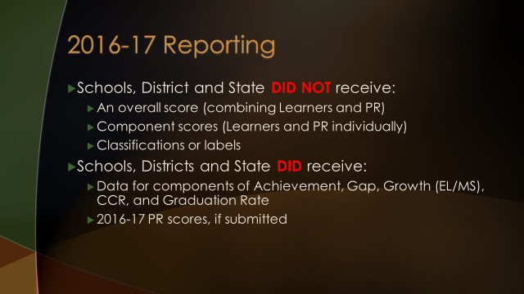

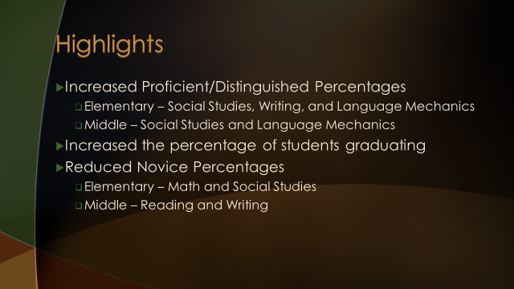

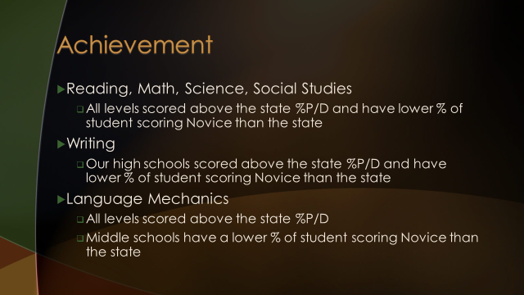

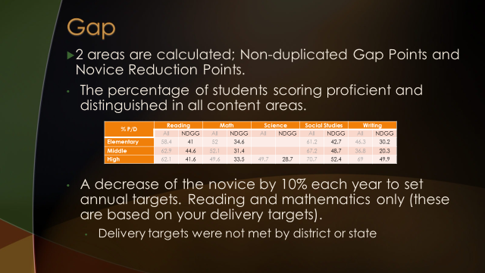

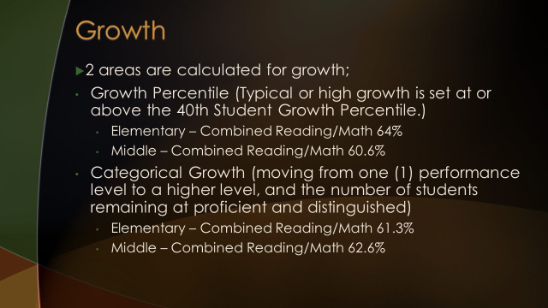

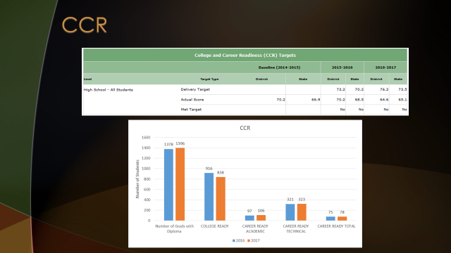

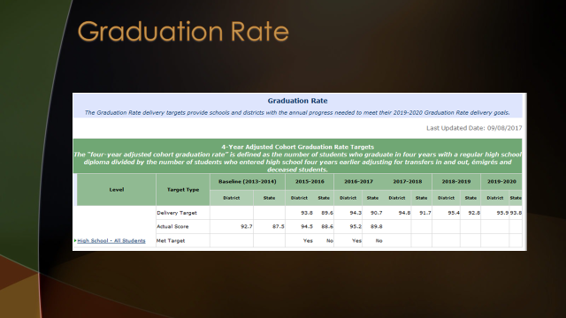

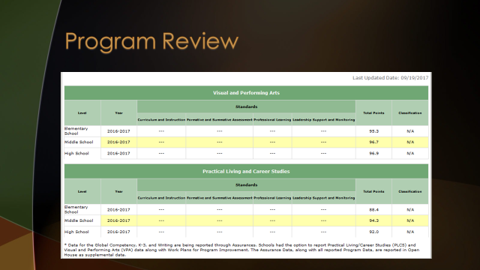

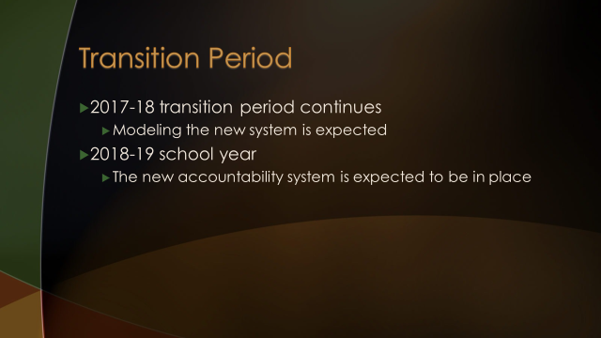

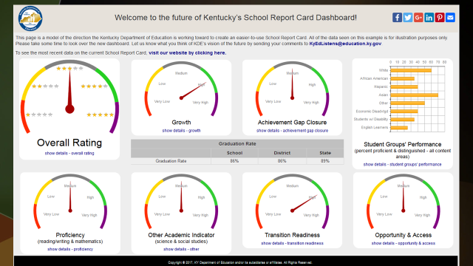

- Dr. Poe, announced - October 17th at 6:30 pm Redistricting for Ballyshannon Public Forum, Ralph Rush Professional Development Center

- Dr. Poe, announced -October 23rd from 5-8:00 pm, Special Board Workshop – Professional Development – Redefining the Role of School Boars as Community Leaders and Advocates for Schools.

XI. INFORMATION, PROPOSALS, COMMUNICATIONS
XI.A. Human Resource Actions
XI.B. Worker's Compensation Claims
XI.C. Overtime Report
XI.D. Construction Status Report
XI.E. Energy Management Report

XII. AUDIENCE OF CITIZENS
- Mary Wilson, BCEA President, invited all to attend and support the Pension Rally at Dixie Heights on October 24th 2017 at 6:00 pm.
- The following College students introduced themselves to the board and their educational majors: Kelsey Olson, Paige Burcham, Gabrielle Monroe, Morgan Nagle, Nichole Jones, Joseph Frakes, and Anna Wiener.

XIII. CLOSED EXECUTIVE SESSION PER KRS 61.810
XIII.A. No closed session

XIV. ADJOURN

- A motion was made by Maria Brown, seconded by Karen Byrd, to adjourn the meeting. Maria Brown, Ed Massey, Bonnie Rickert, Karen Byrd and Matt McIntire voted, “aye” MOTION: The motion passed 5-0.

Meeting was adjourned at approximately 9:57 pm.

_____________________________________
Ed Massey/Chairperson

_____________________________________
Karen Evans/Secretary

