Month 6 – to date (Month 6 ends 3/29/18)
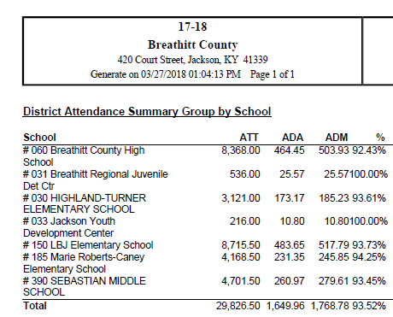

Year to Date
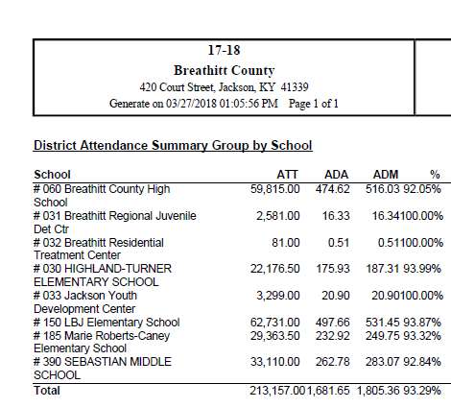
Ended last year at 93.85 – with adjustments

