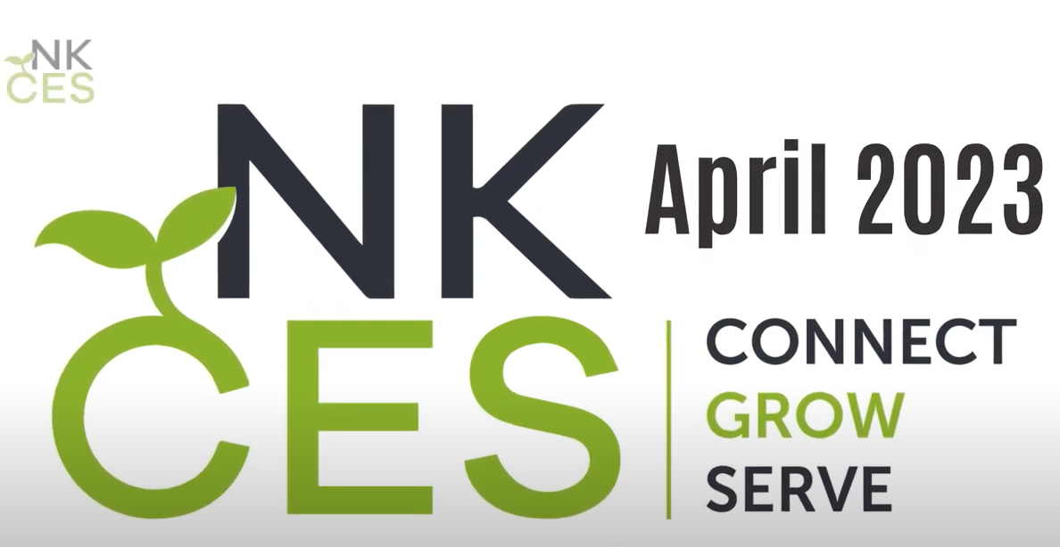
Link to Movie: April 2023 Movie

