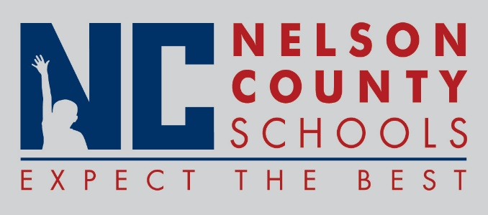

Information Paper
To: | Nelson County Board of Education
From: | Kimberly Brown
cc: | Mr. Tom Brown, Superintendent
Date: | February 20, 2018
Re: | Eligibility Requirements for Dual Credit Associate Degree Program

INFORMATION: Dual credit programs are cost-effective ways for students to earn college credit while in high school, and studies show they increase college enrollment, on-time graduation, and help expose students to career possibilities.

Dual credit programs provide the opportunity for students to both earn those necessary college credits as well as experience "going to college" among friends and close to home and school. Studies show that these programs increase the chances of college enrollment, on-time graduation, as well as reducing college costs. Dual credit programs also expose students to many career possibilities prior to college, helping refine major and degree program selection.
Information: Dual credit courses generate an interest in attending college among students who may not have thought it an option. The programs also promote college-going cultures within schools, providing opportunities for both teachers and students to explore teaching and learning a more rigorous curriculum than before.

In order to ensure success in dual credit coursework while pursuing an Associate Degree, the following entrance criteria will be required of all Nelson County Public Schools students seeking degree/diploma completion.

