Special Board Meeting Workshop Redistricting Steeplechase Boone County Board of Education
September 03, 2020 7:30 PM

Due to the Governor's directive of no more than 50 to gather for safety during the Covid-19 Pandemic, we were able to allow 50 people in the room when the Board Meeting took place. We added an area to view the meeting live if needed. The Board of Education broadcast the meeting on our YouTube page.https://www.youtube.com/user/BooneCountySchools Ralph Rush Professional Development Center 99 Center Street Florence, Kentucky 41042

- CALL TO ORDER
The Special Board Workshop for the Redistricting of Steeplechase of September 3, 2020 at 7:30 pm was called to order by Matt McIntire, Chairperson. This meeting was a workshop for the board to review the redistricting committee work.

Attendance Taken at: 7:30 PM
Present Board Members:
Dr. Maria Brown
Ms. Karen Byrd
Mr. Troy Fryman
Mr. Matt McIntire
Mrs. Julia Pile

Karen Evans, Board Secretary
Matthew Turner, Superintendent

II. PLEDGE TO THE FLAG
The Pledge to the Flag was led by Mr. Matt McIntire, Board Chair.
III. BOARD WORKSHOP ON REDISTRICTING STEEPLECHASE
Mr. Mike Ford, Director of Pupil Personnel, reported to the board the work of the Redistricting Committee within the last year to prepare for the new elementary school. Mr. Ford presented to the board the two scenarios that would relieve the overcrowding at New Haven Elementary and Collins Elementary. The plan included the subdivisions and streets of the students that would be redistricted to the new Steeplechase Elementary, located in of Richwood road in Steeplechase area. Mr. Ford presented a power point presentation for the board and all were given time to discuss the options. Mr. Ford presented the most likely two scenarios from the work of the committee and asked for input from the board, the recommendation will be presented in late October and the final recommendation would be presented at the December board meeting after public forums. Mr. Ford discussed the board sets the boundaries for our schools; the committee looks in to the demographics and growth of the areas. Mr. Ford discussed several questions from the board member. Mr. Kevin Costello, Planning and Zoning attended and discussed the current growth and any potential growth the County sees for planning purposes. Mr. Bob Barrix, Transportation Director, discussed the department would support both plans, but Scenario A, because of the reverse flow on Dixie, traffic issues and time students are on the buses.

Below is the full presentation, with both scenarios presented.

The Committee will have two public forums to hear from the community and parents coming in the next month. Mr. Ford advised for all to check the website for those dates.

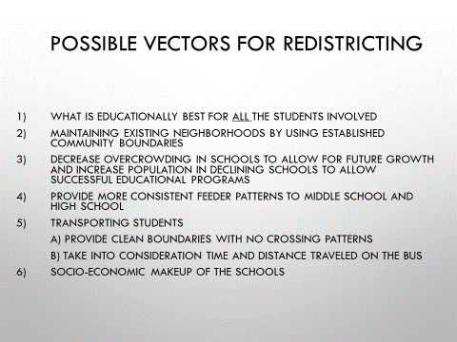

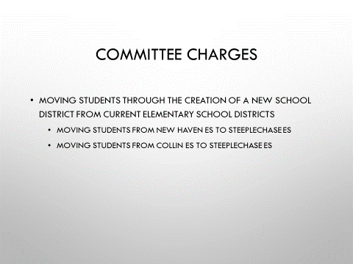

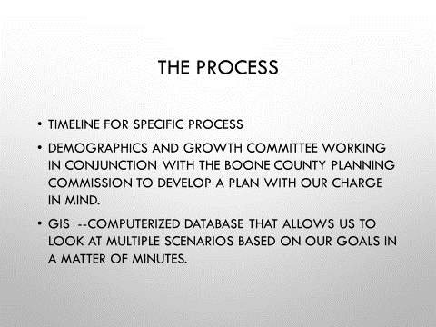

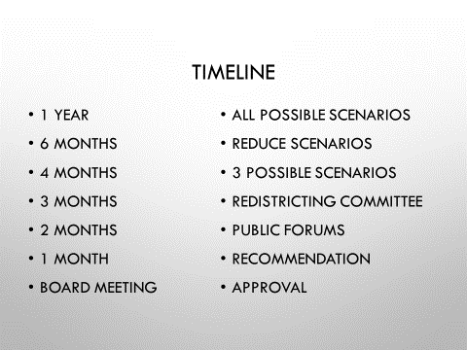

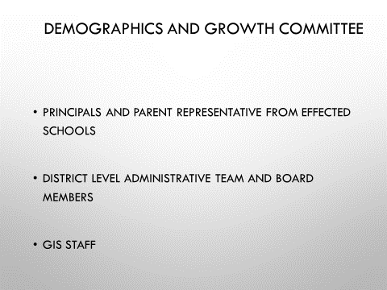

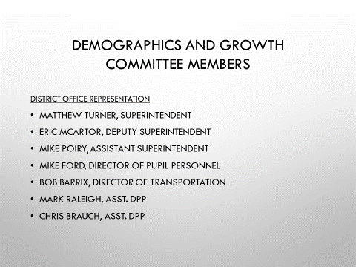

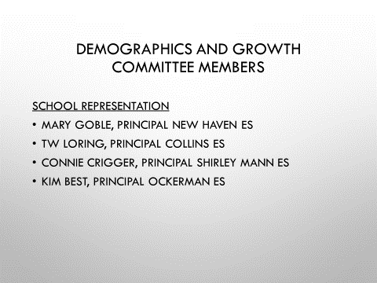

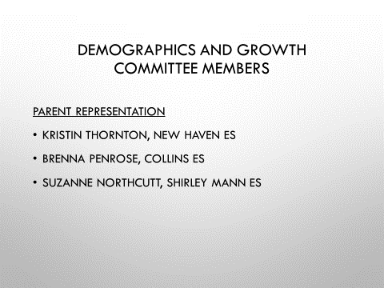
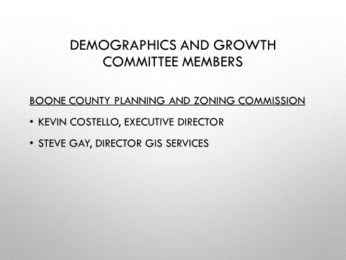

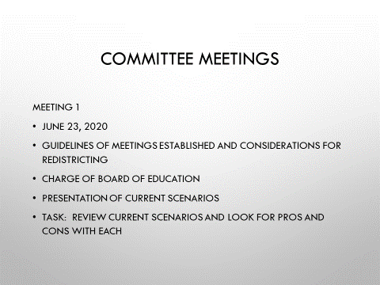

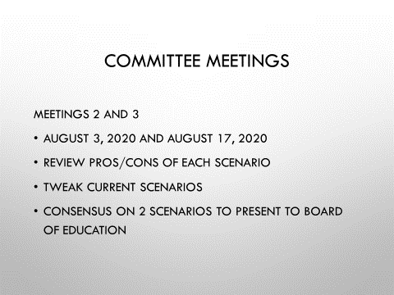

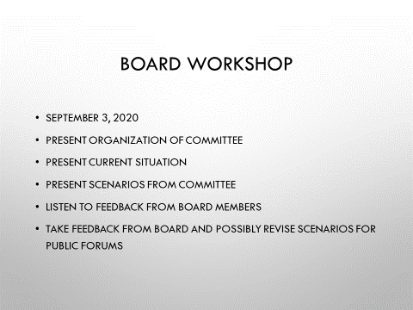

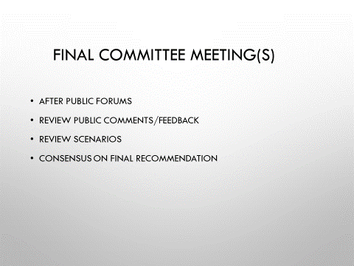

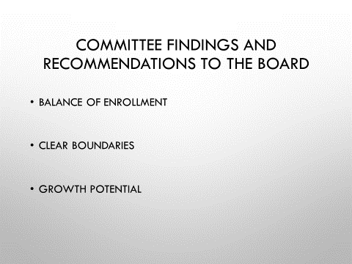

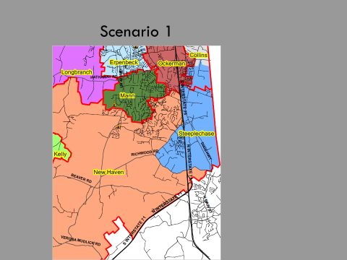

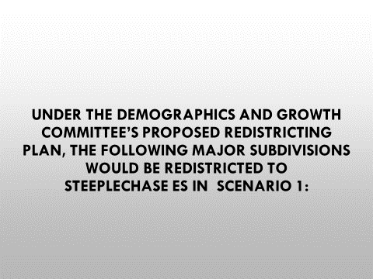

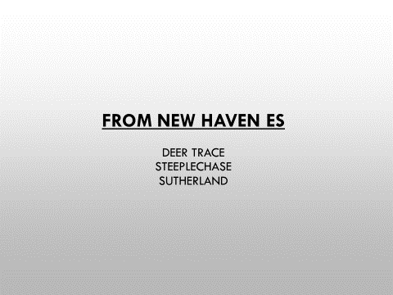

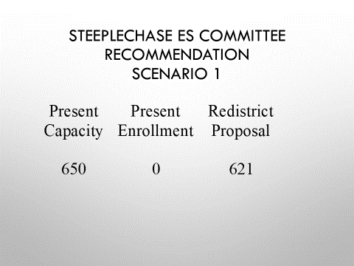

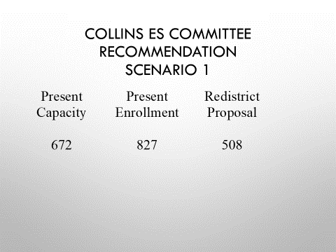

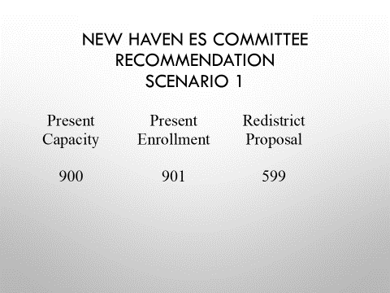

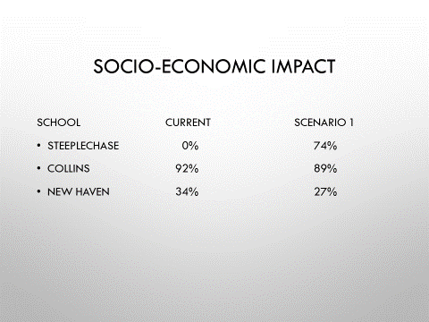

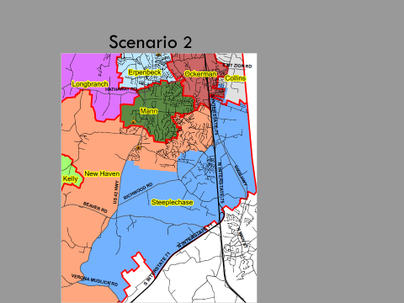

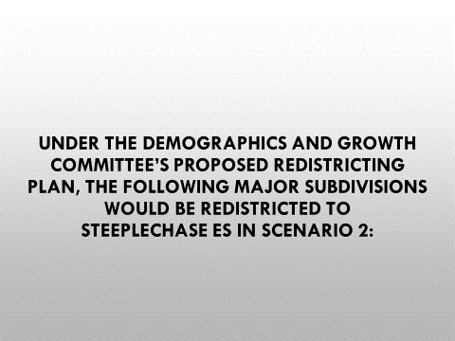

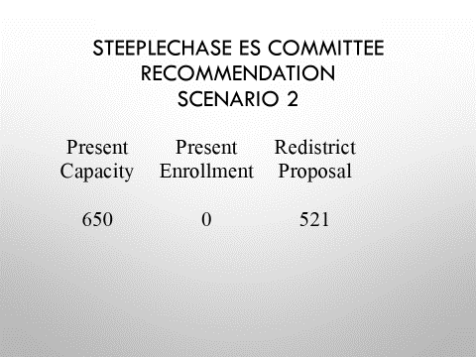

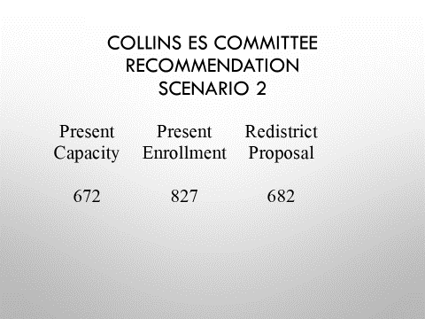

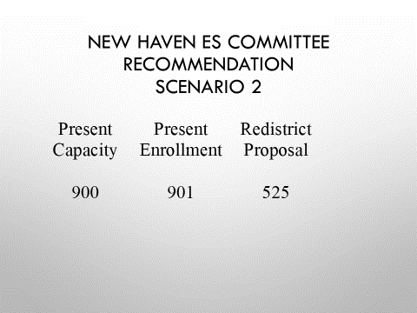

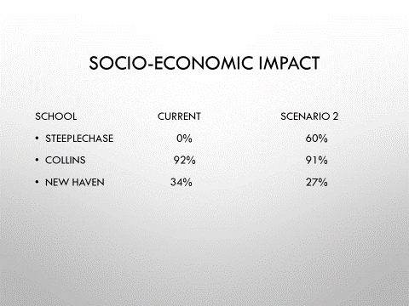

IV. ADJOURN
- A motion was made by Troy Fyrman, seconded by Dr. Maria Brown, to adjourn the meeting. Karen Byrd, Dr. Dr. Maria Brown, Julia Brown, Troy Fryman and Matt McIntire voted, “aye” MOTION: The motion passed 5-0.

Meeting was adjourned at approximately 8:29 pm.

____________________________________
Matt McIntire /Chairperson

_____________________________________
Karen Evans/Secretary

