Special Meeting AdvancEd Accreditation Report Boone County Board of Education
April 26, 2017 3:30 PM
Ralph Rush Professional Development Center
99 Center Street
Florence, Kentucky 41042

I. CALL TO ORDER

The Special Board meeting of the Boone County Schools Board of Education April 26, 2017 was called to order by Chairperson Ed Massie at the Ralph Rush Staff Development Center.
Attendance Taken at 3:30 PM:

Present Board Members:
Dr. Maria Brown
Mr. Ed Massey
Mr. Matt McIntire
Ms. Bonnie Rickert

Absent Board Members:
Ms. Karen Byrd notified the board she was unable to attend due to work.
Karen Evans, Board Secretary, recorded the minutes.

II. PLEDGE TO THE FLAG
II.A. The Pledge to the Flag was led Ed Massey, Chairperson.

III. AdvancEd ACCREDITATION REPORT

Dr. Poe thanked the AdvancEd Accreditation team for their work the past 4 days and the district office personal for working diligently on this improvement process. Dr. Poe, introduced Ms. Tina Woosley, lead evaluator for the AdvancEd team. Ms. Woosley introduced the team.

Ms. Woosley discussed the process of the System Review that had taken place in the last 3 full days in Boone County. Ms. Woosley gave an overview of the AdvancEd, the global leader in providing continuous improvement and accreditation services to over 32,000 institutions serving 20 million students worldwide. She discussed the 2017 External Review Teams process of visiting schools and interviewing over 88 stakeholders. The External Review Team results in powerful practices, opportunities for improvement, index of education quality, and accreditations recommendation. The results were given with a powerpoint presentation to the board.

The team examined student performance results, instructional quality, learner and family engagement, support services for student learning, curriculum quality and efficacy, and college and career readiness data. The findings of Powerful Practice 3.2 – Monitoring and adjusting curriculum, instruction, and assessment throughout the system in response to data from multiple assessments of student learning and examination of professional practice has been identified as a primary emphasis. Powerful Practice 3.12 –the system and its schools provide and coordinate a wide array of learning support services to address the unique learning needs of all students. Improvement Priority 5.4 – Implement scheduled program review cycles to formally evaluate program impact, utilizing verifiable data for continuous improvement.

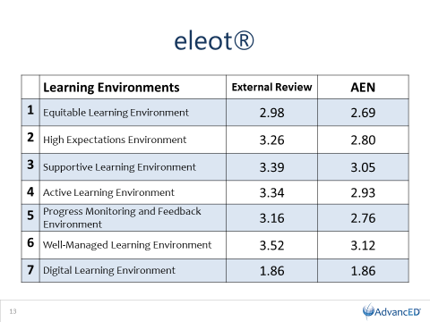

Findings Powerful Practice 1. 4- Leadership demonstrates a conscientious and united effort toward student empowerment by creating authentic learning using innovative and differentiated strategies. Powerful Practice 2.4- Leadership and staff foster a dynamic and intentional culture consistent with the system’s purpose and direction. Powerful Practice 4.4- Strategic resource optimization practiced by the system includes multi-faceted long-range planning in support of system goals of student empowerment and providing a world-class education.

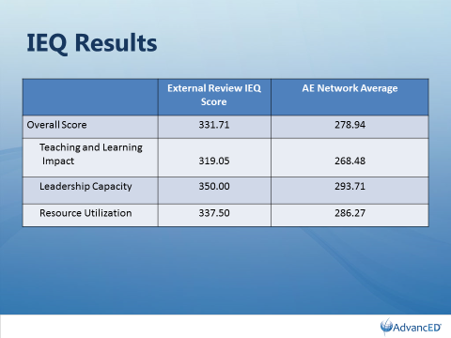

Ms. Woosley reported the IEQ results indicate that Boone County is performing within acceptable ranges as compared to expected criteria as well as other institutions in the AdvancEd network.

Ms. Woosley congratulated Boone County on their results and the External Review Team recommended to the AdvanceEd Accreditation Commission that the Boone County School System earn the distinction of accreditation by AdvanceEd for another 5 years. The Index of Education Quality (IEQ) overall external review IEQ score of 331.71 for Boone County Schools with the AE Network Average of 278.94.

Dr. Poe expressed his appreciation and pride for the district with the accreditation and thanked the administrators, staff, students and community. Ed Massey spoke on behalf of the board and thanked the team for their time and the district staff and students for a great job in making this district the great district that it is. Both thanked the Accreditation team for their time and appreciated having outside eyes of educators reviewing our district.

IV. ADJOURN

- A motion was made by Bonnie Rickert, seconded by Matt McIntire, to adjourn the meeting. Bonnie Rickert, Maria Brown, Ed Massey and Matt McIntire voted, “aye” MOTION: The motion passed 5-0.

Meeting was adjourned at approximately 3:50 pm.

_____________________________________
Ed Massey /Chairperson

_____________________________________
Karen Evans/Secretary

