LEASE AGREEMENT

Spencer County Public Schools will be entering into a one-year agreement to rent the property located at 101 Garrard Street, Taylorsville, KY to be used as a bus garage.

Terms of agreement will be:

Lease of the property will be on a month to month basis. A thirty day notice is required prior to vacating the building or ending the lease agreement. The term will be for the fiscal year July 1, 2021 through July 31, 2021 at a rate of $1800 per month. The payment will be made by the 15th of each month.

Spencer County Board of Education will pay the utilities including water, phone, gas heat, KU Electric and garbage pick up. The utility accounts shall be in the name of Spencer County Board of Education.

The owner will be responsible for the external and internal repair to the building and property insurance for the building. Insurance of contents is the responsibility of the Spencer County Board of Education. Any damage to the building by the occupant will be taken care of by the Spencer County Board of Education. Any necessary repairs should be reported to the owner in a timely manner.

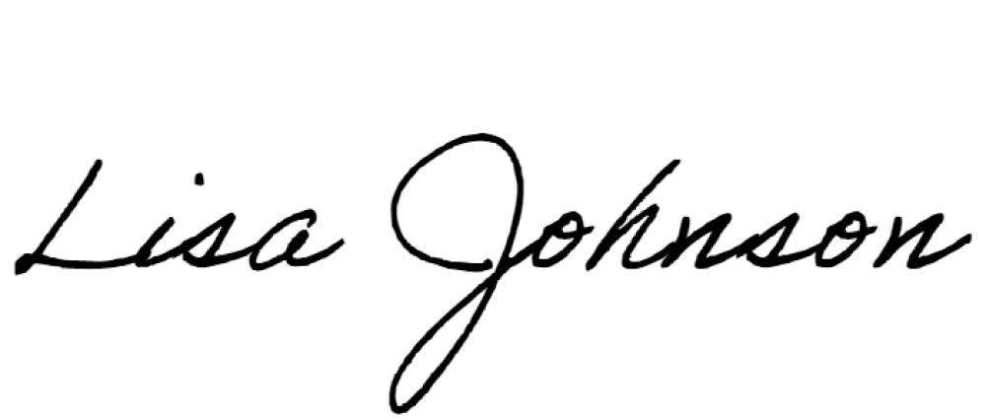
____________________________________ _____________________________
Spencer County Board of Education Lisa Johnson
Charles Adams, Superintendent

Date ________________________________ Date_________________________

Lisa Johnson
3897 Briar Ridge Rd.
Mt. Eden, KY 40046 (502) 902-7016 cell
(502) 477-8137 work
Llewisb63@gmail.com

