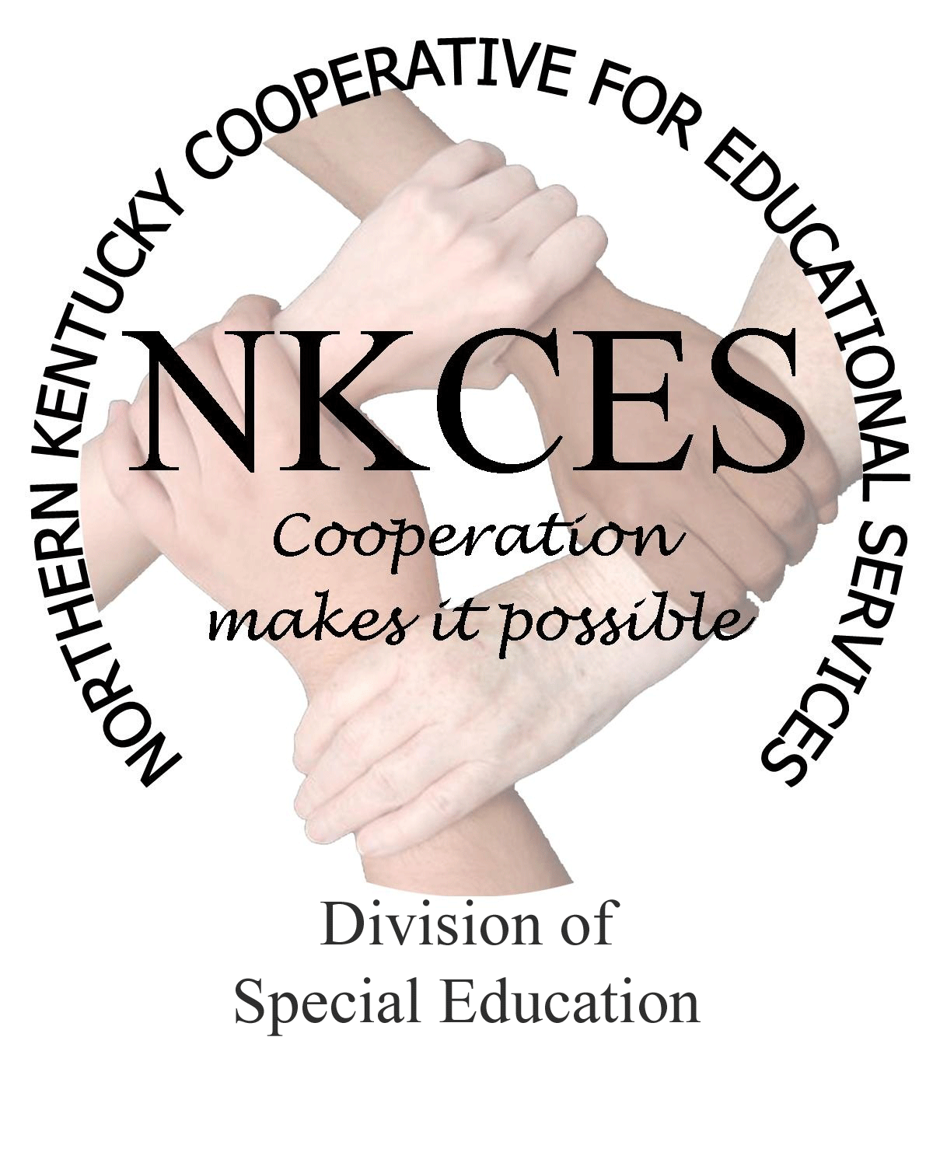
Northern Kentucky Cooperative for Educational Services, Inc.

Member Districts

Beechwood Independent • Bellevue Independent • Boone County • Campbell County

Covington Independent • Dayton Independent • Erlanger-Elsmere Independent

Ft. Thomas Independent • Kenton County • Ludlow Independent • Newport Independent

Pendleton County • Silver Grove Independent • Southgate Independent

Walton-Verona Independent • Williamstown Independent

August 14, 2014, 2014

Curtis Hall, Executive Director
NKCES
5516 E. Alexandria Dr.
Cold Spring, KY 4-176

Re: Superintendents Report

Dear Curtis:

It remained our soul purpose and goal to continue our work throughout the summer months. This effort proved to be successful as we supported and met the needs of our districts regarding the plans we collaborated during our spring district meetings. The following is a synopsis of our staff’s activity, which we are confident assisted in closing the gap in our region.

- Consultants Retreat
- Explored and identified regional and school data to identify schools, with the largest gap, in order to assist specific schools in literacy and math
- Revised the state logic model to reflect our 2014-15 work
- Training evaluations using Google docs
- PGES-student growth goals/co-teaching/integrated into trainings
- Differentiated instruction intertwined within all trainings
- Orton Gillingham training
- The training brought in 36 participants for a full week of training
- Para educator training
  - Para Ed Assistants were given training that connected the standards to the work they do each day with students
  - Total attendance for this training was 276
> Summer Institute
- A total of 40 sessions were offered with an average of 100 people attending each day. Also, a Transition Road trip was offered to districts staff’s with a total of 15 attendees
> Data Retreat
- Erlanger - Elsmere School district participated with a total of 60 staff members receiving training in the data process
> Other trainings and planning sessions
- Literacy/ math/low incidence/early childhood trainings and planning sessions were offered on a request basis to different districts throughout the summer
- NKCES Staff training
- The director and consultants attended several trainings throughout the state bringing the most updated trainings and information to our region

As the 2014 – 2015 school year begins, the consultants and I have already hit the ground running as we have continued to collaborate and gear up for this year’s work. As always, we are excited about implementing our plans as we are assured and confident that 2014 – 2015 will be productive and a successful school year. We welcome all our district’s to contact us if they need or desire trainings, technical assistance, walk-throughs, or any other areas where we can provide our expertise to their staff.

Sincerely,

Linda Alford
NKCES, Regional Director of Special Education

