THIS IS A DECISION PAPER
TO: HARDIN COUNTY BOARD OF EDUCATION
FROM: TERESA MORGAN, SUPERINTENDENT
DATE: OCTOBER 5, 2023
SUBJECT: APPROVAL OF LAND PURCHASES FOR NEW WEST HARDIN
MIDDLE
FACTS:
In order to construct a new West Hardin Middle School adjacent to Cecilia Valley Elementary, the Board needs to procure additional land and road access for a suitable building site
Buchanan Property 1.461 acres 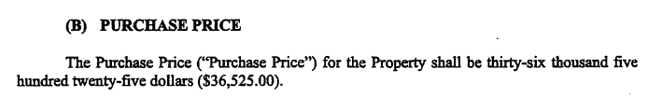
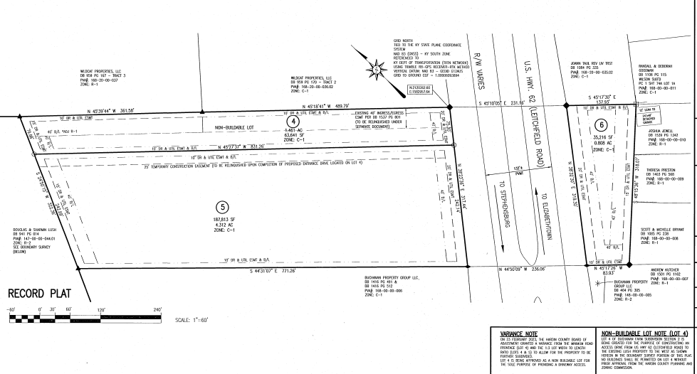

Lush Property 31 Acres ($465,000)
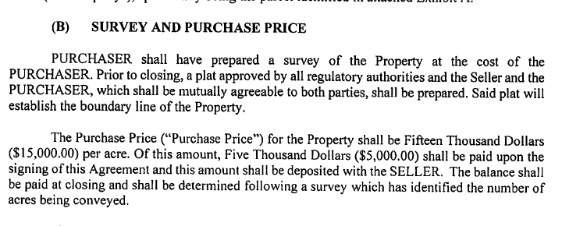

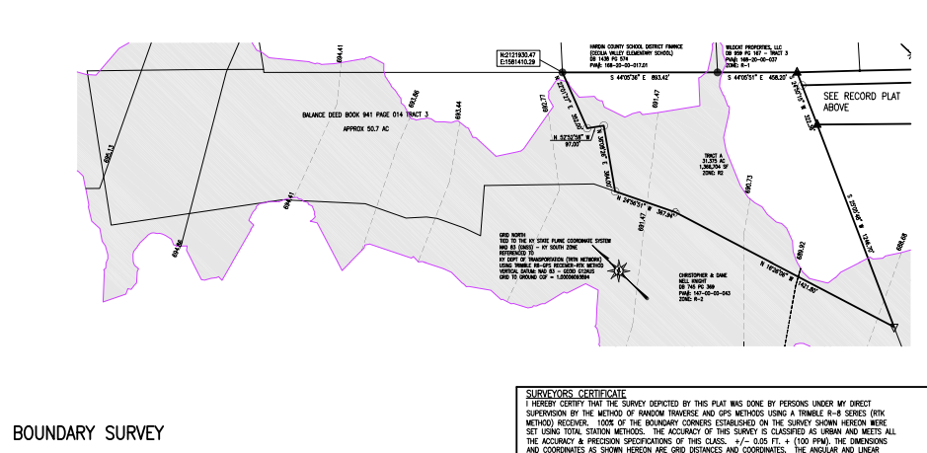

New West Proposed Layout
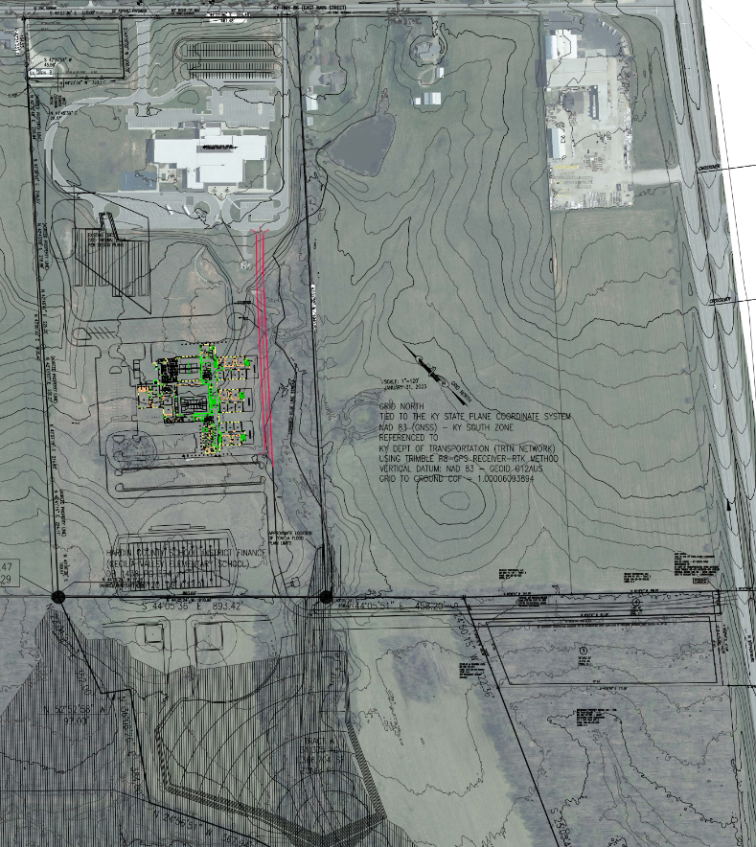
*See attached purchase agreements and record plat/boundary survey.

RECOMMENDATION
I RECOMMEND THE BOARD APPROVE THE PURCHASE OF 1.5 ACRES FROM THE BUCHANAN PROPERTY GROUP and 31 ACRES FROM DOUGLAS AND SHARMAN LUSH AS SHOWN ON THE RECORD PLAT OF BUCHANAN FARM SUBDIVISION SECTION 2 AND BOUNDARY SURVEY OF DOUGLAS AND SHARMIN LUSH PROPERTY.
RECOMMENDED MOTION
I MOVE THE BOARD APPROVE THE PURCHASE OF THE TWO PROPERTIES (32.5 ACRES) FOR A TOTAL PRICE OF $501,525.

