John Hardin SBDM Council
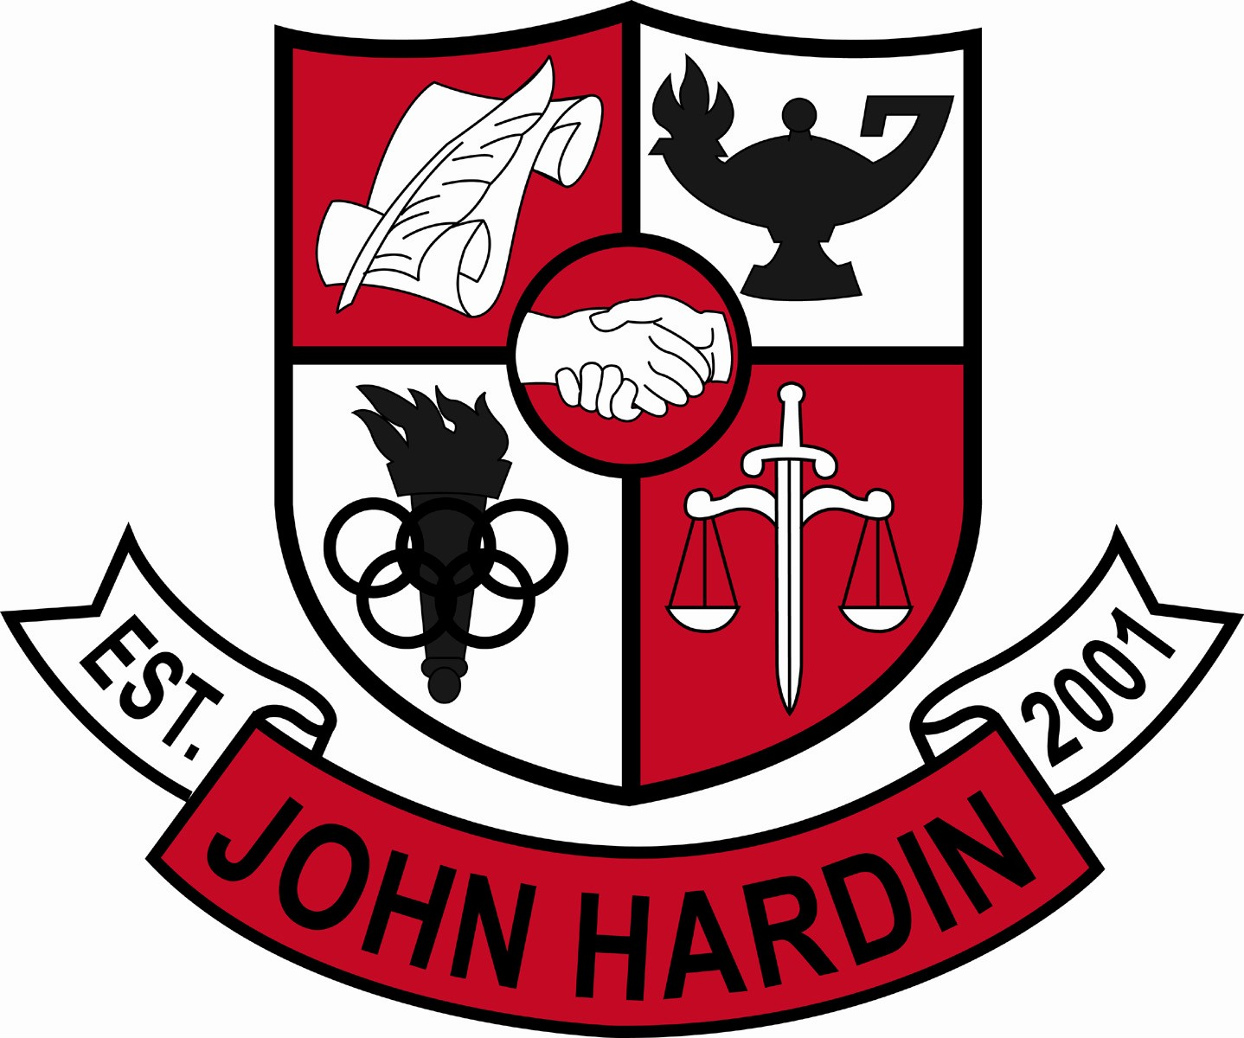
Meeting Minutes

August 14, 2014
4:00 p.m.

- Call to Order at 4:04 p.m.
Members present: Patrick Avery, Jana Haws, Stacey Moore, Pauline Crittenden, and Lynne Gibson. Members absent: Alex Shearer
Visitors present: Bobby Lewis
- Approval of Agenda ORDER #14-15/0001
The council approved the agenda as written.
Motion: Avery Second: Crittenden
Avery - Yes
Crittenden – Yes
Gibson – Yes
Haws – Yes
Moore – Yes
Shearer - Absent
- Approval of Minutes ORDER #14-15/0002 The council approved the minutes as written.
Motion: Moore Second: Haws
Avery - Yes
Crittenden – Yes
Gibson – Yes
Haws – Yes
Moore – Yes
Shearer - Absent
- Principal’s Update
- PGES – full swing with Stace McElfresh taking the lead due to his experience at previous school
- SBDM Minority Elections – need to elect a minority teacher rep and a minority parent rep
- Enrollment Numbers – we are at 1000 students right now
- Assessment Update – ACT Scores from last year’s juniors = 20.1; On Demand Writing scores showing up comparable to district percentages; Power Hour has really helped
- Student Achievements - Magnolia Farms project “Green Garden”; raising tilapia fish, bee hives and lettuce. FFA Chapter was named a three star chapter again
- Financial Report ORDER #14-15/0003
The council reviewed and accepted the financial report for June.
Motion: Avery Second: Moore
Avery - Yes
Crittenden – Yes
Gibson – Yes
Haws – Yes
Moore – Yes
Shearer – Absent
ORDER #14-15/0004
The council reviewed and accepted the financial report for July.
Motion: Moore Second: Avery
Avery - Yes
Crittenden – Yes
Gibson – Yes
Haws – Yes
Moore – Yes
Shearer – Absent
- Budget for 2014-15 ORDER #14-15/0005
The council approved the budget as submitted.
Motion: Moore Second: Avery
Avery - Yes
Crittenden – Yes
Gibson – Yes
Haws – Yes
Moore – Yes
Shearer – Absent
- Personnel
Vacancies: Currently have a Health and PE position vacant
Hired: Numerous hires over the summer
- Questions and Concerns from Council
- Cell phones/electronic devices/headphones have shown an enormous growth in use/abuse; not only distracts that student but others around them. Would love to see them prohibited but would appreciate stiffer penalties at a minimum; Would like to poll staff on their thoughts of changing the policy and enforcing it.
- Would like to create a policy for Final Exam Schedule; proposal will be sent out with cell phone survey
- Agenda Items for Next Meeting
- Exam Schedule Policy Proposal
- Cell Phone Survey
- Adjourn
The meeting was adjourned at 5:20 p.m. The motion was made by Mr. Avery and seconded by Ms. Moore

