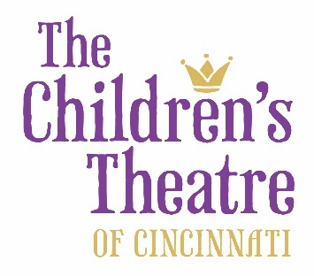

Performance Contract

Order # 2018114 PO# 10932-OE
TCT Offices
4015 Red Bank Road
Cincinnati, OH 45227

Ockerman Elementary
Ms. Kimble Best
8250 US 42
Florence, KY 41042

Show  Date Time | Student Tickets |  | Comp  Tickets |  |  |  | Chaperone  Tickets
Santa Claus: The Musical  12/12/2018 9:45am | 608 |  | 40 |  |  |  | 2

September 4, 2018

Dear Ms. Best

Thank you for submitting your order and choosing to be a part of The Children’s Theatre of Cincinnati’s 18/19 season!

Your booking is not considered “confirmed” until this agreement is signed and returned to TCT. If this contract is not received after 7 days, TCT reserves the right to release the performance dates and/or seats to others. Deposit: A 50% deposit is due at the time of booking. You may either send the deposit payment with this agreement or send as soon as possible after returning this agreement. If your district requires a Purchase Order for payments, I must have the PO number before your group’s seating can be held and your order fully completed. Your total balance due is $4880 Payment received to date $0

Payment Details: Full payment for all programs must be made no later than 30 days prior to your performance date (see date above). Please make your controller/treasurer aware of the need to arrange prompt payment. Cancellations or adjustments to your reservation (including changes in reserved seats) may only be made up to that point, 30 days prior. It is the responsibility of the teacher or contact to be aware of performance dates and deadlines related to his or her reservation(s). After 30 days prior, TCT will consider the reservation final and the school/customer will be responsible for full payment of all seats reserved, no exceptions. If a program is booked within 30 days of the performance date, full payment must be made immediately.

PLEASE NOTE: Payments received after the deadline will be charged a 5% late fee.

If your order information should change, updates MUST be submitted via email to pam.young@tctcincinnati.com. Your update should include the following information:

*# of students, # of complementary chaperons (1 for every 15 students), # of paid chaperones (same price as student)*

Children under three years of age will not be permitted into The Children’s Theatre MainStage performances except for Home School designated performances on Mondays at 1:00 pm.
Cancellation: All bookings are non-refundable and non-exchangeable. The exception being if a show is cancelled due to inclement weather, serious actor illness or other emergency. In this instance TCT will make every effort to reschedule your group during the current season, and only if unable to do so will then refund your order. If your school is closed but the show is not cancelled you will still be responsible for payment. TCT will still make every effort to reschedule your group during the current season but such a change is not guaranteed.

Credit cards, checks and cash are accepted (POs are not acceptable as final payments). Checks payable to TCT. TCT is a 501(c)(3) Non-profit organization. EIN # 31-6026285. Any questions regarding payments should be directed to Pam Young (513) 569-8080 ext. 26 or pam.young@tctcincinnati.com. Fax completed contract to 513-569-8084 or email a scanned copy to pam.young@tctcincinnati.com.

Again, thank you for your order. We look forward to seeing you and your students this year and in the seasons to come!

Accepted and Agreed: ___________________________________ _____________________________________
Signature of School Contact Print Name
_________________________
Date

