Regular Meeting Boone County Board of Education
February 08, 2018 7:30 PM
Ralph Rush Professional Development Center
99 Center Street
Florence, Kentucky 41042

I. CALL TO ORDER

The Regular meeting of the Boone County Schools Board of Education February 08, 2018 was called to order by Chairperson Bonnie Rickert at the Ralph Rush Staff Development Center.
Attendance Taken at 7:30 PM:

Present Board Members:
Dr. Maria Brown
Ms. Karen Byrd
Mr. Ed Massey
Mr. Matt McIntire
Ms. Bonnie Rickert

Gerry Dusing attended as Board Attorney
Karen Evans, Board Secretary, recorded the minutes.
Dr. Randy Poe was not in attendance, he was attending the CZI Superintendent Conference. Eric McArtor, Deputy Superintendent, presided over the meeting.

II. NATIONAL ANTHEM
II.A. The National Anthem was presented by students from Conner High School Women's Choir.

III. PLEDGE TO THE FLAG
III.A. The Pledge to the Flag was led by students from Stephens Elementary.

IV. STUDENT BOARD MEMBER REPRESENTATIVE REPORT
IV.A. Bryan Padilla gave the Student Board Member Representative report. Bryan reported on the Councils starting the work of the Healthy Choice Campaigns in the elementary schools. He discussed the Drug Free Clubs in all high schools and encouraged parents to have their students get involved in this worthwhile group. Bryan discussed the nomination for Student Board Member Representative will be at the next Student Advisory meeting in March, since his term ends in May.

V. GOOD NEWS
V.A. The board recognized and congratulated the 2018 February Break the Mold Winner, Ms. Laurie Willis, Special Education Teacher, Gray Middle School.
V.B. Mrs. Sarah Wolfe, new Director of Comprehensive Health Services was introduced to the board.
V.C. The board recognized and congratulated the 2018 Kentucky School Counselor of the Year, Ms. Meredith Palmer, Longbranch Elementary.
V.D. Energy Star Schools Recognition: The following schools were presented with the Energy Star Award - Conner Middle School, Burlington Elementary, Florence Elementary, Kelly Elementary, Longbranch Elementary, Stephens Elementary and Thornwilde Elementary
V.E. The board recognized and congratulated the 2018 February Sportsmanship Award Recipients.
Morgan Black of Boone County High School
Trevor Corts of Conner High School
Nathan Byrd of Cooper High School
Samantha Duty of Ryle High School

- Ed Massey discussed the Stars of Hope program where local business gave to the program to purchase wooden stars that were painted by our students. The stars where given to the Marshall County School District and community as an encouragement of hope and to let them know that all of Kentucky was thinking of their community. The students painted messages of hope and these stars are placed around the Marshall Community. Mr. Massey expressed his gratitude to the local business and Ehmet Hayes for their support of this Project Based Learning program. A short video was shown of the students painting the stars and what it meant to each to be a part of the program.

VI. AUDIENCE OF CITIZENS
Jennie, concerned parent, asked the board to look into a vendor that is used called Bio Corporation and the unethical treatment of pigeons for use as dissection species. She discussed the manor as to how the pigeons are killed and asked the board use digital dissection because it was as effective as hands-on dissection. She also asked that students have a vote.
Dr. Maria Brown, discussed the use of animal dissection in the classrooms and how she as a College Professor does use both methods and both are found to be beneficial. Ms. Brown, discussed the use of dissection in the biology classes is an SBDM decision.

VII. RECOMMENDED ACTION - CONSENT AGENDA

Eric McArtor, Deputy Superintendent, recommended the following Consent Agenda items A- EEE for Board approval., as presented.

- A motion was made by Karen Byrd, seconded by Maria Brown, to approve the consent agenda items A-EEE, as presented. Matt McIntire, Karen Byrd, Maria Brown, Bonnie Rickert and Ed Massey voted, “aye” MOTION: The motion passed 5-0.

VII.A. Minutes of the regular board meeting of January 11, 2018.
The board approved the minutes of the regular board meeting of January 11, 2018, as presented.
VII.B. Bill List
VII.C. Treasurer's Report was given by Linda Schild.
VII.D. Leaves of Absence
The board approved following persons submitted leave of absence requests, as presented:
Recommended by Principal/Supervisor for approval:
Back, Shannon Lea, Teacher @ Conner MS, 1/8/2018 -02/05/2018
Bishop, Molly, Teacher @ Camp Ernst MS, 1/17/2018 – 02/09/2018
Blank, Leslie, Bus Duty Aide @ Ockerman ES, 12/7/2017 – 12/19/2017
Alvarado Chavero, Alejandra, Teacher @ Ryle HS, 2/13/2018 – 3/8/2018
Day, David. Bus Driver @ Transportation, 1/18/2018 – 2/16/18
Dierken, Christen, Teacher @ Yealey ES, 1/18/2017 – EOY
Duncan, Martha, Teacher @ Mann ES, 02/20/2018 – 5/04/2018
Ebert, Shannon, Cafeteria @ RA Jones MS, 03/22/2018 – 5/3/2018
Embry-Walker, Nedra, Bus Driver @ Transportation, 1/17/2018 – 2/2/2018
Farrell, Sena, Bus Driver @ Transportation, 12/12/2017 – 03/22/2018
Henry, Elizabeth, Teacher @ Collins ES, 04/04/2018 – EOY
Herald, Cheri, Para Educator @ North Pointe ES, 11/27/2017 – 12/8/2017
Jackson, Kelly, Teacher @ North Pointe ES, 1/3/2018 - EOY
Nielson, Marion, Para Ed @ Ockerman MS, 2/2/2018 – 3/8/2018
Sullivan, Anita, Cafeteria Aide @ Erpenbeck ES, 1/29/2018 – 03/09/2018
Whaley, Danelle, Teacher @ Ryle HS, 1/17/2018 – 03/12/2018
Not Recommended by Principal/Supervisor for approval:
Nothing to Report
Amended Leaves:
Dziad, Lynn, Bus Driver @ Transportation, 8/14/2017 – EOY
Hall, Barabara, Cafeteria @ Goodridge ES, 8/16/2017 – 4/18/2018
Hathorn Schaub, Danielle, Para Ed @ Collins ES, 11/15/2017 – 2/2/2018
Holt, Rebecca, Bus Driver @ Transportation, 11/15/2017 – 02/12/2018
Hunter, Robert Bus Driver @ Transportation, 10/10/2017 - 3/5/2018
Jones, Sylvia, Staff Support @ Camp Ernst MS, 12/13/2017 – 01/17/2018
Kellinghaus, Delilah, Teacher @ Conner MS & Conner HS 1/8/2017 – 01/16/2018
Lake-Brooks, Stephanie, Bus Driver @ Transportation, 9/25/2017 – 1/15/2018
Moore, Randy, Custodian @ Stephens ES, 11/28/2017 – 04/12/2018
Simpson, Angela, Cafeteria @ Boone County High School 12/18/2017 – 2/5/2018
Warner, Megan, Teacher @ Thronwilde ES, 11/30/2017 – 01/19/2018
Cancelled Leaves:
Axon, Melissa, Para Ed @ Ockerman Middle School, 12/13/2017 – 3/8/2018

VII.E. Simplicety Program Collins Elementary
The board approved the Simplicety Program for Collins Elementary, as presented.
VII.F. Plan Ahead Smiles Program, SES, YES, OES
The board approved the Plan Ahead Smiles Program at SES, YES, OES, as presented.
VII.G. Big Smile Dental Program Boone County High School
The board approved the Big Smile Dental Program Boone County High School, as presented.
VII.H. Memorandum of Agreement-Boone County Schools and Women's Crisis Center
The board approved the Memorandum of Agreement-Boone County Schools and Women's Crisis Center, as presented.
VII.I. Thomas More College Standard Education Affiliation Agreement
The board approved the Thomas More College Standard Education Affiliation Agreement, as presented.
VII.J. NWEA OECD Advisory Board Meeting
The board approved Dr. Randy Poe to attend the NWEA OECD Advisory Board Meeting in Washington, DC on March 21 & 22, 2018, with expenses for travel provided by NWEA OECD, as presented.
VII.K. Access to Change Conference & KSBA LEAD Event
The board approved Ed Massey and Randy Poe to attend Access to Change Conference on Feb. 23 & 24, 2018 & KSBA LEAD Event on Jan. 31 and Feb. 1, 2018, as presented.
VII.L. FRYSC Grant District Assurance
The board approved the FRYSC Grant District Assurance Page, as presented.
VII.M. Approval of Final Project Closeout BG-5 Boone County High School HVAC Upgrade BG#15-062
The board approved the Final Project Closeout BG-5 Boone County High School HVAC Upgrade BG#15-062, presented.
VII.N. 2018 KETS Offer of Assistance
The board approved the 2018 KETS Offer of Assistance, as presented.
VII.O. SFCC Offer of Assistance
The board approved the SFCC Offer of Assistance, as presented.
VII.P. Bidding Documents and BG-3 for ATC Ventilation System BG#18-177
The board approved the Bidding Documents and BG-3 for ATC Ventilation System BG#18-177, as presented.
VII.Q. Bidding Documents and BG-3 for Paving 2018 Project BG#18-233
The board approved the Bidding Documents and BG-3 for Paving 2018 Project BG#18-233, as presented.
VII.R. Change Order #9 Ryle High School Addition/Renovations BG#15-281
The board approved the Change Order #9 Ryle High School Addition/Renovations BG#15-281, as presented.
VII.S. Financial Auditor Services Renewal
The board approved the Financial Auditor Services Renewal with Barnes Dennig, as presented.
VII.T. Ballyshannon Middle School Furniture RFP
The board approved the Ballyshannon Middle School Furniture RFP, as presented.
VII.U. Surplus Technology
The board approved the technology items in the warehouse as surplus and dispose of according to board policy, as presented.
VII.V. Surplus Equipment
The board approved the old equipment items in the Warehouse as surplus and to dispose of according to board policy, as presented.
VII.W. Settlement of Threatened Litigation
The board approved the matter which involves a parent claim of Title VI violation. Our attorneys recommend settlement. The cost of the settlement is for less than the estimated cost of defense, is paid by the liability insurance carrier after the Board's deductible and there is a denial of liability, as presented.
VII.X. Ignite Institute Fiber Bid
The board approved the Ignite Institute Fiber Bid from Cincinnati Bell, as presented.
VII.Y. Gasoline and Diesel Bid Renewal
The board approved the gasoline and diesel renewal, as presented.
VII.Z. Ballyshannon Middle School Fiber Bid
The board approved the Ballyshannon Middle School Fiber Bid to Cincinnati Bell, as presented.
VII.AA. Annual Commissioning Services RFP
The board approved the Annual Commissioning Services RFP with ZH Commissioning, as presented.
VII.BB. Agreement with Transportation Cabinet and Boone County High School for the Alive at 25 Defensive Driving Course
The board approved the agreement with Transportation Cabinet and Boone County High School Alive at 25 Defensive Driving Course, as presented.
VII.CC. Petermann Bus Service - Conner Middle School
The board approved the Petermann Bus Service for Conner Middle School, as presented.
VII.DD. Miller Transportation Agreement for District Robotics St. Louis Competition
The board approved the Miller Transportation Agreement for the District Robotics team to St. Louis Competition, as presented.
VII.EE. Miller Transportation Agreement for District Robotics Team to Cleveland Competition
The board approved the Miller Transportation Agreement for District Robotics Team to Cleveland Competition in March , as presented.
VII.FF. Sales Campaign Approvals
The board approved the Sales Campaigns, as presented.
VII.GG. Queen City Transportation Agreement for Conner Middle School
The board approved the Queen City Transportation Agreement for Conner Middle School, as presented.
VII.HH. Croswell Motorcoach Service Agreement for Conner High School
The board approved the Croswell Motorcoach Service Agreement for Conner High School for August, as presented.
VII.II. Agreement for Slam Dunk Sports Marketing for Cooper High School
The board approved the Agreement for Slam Dunk Sports Marketing for Cooper High School, as presented.
VII.JJ. Queen City Transportation Agreement for Conner High School
The board approved the Queen City Transportation Agreement for Conner High School for March, as presented.
VII.KK. Lifetouch Yearbook Publication Agreement with Cooper High School
The board approved the Lifetouch Yearbook Publication Agreement with Cooper High School, as presented.
VII.LL. Agreement between Madison Event Center and Cooper High School Senior Dinner
The board approved the Agreement between Madison Event Center and Cooper High School Senior Dinner, as presented.
VII.MM. Agreement between Receptions, Inc. and Conner High School
The board approved the Agreement Between Receptions, Inc. and Conner High School Character Counts Recognition Dinner, as presented.
VII.NN. Agreement Between Self Diploma DJ and Cooper High School
The board approved the Agreement Between Self Diploma DJ and Cooper High School, as presented.
VII.OO. Bid Award and Revised BG-1 for Stephens and Collins Elementary HVAV Upgrades BG#17-121
The board approved the Bid Award and Revised BG-1 for Stephens and Collins Elementary HVAV Upgrades BG#17-121, as presented.
VII.PP. Bid Award and Revised BG-1 for Gray Middle School-MEP Upgrades BG#17-121
The board approved the Bid Award and Revised BG-1 for Gray Middle School-MEP Upgrades BG#17-121, as presented.
VII.QQ. Approval of Contract Closeout BG-4 Boone County High School HVAC Upgrades BG#15-062
The board approved the Contract Closeout BG-4 Boone County High School HVAC Upgrades BG#15-062, as presented.
VII.RR. Change Order #6 Ballyshannon Middle School BG#15-279
The board approved the Change Order #6 Ballyshannon Middle School BG#15-279, with the addition of $20,483.00 as presented.
VII.SS. Millennium Business Systems and Yealey Elementary Agreement
The board approved the Millennium Business Systems and Yealey Elementary Agreement of printers, as presented.
VII.TT. Agreement between Franklin Covey Client Sales, Inc. and Stephen's Elementary-Leader in Me Program.
The board approved the Agreement between Franklin Covey Client Sales, Inc. and Stephen's Elementary-Leader in Me program, as presented.
VII.UU. Agreement between Stephens Elementary and Boosterthon Fun Run
The board approved the Agreement between Stephens Elementary and Boosterthon Fun Run, as presented.
VII.VV. Ignite Institute Support Contracts
The board approved the Ignite Institute Support Contracts, as presented.
VII.WW. Croswell Motorcoach Services-Yealey
The board approved the Croswell Motorcoach Services for Yealey Elementary, as presented.
VII.XX. Queen City Transportation For Cooper High School

The board approved the Queen City Transportation for Cooper High School, as presented.
VII.YY. Executive Transportation Agreement for Conner Middle School
The board approved the Executive Transportation Agreement for Conner Middle School for State Archery Tournament, as presented.
VII.ZZ. Bidding Documents and BG-3 for Bus Garage/Facility Management Generators BG#17-280
The board approved the Bidding Documents and BG-3 for Bus Garage/Facility Management Generators BG#17-280, as presented.
VII.AAA. NSBA & KSBA Conferences 2018 Superintendent and Board Members
The board approved the travel expenses for the NSBA & KSBA Conferences 2018 for the Superintendent and Board Members attending, as presented.
VII.BBB. Chan Zuckerberg Initiative (CZI) Conference Randy Poe
The board approved Randy Poe to attend the Chan Zuckerberg Initiative (CZI) Conference on Feb. 8 & 9th, with expenses paid by CZI, as presented.
VII.CCC. The Happiness Advantage-Orange Frog Educator's Use and Development Rights Agreement and the License Rights and Use Agreement for the Happiness Advantage-Orange Frog Intellectual Property
The board approved The Happiness Advantage-Orange Frog Educator's Use and Development Rights Agreement and the License Rights and Use Agreement for the Happiness Advantage-Orange Frog Intellectual Property, as presented.
VII.DDD. Field Trips
The board approved the Field Trips, as presented.

School | Date Of Trip | Location | Reason
Conner High School | August 6-8, 2018 | Camp Carlisle | Soccer Team Training Camp
Conner High School | March 15, 2018 | Louisville | Orchestra Assessment
Conner Middle School | March 15, 2018 | Louisville | Orchestra Assessment
Conner Middle School | March 30, 2018 | Louisville | State Archery Tournament
Conner Middle School | February 19 & February 20, 2018 | Fairfield, OH | Educational
Cooper High School | March 26, 2108 | Louisville | Educational
District Robotics Team | March 7-10, 2018 | St. Louis, MO | Competition
District Robotics Team | March 28-31, 2018 | Cleveland, OH | Competition

VII.EEE. Surplus at Ignite Institute
The board approved the Surplus Property at the Ignite Institute, as presented.

VIII. RECOMMENDED ACTION - OLD BUSINESS
VIII.A. No Old Business

IX. RECOMMENDED ACTION - NEW BUSINESS

IX.A. Allocation Formulas for 2018-2019
Eric McArtor, Deputy Superintendent, recommended the board to approve the Allocation Formulas for 2018-2019 school year with the inclusion of the following: Minus one (-1) Certified, minus one (-1) Administrator and minus one (-1) Classified will be taken from the total allocation, pending the outcome of the budgetary session with the General Assembly, as presented.

- A motion was made by Ed Massey, seconded by Karen Byrd, to approve the Allocation Formulas for 2018-2019 school year with the inclusion of the following: Minus one (-1) Certified, minus one (-1) Administrator and minus one (-1) Classified will be taken from the total allocation, pending the outcome of the budgetary session with the General Assembly, as presented. Matt McIntire, Karen Byrd, Maria Brown, Bonnie Rickert and Ed Massey voted, “aye” MOTION: The motion passed 5-0.

- Eric McArtor discussed the proposed Governors cut and how this could impact our district budget. The fiscal year 2019 estimated cuts for the district would be approximately 8 million + dollars. The state budget cuts of 12% to Administration reduction, Transpiration (SEEK)cuts, Employee Health Insurance and CERS match increases. The Education programs targeted for Elimination with the Governor’s budget plan would be Textbooks at over $500,000, Professional Development over $280,000, and Kentucky Teacher Internships less $43,000 and Community Education Programs less $20,000. Mr. McArtor discussed what this will mean for the district, which would include a reduction of approximately 110 positions through teaching staff, which would increase class sizes, eliminate planning periods, etc. to cover classes. There would be an approximate reduction of 50 positions on the district level through Finance, HR, Transportation, Technology, and Maintenance. This could mean transportation elimination of 50 routes, elimination of 14 driving positions, students living within one mile of the school would need to provide their own transportation and no new buses which are desperately needed. As you can see on the formula presented tonight, a 12% reduction of administration, would mean losing an assistant principal or counselor each year, the Allocations presented tonight reflect the minus 1 certified, minus 1 classified and the minus 1 administrator until the budget is finalized with the state legislatures. Mr. McArtor urged the audience and community to call their legislatures and support funding our education system.
- Ed Massey and Matt McIntire discussed recent legislature visits at Frankfort to support public education funding. Both spoke on the Governor’s budget cuts that will be devastating to our education system.

IX.B. 2017-2018 District Improvement Plan Revised
Eric McArtor, Deputy Superintendent, recommended the board to approve the 2017-2018 District Improvement Plan Revised, as presented.

- A motion was made by Karen Byrd, seconded by Ed Massey, to approve the 2017-2018 District Improvement Plan Revised, as presented. Matt McIntire, Karen Byrd, Maria Brown, Bonnie Rickert and Ed Massey voted, “aye” MOTION: The motion passed 5-0.

X. SUPERINTENDENT'S REPORT
- Mrs. Jenny Watson, LSS Assistant Superintendent, gave a detailed powerpoint presentation along with handouts of the Comprehensive District Improvement Plan Executive Summary. Mrs. Watson, explained the Continuous Improvement Process and the 5 required goals of: Proficiency, Gap, Graduation Rate(High School), Growth (Elementary and Middle) and Transition Readiness. Report below:

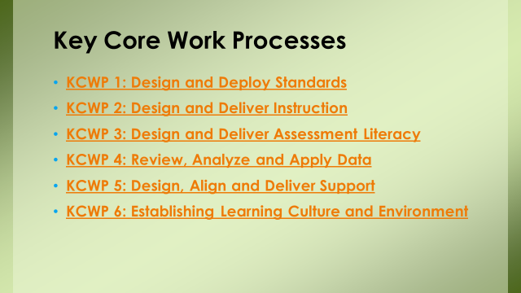

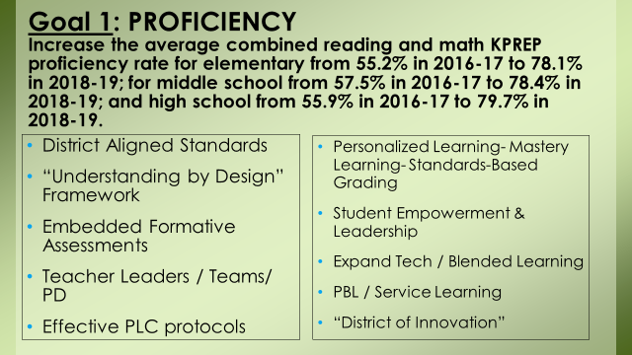

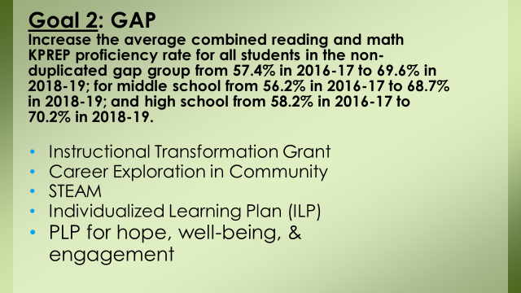
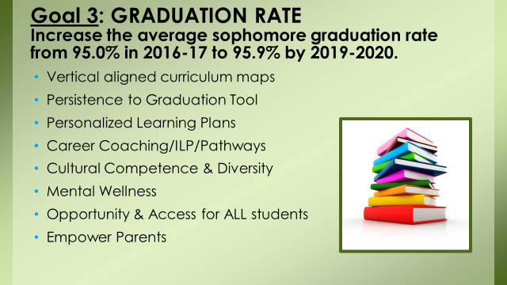
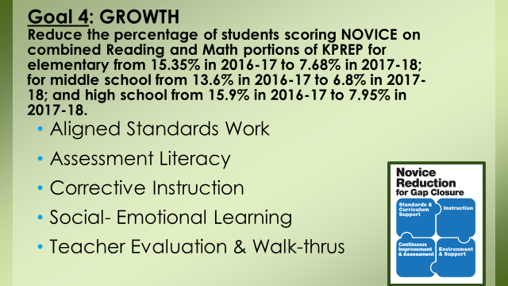
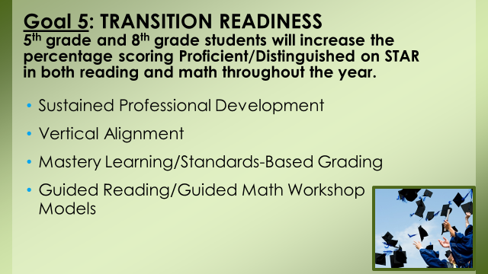

XI. INFORMATION, PROPOSALS, COMMUNICATIONS
XI.A. Human Resource Actions
XI.B. Worker's Compensation Claims
XI.C. Overtime Report
XI.D. Construction Status Report
XI.E. Energy Management Report

XII. AUDIENCE OF CITIZENS
The following Educational Majors College Students introduced themselves to the board: Sadie Moore, Kayla Rowe, Savanna Woods, Ashley Brodeman and Madison Catalano – NKU and Taylor Orsburn of Asbury.

XIII. CLOSED EXECUTIVE SESSION PER KRS 61.810
XIII.A. No closed session

XIV. ADJOURN

4.. A motion was made by Ed Massey, seconded by Maria Brown, to adjourn the meeting. Ed Massey, Bonnie Rickert, Karen Byrd, Maria Brown and Matt McIntire voted, “aye” MOTION: The motion passed 5-0.

Meeting was adjourned at approximately 8:47 pm

_____________________________________
Bonnie Rickert/Chairperson

_____________________________________
Karen Evans/Secretary

