I am writing this letter in support to receive permission to have the Bike Safety Rodeo program here at Collins Elementary. The program is run through The Norton Children's Hospital for Prevention and Wei/ness and is funded through the Children's Hospital Foundation. The rodeo is designed to teach bicycle safety to third,fourth and fifth grade students in Kentucky and Southern Indiana.

Overview:

Focus: Students must be able to ride a 20 inch bicycle independently without training wheels. By riding bicycles through a mini obstacle course, students learn the rules of the road and how to apply them.

Collins Elementary will provide: An indoor or outdoor area measuring at least 100feet by 100 feet that is required to set up the course and conduct the rodeo.

{:ost: Free-the program is funded through the Children's Hospital Foundation.

Duration: 45 minutes needed for each session(40 minute session with five minutes between sessions). We

ore doing only 4t" grade students on Tuesday, 24 1
n
and it will start at 9:00 and end at 3:30.

Students Serveg: Any 41
;-
grade students with a completed and signed permission slip can participate.

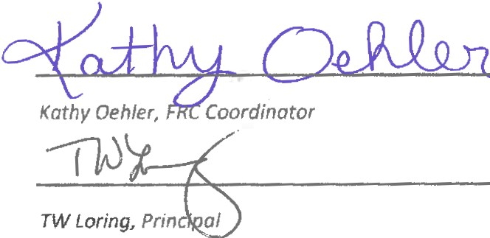Students who do not have a permission slip may watch as long as they are not interfering with the program or distracting the students who ore participating.

I am writing this letter in support ta receive permission to have Big Smiles Dental program here at Collins Elementary. The program is run through Big Smiles Kentucky and is based out of Lexington, KY. A state licensed dentist will come to the school and check the student's mouth & teeth, as well as provide a cleaning, x-rays as necessary,fluoride treatment and apply sealants, as needed. Additional care such as fillings may also be provided. A dental report card is sent home with the student, and this includes /nitiol dental core & follow· up visits. Normally there are two license dentists that provide care to our students.

Overview:

Focus: Students receive dental core at little or no cost. Agency will provide: state licensed dentist.
Collins Elementary will provide: Space during the school day for the dental team to be able to work on
students dental needs. FRC will distribute flyers to parents explaining this service and will mail or fax returned forms to the big smiles facilitators. Once the FRC receives a list from the Big Smiles team, they will look up teacher's names so they can get the students that have signed up for the program.

Cost: Free

Duration: 5-7 days every 6 months depending on the amount of students that wont to receive services. Students Served: At risk students in need of dental services.

0
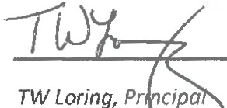Koth y Oehle-;t!);;ordinatar

