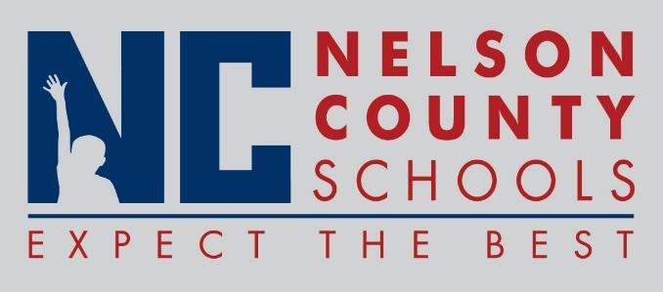

Information Paper
To: | Nelson County Board of Education
From: | Bob Morris Executive Director of Student Support
cc: | Dr. Anthony Orr, Superintendent
Date: | July 18, 2017
Re: | Personnel Notifications

New Hires: Jennifer Moore Teacher CCES
Christena Murphy Teacher BMS
Michella Colby Teacher BMS
Robert Wartschlager Teacher FH
Amy Deaton Teacher NCHS SPED
Kris Murphy Teacher BMS
Colleen Downing Speech District
Traci Wethington Secretary CCES
Josh Bunch Energy MGR District
Michelle Kail Teacher BMS
Kelsey McGuffey Speech Path DIST
Jenna Arnst Teacher Boston
Leslie Catanzarito Teacher FH
Jenny Cox Teacher ELC
Morgan Scrogham FRYSC Asst BES
Traci Wethington Secretary CC
Stacie Vittitow FRYSC Asst NCHS
Tara Boone IA III FH
Zach Allender Teacher NCHS
Elizabeth Dunn Teacher NCHS
Leah Hardin IC District
Michelle Arras Teacher OKH
Aaron Young Teacher NCHS
Joshua Bunch Energy MGR DIST
Beth Bartley Teacher New Haven
Krista Wasson Teacher ELC
Leah Hardin IC District
Samantha Duchschere Teacher OKH
Katie Barnett Teacher ELC
Dee Dee Smith FRYSC Cord DIST

Transfers: Robin Handloser IC Principal OKH

Reinstatements: None

One Year Certification:

Classified Subs:
Certified Substitute:

Student Workers: None

Non-Renewals:

Resignation: Bethany Watkins Speech DIST
Kelly Gray Librarian BMS
Diana Smith Principal CC
Paige Wood AP OKH
Richae Logan Teacher SPED
Stacey Chevalier Teacher ELC
Sarah Wilson Teacher OKH
Derek Shouse Teacher OKH
Emily Pile Teacher ELC

Retirements:

Reprimands/Terminations: None

