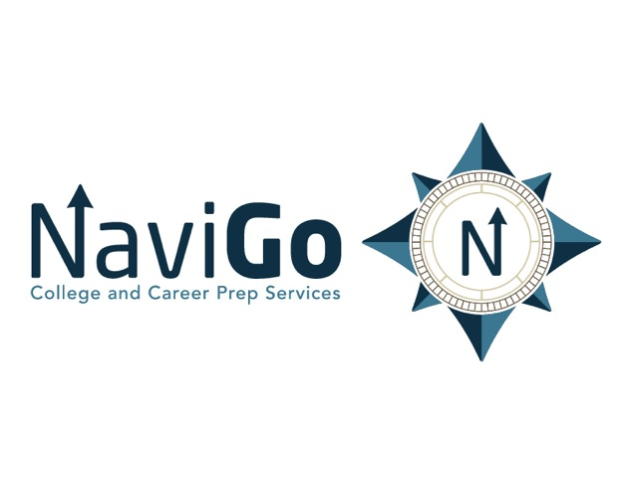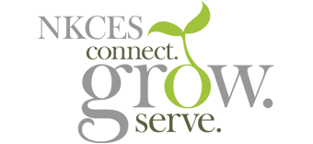

Northern Kentucky NaviGo College and Career Network

The purposes of the Northern Kentucky NaviGo College and Career Network, in collaboration with Northern Kentucky Education Cooperative (NKCES) would include, but not be limited to:
- Providing ongoing access to and services from a NaviGo College and Career Coordinator/Connector for participating NKCES school districts. This position would work in collaboration with NKCES, with training and support from NaviGo. (NaviGo is seeking the majority of the funding for the position via sponsorship and grants.)
- Providing ongoing connections between business/industry and participating school districts - leading to a opportunities for students, educators and businesses (i.e., FAME, Work Ready Scholarships, Teacher Externships)
- Providing ongoing connections between local colleges and universities with participating school districts to further expand dual credit and early college opportunities.
- Providing services as the regional lead on working with participating districts to create apprenticeship and internship programs within business and industry.
- Working in local participating high schools to provide support for teachers/administrators serving as NaviGo Coaches.
- Working to expand the NaviGo Scholars program by connecting schools/businesses for 'NaviGo School-based Scholars ' programs.
- Conducting monthly meetings with the NaviGo College and Career Coordinator/Connector through NKCES with participating high school and/or district reps to engage in meaningful collaboration as a region.

