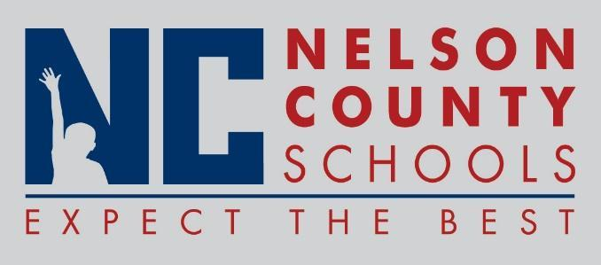

Decision Paper
To: | Nelson County Board of Education
From: | Tiffanie Clark, Director of Special Education
cc: | Wes Bradley, Superintendent
Date: | 6/19/18
Re: | Agreement with Office of Vocational Rehabilitation

RECOMMENDATION: Approve agreement with OVR to provide collaborative efforts in providing students with disabilities opportunities and supports for pre-employment transition services.

RECOMMENDED MOTION: I move that the Nelson County Board of Education approve as presented.

