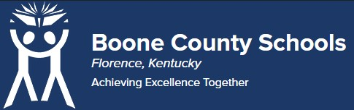
Boone County Board of Education Members
Dr. Maria Brown, Board Chair Mrs. Julia Pile, Vice Chair
Ms. Karen Byrd Mr. Jesse Parks
Mr. Keith Collins Mr. Matthew Turner, Superintendent

Board Memo

DATE: 11/16/2021

AGENDA ITEM DETAILS:
School/Department
LSS

Product Vendor or Grant Issuer
Solution Tree, Inc.

Product or Grant Name
Onsite and Virtual Professional Development Date/Term (Beginning and End Dates/Year) January 26 2022 - April 6, 2022

APPLICABLE BOARD POLICY:
N/A

DESCRIBE USE OF CONTRACT/PURCHASE/AGREEMENT

Description of Services: Solution Tree agrees to provide a speaker, Kim Bailey (“Associate”), to disseminate information for Customer on the topic of Assessment on January 26, 2022 and Chris Jakicic (“Associate”), on the topic of Assessment for up to 2 hours each session on February 17, March 16, and April 6, 2022.
This supports assessment literacy work for Teacher Ambassadors & Instructional Coaches.

FUNDING FOR PURCHASES AND OTHER REQUESTS:
Total Cost
$13,700.00

Funding Source
Title II

*If more than one funding source, list below along with amount or percent for each source
N/A

IF THIS IS A GRANT, ENTER AMOUNT TO BE AWARDED:
n/a

RECOMMENDATION:
I, Jenny Watson, Assistant Superintendent Learning Support Services, recommend the Board approve this Purchase Agreement as presented.

CONTACT PERSON: (submitter)
Kim Thomson/Jenny Watson

