DISTRICT SERVICE

AGREEMENT

GRANT NUMBER # OPP1157552

AGREEMENT # 0410400003

TITLE: Beyond Accountability

PRIME CONTRACTOR: American Institutes for Research (AIR)
1000 Thomas Jefferson St, N.W.
Washington, D.C. 20007-3835

RECIPIENT:

AMOUNT: $10,000.00

PERIOD OF PERFORMANCE: September 1, 2016 – July 31, 2017

IN WITNESS WHEREOF, AIR and the Recipient have each caused this Agreement to be signed and delivered by its duly authorized representative, all as of the date set forth below.

American Institutes for Research |  | RECIPIENT
AIR Contractor Officer Signature |  | Authorized Superintendent’s Designee Signature
Nilva da Silva
Typed/Printed Name |  | Typed/Printed Name
Senior Contract Officer
Title |  | Title
Date |  | Date

1.0 CONTRACT PROVISIONS
This Agreement between the American Institutes for Research (AIR) and Boone County Schools (hereinafter referred to as the Recipient). AIR is a not-for-profit corporation organized under the laws of the Commonwealth of Pennsylvania, with its headquarters and one of its principal places of business at 1000 Thomas Jefferson Street, NW, Washington, D.C. 20007. Boone County Schools has its principal place of business at 8330 US Highway 42, Florence, KY 41042.

AIR enters into this Agreement pursuant to its grant number: OPP1157552 to perform a project entitled “Beyond Accountability” (hereinafter called the Project). The Project is sponsored by the Bill & Melinda Gates Foundation (“Gates Foundation”). The purpose of this project is to support districts in short improvement efforts to ensure educator evaluation systems improve instruction.

1.1 Scope of Work

- Boone County Schools, as an independent Recipient and not as an agent or employee of AIR or the Gates Foundation, shall in a good and businesslike manner, and subject to the provisions hereof perform the task and services as described in the Scope of Work.

(b) A detailed statement of work and budget is contained in Appendix 2 Roles and Responsibilities of this Agreement.

1.2 Inspection & Acceptance

AIR’s Project Director or his designated representative is responsible for inspection of all items to be delivered under this Agreement. Recipient shall receive final payment when all work required by the Scope of Work has been completed to the reasonable satisfaction of AIR’s Project Director and AIR’s Contract Officer and subject to the approval of the Gates Foundation’s Grants Officer.

1.3 Technical Direction

Performance of the work under this Agreement shall be subject to the technical direction of AIR's Project Director or his/her designated representative. Technical directions are directions to Recipient, which fill in details, suggest possible lines of inquiry or otherwise complete the general scope of the work. Technical directions must be within the terms of this Agreement and shall not change or modify the terms in any way.

1.4 Expense Approval Reports

The Recipient shall prepare expense approval reports on the progress of all Agreement-related activities during the reporting period. The expense approval reports are required to be submitted prior to any expenses are incurred. All reports shall be submitted in electronic file to the AIR Liaison Mariann Lemke (mlemke@air.org) (See Appendix 4). The monthly status report will include:

- General Information

- Title “Expense Approval Form”
- Key Personnel (District Liaison)’s name
- Complete Mailing Address
- Agreement number
- Payment Request

- Reporting period
- Date report prepared
- Key Personnel (District Coordinator’s)’s signature
- (Designated) Supervisor’s signature, if applicable

- Technical Status Report

- A complete description of all Recipient activities under this Agreement for the month, including the status of any applicable milestones or deliverables (See Scope of Work within the R & R).
- Any other reports that may be required under this agreement,
- A discussion of any significant issues concerning the contract or its administration that needs to be brought to the attention of the Gates Foundation, including recommendations for necessary actions.

- Special Reports as requested.

1.5 Period of Performance

Unless terminated earlier pursuant to this Agreement, the period of performance of this Agreement shall be from September 1, 2016 to July 31, 2017, inclusive of all specified deliverables and/or project work.

2.0 CONTRACT ADMINISTRATION

2.1 Authorized Negotiator(s)

The person named below in this section is the Recipient’s representative for contractual matters. His or her properly designated representative shall be the only person(s) authorized to modify this Agreement on behalf of Recipient.

Authorized Person Name | Title | Phone Email

2.2 Recipient’s Remittance or Billing Address

Email address:

TIN:
2.3 Recipient Personnel

2.3.1. General

Recipient shall provide appropriate personnel during the Agreement term as necessary to carry out the Work required to be performed pursuant to this Agreement. Such Recipient personnel shall remain under the direction of Recipient, and Recipient shall be solely responsible to them for their compensation, and related benefits.

2.3.2 Specifically Identified Personnel

Specific personnel identified below are considered key personnel and essential to the work being performed hereunder. Prior to diverting any of these key personnel to other duties, Recipient shall notify AIR’s Project Director in advance and shall submit justification and explanation (including proposed substitutions) in sufficient detail to permit evaluation of the impact on the Project (including budget implications). No diversion or replacement of key personnel shall be made by Recipient without the prior written consent of the AIR’s Contract Officer.

Key Personnel (District Coordinator)

2.4 AIR Personnel

AIR personnel involved in a task led by Recipient shall remain employees of AIR, and AIR shall be solely responsible to them for their compensation, related benefits and out-of-pocket expenses (including travel and travel-related expenses).

(a) AIR’s Project Director shall be responsible for the overall management of the Project and for monitoring the scientific and technical performance of Recipient.

Project Director: Mariann Lemke
Address: 1000 Thomas Jefferson Street, NW
Washington, D.C. 20007
Telephone: (773) 286-2898
Email: mlemke@air.org

(b) The AIR Contract Officer, or her designated representative, is the person authorized to execute modifications relating to changes in the Scope of Work, Agreement cost, price, quantity, quality or delivery schedule.

Contracting Officer: Nilva da Silva
Address: 1000 Thomas Jefferson Street, NW
Washington, D.C. 20007
Telephone: (202) 403-5086
Email: ndasilva@air.org

2.5 Premises

Each party shall be responsible for causing its employees, agents and invitees, whenever on the premises of the other party, to comply with all reasonable security and safety procedures of the other party and to obey all reasonable instructions and directions relative to such premises issued by the other party.

2.6 Precedence for Settling Conflicts between Documents

In the event of any apparent conflict between documents which set forth the obligations of the parties, the precedence for settling the conflict shall be set by the following documents in the order of priority as listed:

- General Provisions of Gates Foundation Grant No. OPP1157552
- Agreement between AIR and Recipient,
- Statement of Work & Budget (Appendix Roles and Responsibilities)

3.0 FINANCIAL PROVISIONS

3.1 Approved Annual Budget

Recipient shall be reimbursed according to the payment schedule included in the Appendix. Payments are subject to acceptance of the AIR Project Director. The total cost to the School District for full performance of this Agreement is $10,000.

3.2 Compensation and Submission of Payment requests

(a) AIR agrees to reimburse Recipient, as complete compensation for all work performed under this Agreement, for costs as defined in the terms and conditions of the prime contract and according to the amounts stated above in 3.1.

(b) All invoices from the Recipient are subject to the approval of the AIR Project Director. Recipient shall submit payment requests as follows:

Accounts Payable
American Institutes for Research
1000 Thomas Jefferson Street, NW
Washington, DC 20007

Alternatively, invoices may be e-mailed directly to accountspayable@air.org.

(c) Quarterly invoices must include cost information in sufficient detail to allow comparison between the payment request and the Recipient’s approved payment schedule. Approved payment requests shall be forwarded by the Project Director or his designee to the AIR Business Office for payment.

(d) Following full execution of this agreement, a Purchase Order number will be provided to the Recipient which will need to be referenced in each invoice. Any invoice that does not have the Purchase Order number shall not be processed for payment and will need to be resubmitted

3.3 Withholding of Agreement Payments

Notwithstanding any other term of this Agreement, failure of Recipient to submit the required reports when due, or failure to perform or deliver other required work or services, shall result, after written notice and 30 days to rectify, in the withholding of payments under this Agreement.

3.4 Overpayment

Recipient agrees to return to AIR any overpayments due to unearned funds or funds disallowed pursuant to the terms of this Agreement that were disbursed to the Recipient by AIR. Such funds shall be refunded to AIR within 45 days following the time of the overpayment and/or disallowance is discovered unless otherwise authorized by AIR’s Contract Officer in writing.

4.0 GENERAL PROVISIONS

4.1 Termination/Default

(a) Either party may terminate the whole or any part of this Agreement, by written notice to the Recipient, in any one of the following circumstances:

(1) if the other party materially fails to perform the work called for by this Agreement within the time(s) specified herein or by any extension thereof;

(2) if the other party materially fails to perform any of the other provisions of this Agreement, or so fails to prosecute the work as to endanger performance of this Agreement or the Prime Contract in accordance with its terms.

(3) if for any reason the Gates Foundation terminates the Grant with AIR, ceases to provide funds, or modifies the terms or conditions of the Contract so as to alter the scope of the work required under the Agreement.

(b) Termination for either 4.2(a)(1) or 4.2(a)(2) will occur if failure to perform is not cured within a thirty-day period after written notice of the failure to perform is given.

(c) Immediately upon receipt of a written notice of termination from AIR, the Recipient shall:

(1) Stop work under this Agreement on the date and to the extent specified in the notice of termination;

(2) Make no further commitments for services or expenses required to perform services, except as they may be necessary for completion of a portion of work specified in the termination notice;

(3) Complete performance of any portion of the work specified for completion in the notice of termination;

(4) Assemble and transfer to the AIR Project Director all written research products, files, reports, documents, and supplies developed under this Agreement or supplied in connection with this Agreement.

(d) In the event of termination, the Recipient is entitled to payment of all reasonable and allowable costs and expenses reimbursable in accordance with the terms of this Agreement, including those incurred but not paid prior to the effective date of the notice of termination and those incurred in the performance of work specified for completion in the notice of termination.

d. Retention of Records, Access, and Right to Audit

Recipient shall retain financial records, supporting documents and other records relating to the administration of the Agreement for a period of five years after the final payment by AIR to Recipient; but in the event that any claim for expenditure is in dispute at the expiration of the five-year period, all records relating to the disputed claim shall be maintained until the dispute is finally resolved.

Copies of all documents and materials including, but not limited to reports, working papers, articles, monographs, data, field notes, etc. produced by Recipient for this Project will be provided to and retained by AIR, upon request, in accordance with grant requirements.

4.2 Notice and Assistance Regarding Copyright Infringement

The Recipient shall report to AIR promptly and in reasonable written detail, each instance, notice or claim of copyright infringement of which the Recipient has knowledge in performance of this agreement. When necessary, the Recipient will execute formal release of copyrighted materials for use by the project.

4.3 Modification

Any changes, amendments, or modifications to this Agreement must be made and agreed to by the parties in writing.

4.4 Amendments

No amendment, change, waiver, or discharge hereof shall be valid unless in writing and signed by an authorized representative of the party against which the amendment, change, waiver, or discharge is sought to be enforced.

4.5 Release of Information

Because AIR is responsible to the Gates Foundation for all work performed under this Agreement, Recipient shall neither transmit nor publish any information on this Project without the consultation and prior approval of the AIR’s Project Director.

4.6 Agreements

Recipient shall not assign any work to be performed by Recipient under this Agreement, in whole or in part, without prior written consent of the AIR Contract Officer.

4.7 Covenant Against Contingent Fees

Recipient warrants that no person or selling agency has been employed or retained to solicit or acquire this Agreement upon an agreement or understanding for a commission, percentage, brokerage or contingent fee. For breach or violation of this warranty, AIR shall have the right to annul this Agreement without liability or in its discretion to deduct from the Agreement price or consideration, or otherwise recover, the full amount of such commission, percentage, brokerage or contingent fee.

4.8 Indemnification and Hold Harmless

Each party agrees to indemnify, defend, and hold harmless the other party, its officers, agents, and employees from and against any and all claims, actions, losses, damages, injuries, liabilities, suits, and costs and expenses, including reasonable attorneys’ fees and expenses, arising out of or related to the performance of this Agreement by the indemnifying party, its officers, agents, or employees.

In no event shall either party be liable to the other for any lost profits, lost savings, consequential, incidental, or special damages. Notwithstanding the foregoing, Recipient shall be liable to the full extent of its responsibility therefore for claims by the Gates Foundation or Gates Foundation personnel brought against AIR arising out of related to Recipient’s performance under the Agreement, including but not limited to (1) any claim for reprocurement costs; and (2) any claim for administrative or civil false claims remedies.

Recipient shall have the following types of insurance and shall maintain them in the amounts shown during the term of this Agreement:

- Comprehensive General Liability: $1,000,000 for each occurrence and $2,000,000 aggregate per project.
- Automobile Insurance: $1,000,000 for liability coverage and $1,000,000 for personal injury.
- Workers’ Compensation and Employer’s Liability Coverage: $1,000,000 for bodily injury per accident and $1,000,000 for bodily injury by disease.
- The Recipient shall provide a certificate executed by an authorized insurer that such insurance is in full force and effect and that AIR will be notified thirty days prior to the modification or cancellation of such insurance. The Recipient further certifies that it shall continuously maintain such insurance for the duration of this Agreement.

4.9 Drug-Free Workplace

Recipient shall provide a drug-free workplace in accordance with all Federal and State laws and regulations.

4.10 AIR Data

All data provided to Recipient by AIR in the performance of this Agreement (“AIR Data”) shall be and remain AIR's property. AIR hereby authorizes Recipient to have access to and to make use of the AIR Data as is appropriate for the performance by Recipient of its obligations under the Agreement. Upon the expiration or termination of the Agreement for any reason, Recipient shall request instructions from AIR regarding whether Recipient should (1) erase AIR Data from the data files maintained by Recipient, or (2) return, on such media as may be mutually agreed upon by the parties, the AIR Data to AIR. Recipient may not utilize the AIR Data for any purpose other than in performing services for AIR pursuant to this Agreement.

4.11 Legal Compliance

This Agreement and each party's obligations hereunder shall be subject to, and each party shall comply with, all applicable laws, regulations, ordinances, codes, orders, and judgments.

4.12 Severability

If any provision of this Agreement is illegal, unenforceable or void, then both parties shall be relieved of all obligations arising under that provision, but only to the extent the provision is illegal, unenforceable or void. In such an event, if the remainder of this Agreement is capable of substantial performance, then each provision not so affected shall be enforced to the extent permitted by law.

4.13 Waiver

No delay or omission by either party to exercise any right or power hereunder shall impair that right or power or be construed to be a waiver thereof. A waiver by either of the parties of any of the covenants to be performed by the other or any breach thereof shall not be construed to be a waiver of any succeeding breach thereof or of any other covenant herein contained.

4.14 Bankruptcy

In addition to the rights set forth in Article 4.2 herein, AIR may terminate this Agreement for default, in whole or in part, by written notice to Recipient if:

- Recipient shall become insolvent or make a general assignment for the benefit of creditors; or
- a petition under any bankruptcy act or similar statute is filed by or against Recipient and not vacated within 10 days after it is filed.

4.15 Approvals and Similar Actions

Whenever agreement, approval, acceptance, consent or similar action by either party is required by any provision of this Agreement, such action shall not be unreasonably delayed or withheld unless a different standard for that action is specifically set forth.

4.16 Headings

The section and clause headings used herein are for reference and convenience only and shall not enter into the interpretation hereof.

4.17 Conflict of Interest

The Recipient warrants that, to the best of the Recipient’s knowledge and belief, there are no relevant circumstances that could give rise to an organizational conflict of interest, and that the Recipient has disclosed all such relevant information. If an actual or potential conflict of interest is discovered after award, the Recipient will make a full disclosure in writing to AIR and include a description of the action(s) which the Recipient will take to avoid, mitigate, or neutralize the actual or potential conflict.

4.18 Entire Agreement

This Agreement, including any schedules and Appendices referred to herein or attached hereto, each of which is incorporated herein for all purposes, constitutes the entire agreement between the parties with respect to the subject matter hereof and supersedes all prior and contemporaneous representations, understandings or agreements relating to the subject matter hereof.

4.19 Choice of Law

Irrespective of the place of performance, this Agreement will be construed and interpreted according to the Federal common law of Government contracts as enunciated and applied by Federal judicial bodies, boards of contract appeals, and quasi-judicial agencies of the Federal Government. To the extent that the Federal common law of Government contracts is not dispositive, the laws of the District of Columbia shall apply.

4.20 Incorporation of Additional Agreement Clauses

Attached hereto as Appendices 1 and 2 are those additional clauses and Notes pertaining thereto, including clauses from the Gates Foundation which are incorporated into this Agreement.
APPENDIX 1: APPLICABLE GATES FOUNDATION CLAUSES

PROVISIONS

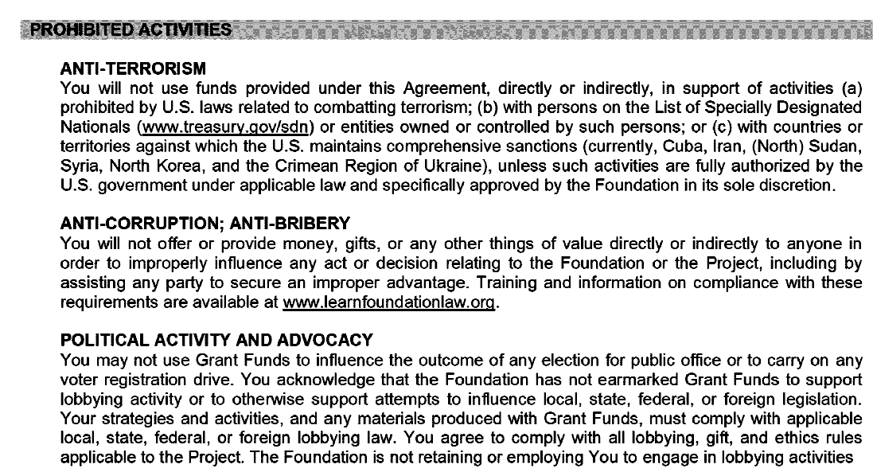

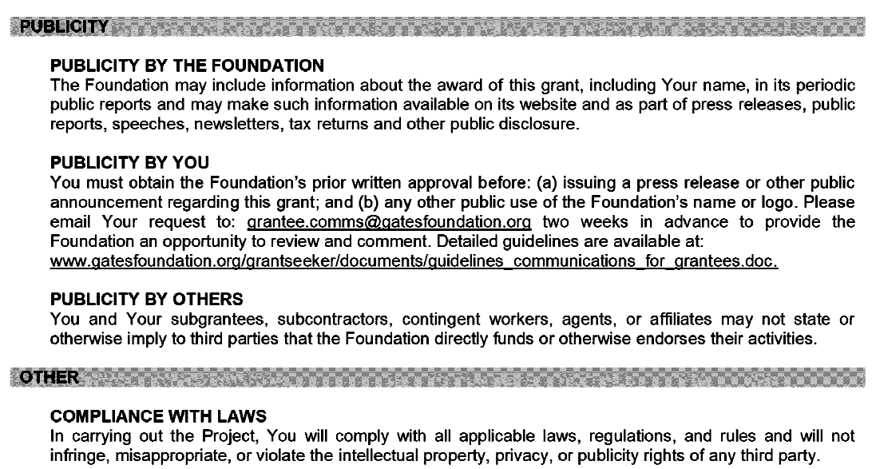
APPENDIX 2: ROLES AND RESPONSIBILITIES

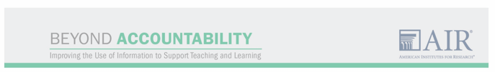

Roles and Responsibilities for Project Participation

This document summarizes the shared understanding between AIR and District regarding the Beyond Accountability: Improving the Use of Information to Support Teaching and Learning initiative. It describes project activities and the roles and responsibilities of both AIR and the school district. To ensure shared understanding, signatures on this document are requested from AIR and school district leaders.

Overview of Project

The Beyond Accountability initiative is designed to create effective communities of practice within and across districts aimed at addressing challenges in the use of professional practice data for instructional improvement. The goal of the project is to enable districts to improve teacher practice and support teacher growth in ways that ultimately lead to improved student achievement.

Within districts, participants will collaborate with AIR and experts in the field to identify context-specific challenges related to data use and to develop and test solutions to those challenges. Participants will also be matched with other districts facing similar challenges for peer-to-peer support.

The project will include approximately 10 participating districts. Within each district, a group of relevant stakeholders (which may include teachers, principals, and district staff) will meet to identify and select a pressing challenge, identify causes of that challenge, and develop strategies for addressing the problem and measures to assess progress in solving it. Cross-district groups will meet in person approximately three times during each of the 2 years of the project. AIR is responsible for the overall implementation of the project through a grant from the Bill & Melinda Gates Foundation. The formation and facilitation of the project’s communities of practice is a coordinated effort involving AIR, supporting organizations as needed, and the district.

The remaining sections of this document describe (1) the project components and timeline; and (2) responsibilities of AIR and the district. The document includes a signature form for AIR and district staff.

Project Activities and Timeline

The project will begin with development of initial plans for communities of practice (CoPs) focused on the use of professional practice data for improvement in summer 2016. Table 1 provides a more detailed timeline for project activities in Year 1, including information about event participants, timing, and format. Upon approval by the Gates Foundation, Year 2 (2017–18) project activities will include similar meetings and timelines, with adjustments as needed based on Year 1 experiences.

Table 1. Overview of Project Activities and Timeline—Year 1
Event | Participants | Activity | Timing | Format
July 2016 – June 2017
Cross-District Launch Meeting | Select district staff and AIR facilitators | Learn more about project and participation requirements; consider possible problems of practice; begin to identify within-district CoP participants | July 2016 | In person
Within-District Meeting 1 | Select district staff, AIR facilitators, and relevant stakeholders | Select district’s problem of practice; design solutions, measures, and intended outcomes for testing solutions | August–September 2016 | In person
Within-District Meeting 2 | Select district staff, AIR facilitators, and relevant stakeholders | Midpoint check-in on progress and strategy | December 2016 | In person
Cross-District Community  of Practice Meeting 1 | Select staff from districts and AIR facilitators | Discuss problems of practice, solutions, and approaches to testing solutions, logic models, and progress to date | January 2017 | In person
Within-District Meeting 3 | Select district staff, AIR facilitators, and relevant stakeholders | Year-end check-in on progress, strategy, and outcomes; discuss communication regarding project activities and lessons learned, and share out with networks | May 2017 | In person
Cross-District Community of Practice Meeting 2 | Select staff from districts and AIR facilitators | Year-end check-in on progress and strategy; discuss communication regarding project activities and lessons learned, and share out with networks | May 2017 | In person
Ongoing
Within-District Ongoing Meetings | Select district staff; AIR facilitators if appropriate | Implementation monitoring and strategy refinement in between in-person, AIR-facilitated meetings; communication about project activities | Ongoing; frequency TBD by district | In person, with online component if appropriate
Cross-District Ongoing Meetings | Select staff from districts; AIR facilitators if appropriate | Sharing of implementation progress and strategy refinement in between in-person meetings | Ongoing; frequency TBD | Online
Meetings With Other Districts or Networks | Select staff from districts; stakeholders from networks such as regional collaboratives and comprehensive centers | Communication regarding project activities and lessons learned | 2016–17 school year | In person and online

Responsibilities of AIR and of the Participating School Districts

AIR will:
- Designate a single point of contact for each district. AIR will designate one staff person to be each district’s main point of contact. That staff person will work with the district’s designated coordinator and will make connections to other AIR or external staff as needed.
- Facilitate communities of practice. AIR will help create and facilitate within- and cross-district communities of practice, including helping to develop each district’s change ideas and strategies and developing measures to track change.
- Provide additional technical assistance as needed by districts. As districts refine their problems of practice and begin to identify possible solutions, AIR will provide technical assistance in addressing the challenges identified and will help to match districts with partner organizations if relevant expertise is needed. Districts will also be able to request funds for specific project activities such as stipends to support meetings of teachers.
- Support evaluation of the project and dissemination of information. AIR will collect data and report on project progress and outcomes across all districts, check in with districts to determine whether project activities are on track within each district, assist districts in documenting lessons learned, and support the dissemination of effective practices to inform the district and other districts.

Participating school districts will:
- Identify a “champion” to support the work. Each district in the project will designate at least one staff person to serve as the “champion” for the project. The “champion” will support the work by ensuring that the necessary resources and staff are made available. In case this person decides to leave his or her position with the district during the study, it is the responsibility of the district to ensure smooth transition of information and responsibilities to incoming district staff.
- Identify a “district coordinator.” The district will designate a district coordinator to manage day-to-day communications and activities with teachers, school leaders, and other staff within the district and with AIR project staff. In case this person decides to leave his or her position with the district during the study, it is the responsibility of the district to ensure smooth transition of information and responsibilities to incoming district staff.
- Identify and recruit appropriate, relevant stakeholders to participate in within-district and cross-district meetings. Participants in within- and cross-district communities of practice should have insight into the nature of challenges faced by the district in increasing the use of teacher practice data to improve practice. These participants should have the capacity to contribute to the identification and refinement of one or more problems of practice to be addressed by the district. District leadership and other identified staff within each district agree to support the study by participating in project activities as described earlier, to include approximately four in-person within-district meetings, three in-person cross-district meetings, and additional ongoing communication or other meetings as deemed necessary across the 2 years of the project. Participants will share strategies, data, experiences, and lessons learned with all identified stakeholders and partner districts.
- Share information with other districts and networks. Participating districts will contribute in efforts to scale up effective use of instructional practice information to additional districts. To achieve this scale-up goal, districts will be required to:
  - Participate and contribute in project team efforts to gather data throughout the duration of the project by completing feedback forms at in-person meetings, surveys, and interviews.
  - Propose and implement three strategies for sharing information about their work with existing local, state, regional, or national networks and within their districts. Districts will share information about their work (what worked and some of the remaining challenges) with broader networks (e.g., regional collaboratives, partnerships with institutions of higher education, regional educational laboratories, regional comprehensive centers, union/association networks, and regional professional development centers). In this process, districts will also seek further input from broader networks.
  - Provide at least one example of how sharing this work through their broader networks influenced practice in a nonparticipating school or district.
  - Participate in project-sponsored Webinars or other presentations to disseminate information of best practices and lessons learned.
- Participate in and facilitate project data collection and monitoring efforts in the district. As part of the project, we plan to collect information about teacher or other educator perceptions (likely through surveys), instructional practice, and possibly other forms of data from those engaged in the project. We will obtain any necessary research permissions to collect data and discuss specific requests with the district coordinator. We ask that participating districts cooperate and help to facilitate data collection.

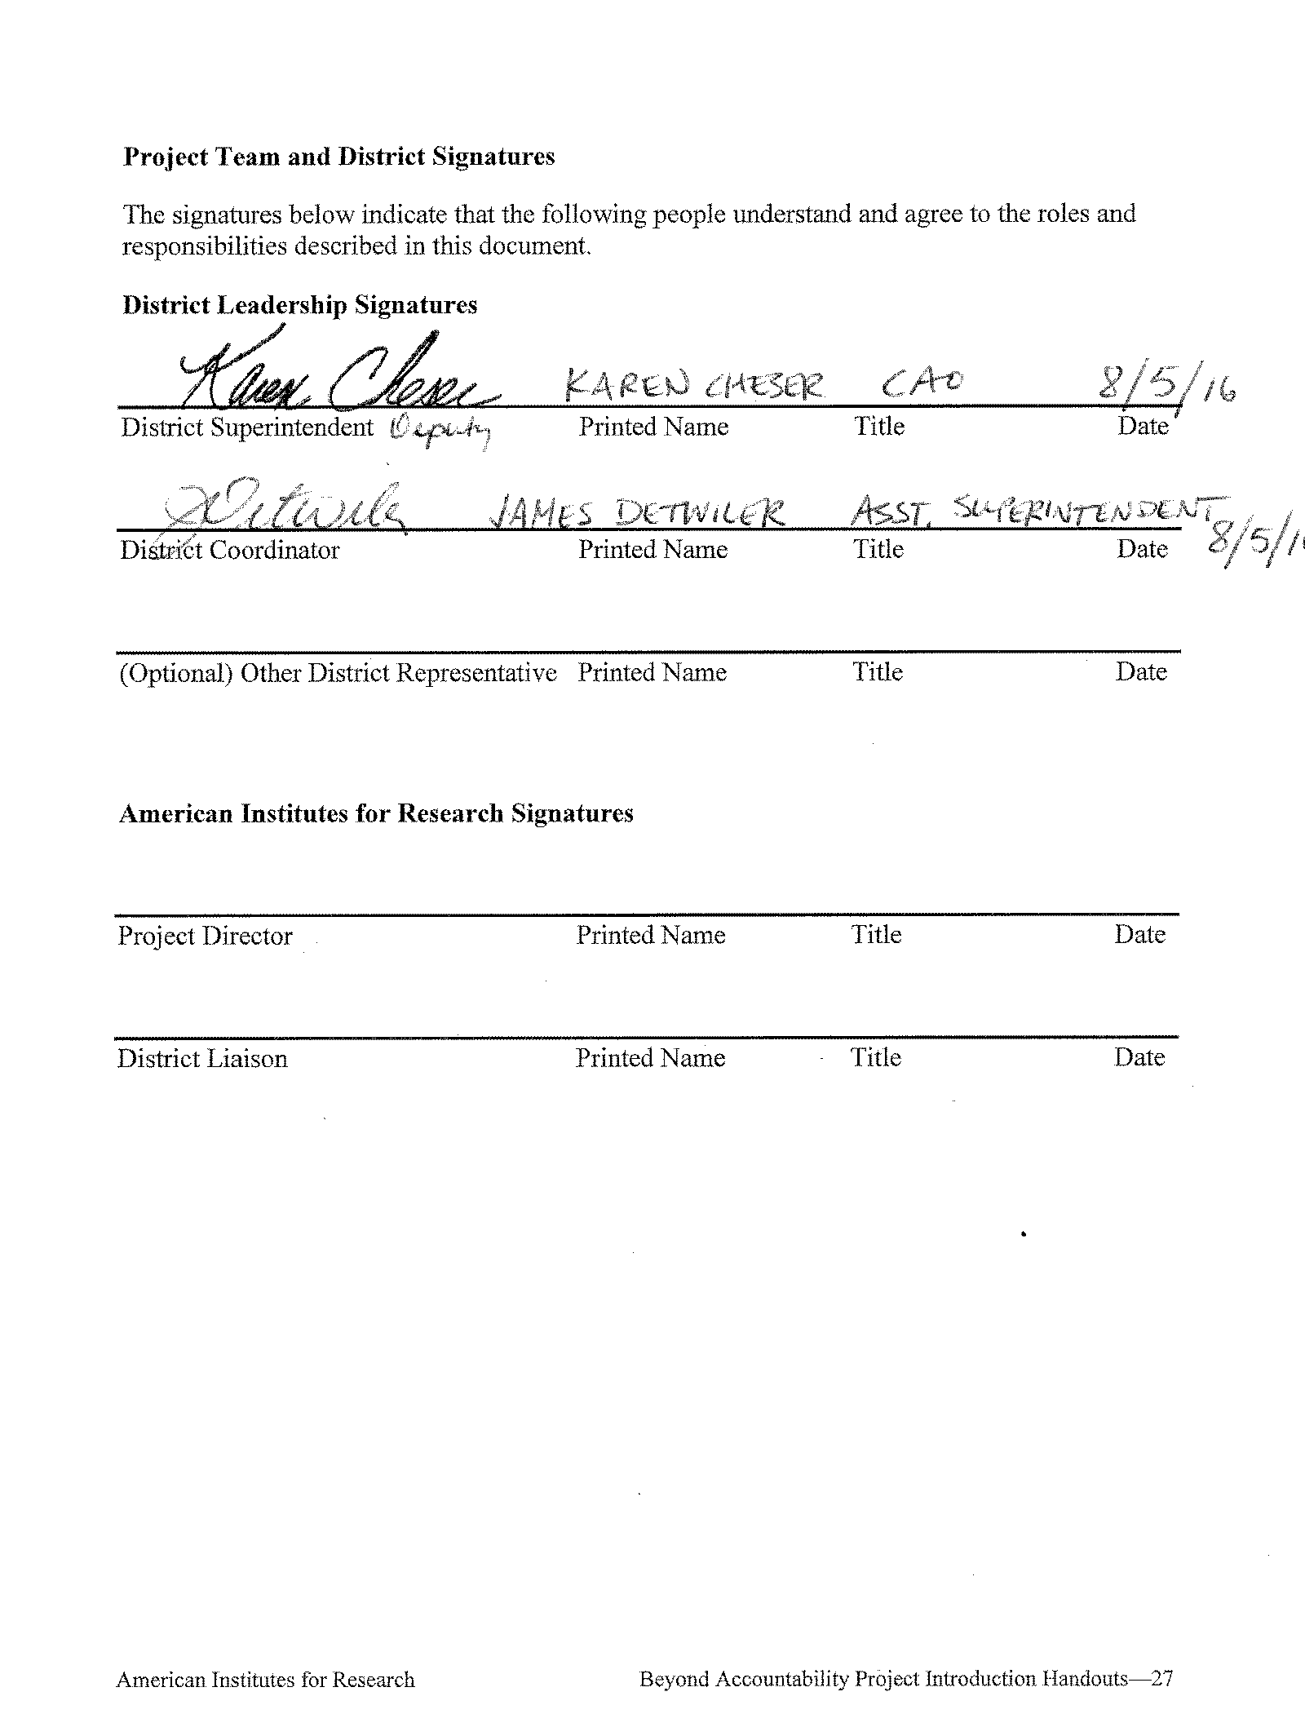
APPENDIX 3: PAYMENT SCHEDULE
Compensate the District and Schools for Participation

District Coordinator:

Payments:

2016-2017
1. June $x,xxx.xx
2. September $
3. December $
4. March $

Total: $10,000.00

Teachers and substitute reimbursement: To be compensated by AIR as allocated in the Roles and Responsibilities

APPENDIX 4: EXPENSE APPROVAL FORM

Expense Approval
District Name: ______________________
District Liaison: ______________________
Agreement number: ______________________

Mailing Address: ______________________
______________________
______________________

Date report prepared: ______________________
Reporting period: ______________________

Date(s) of meetings with the liaison during this reporting period: ___________________

Please specify the district expenses for this quarter. Common expenses include teacher stipends, substitute coverage and consultant fees. Include as much detail as possible, including the number of teacher stipends and the number of days of substitute coverage.

District liaison signature: __________________________

Initial request Approved Not approved

Describe reason if not approved:

AIR district liaison signature: ______________________
AIR project director signature: ______________________
Pre-approval date: ______________________

