UK Next Generation Scholars
Memorandum of Agreement
2021-22

DUAL CREDIT AGREEMENT BETWEEN
UNIVERSITY OF KENTUCKY
AND
Boone County Schools

UK Dual Credit Website: https://www.uky.edu/sal/dual-credit
1. Introduction 2
2. Dual Credit 2
2.1 - UK Responsibilities 2
2.2 - School Responsibilities 5
2.3 - Student Responsibilities 5
3.0 Professional Learning Network 7
3.1 Professional Learning Network Membership & Operations 7
3.2 - Professional Learning Network Activities 7
3.3 - Professional Learning Network Fees 8
4. Additional Material 8
Appendix A: SACSCOC Dual Enrollment Policy Statement 10
Appendix B - Professional Learning Network Fees, Structure & Benefits 12

1. Introduction
In an effort to provide a seamless educational pathway for high school students seeking the academic rigor of a Research I institution and to redesign the high school experience to better prepare students on that path, the University of Kentucky (UK) and Boone County Schools, have agreed to cooperate in UK Next Generation Scholars, an initiative for secondary students (grades 9-12) to receive dual credit toward both the high school and UK curriculum requirements. The parties share a two part mission:
Dual Credit Mission - Provide access to University of Kentucky courses to a diverse population of students in high school to increase college- and UK-going rates across the Commonwealth while reducing both the cost and time to degree.

Network Mission - Link together schools in Kentucky through a formal Network operated by the UK Center for Next Generation Leadership, in the College of Education, to address the challenges of leading and reforming school models in the 21st Century. Network schools will collaboratively work toward deeper learning models that prepare all students for success in college, careers, and life.
Collectively, the effort to achieve both components of the mission shall be entitled UK Next Generation Scholars. Students enrolled dually in high school and UK shall be referred to as Next Gen Scholars. Member schools shall be referred to as Next Gen Network Schools. The UK Center for Next Generation Leadership of the College of Education will serve as the intermediary and operator of UK Next Generation Scholars.
This Agreement specifies the roles and responsibilities of UK and District, (collectively, the Parties) in the dual credit partnership as well as the school improvement network for the purpose of implementing the Kentucky Dual Credit Scholarship Program.
The Program will include high school students screened by Boone County Schools, hereafter referred to as District, for eligibility, and District employed teachers partnered with UK faculty in the appropriate academic departments offering the dual credit courses. For the purposes of this Agreement, dual credit is defined as a college-level course offered to eligible high school students with the enrolled students earning high school credit and college credit simultaneously. This definition is consistent with Kentucky Revised Statute 164.002 and the University Senate Rules 3.2.0 and 4.2.1.3.1.2.

2. Dual Credit

2.1 - UK Responsibilities
2.1.1 - Course Availability - District and UK agree that for the purposes of this Program, UK will annually determine the courses to be offered for dual credit. The courses offered in this program will be in accordance with the current UK Senate Rules. As dictated by the Governor's Executive Order 2016-378, this Program includes only those courses that are transferable for general education certification in Kentucky.
2.1.2 - Canvas Access - UK will provide guest access to the Canvas course shells to the high school faculty prior to the term in which courses are offered. High school faculty are responsible for regularly accessing the course shell and contributing in the predesignated ways as determined by each UK course instructor.
2.1.3 - Enrollment Management - UK's Office of Enrollment Management, in coordination with the Center, will designate a single point of contact to manage admission and registration.
a. UK's Enrollment Management staff will be responsible for informing the school staff
and teachers of the current requirements, costs and fees associated with enrollment at UK as a participant in the dual credit initiative.
b. School staff will be responsible for gathering all the information needed for the online
UK application for the students who choose to participate in the dual credit initiative and will adhere to due dates and guidelines, as outlined in the UK Bulletin.

c. UK's Enrollment Management staff (in collaboration with the appropriate UK
department and college staff) will be responsible for enrolling the students in the dual credit course section at UK.
d. In some cases ACT equivalents or UK Placement Tests may be used for certain courses at UK as required by specific course expectations applicable to all UK students. The professional advising staff will be responsible for working with the UK department and college staff to assure appropriate placement and/or supplemental instruction, if required, for each student.

e. UK's Enrollment Management staff will work with District, and KHEAA when necessary, to identify and report on each student who chooses to participate in the dual credit initiative to establish deadlines, to bill for payment, and to communicate tuition rates and refund policies.
f. District staff will use Infinite Campus in accordance with KDE Course Data Standards (http://education.ky.gov/districts/tech/sis/pages/ksis-data-standards.aspx) to identify the course alignment and titles for dual credit courses and allow for KHEAA to create the report for statewide accounting purposes.
g. School staff will be responsible for obtaining parental permission for the release of all grades in the dual credit class, if necessary, from District to UK.
2.1.4 - Teacher Training and Information - The UK Center for Next Generation Leadership, in conjunction with UK faculty of each dual credit course offered, will train the high school teachers to teach the curricula for all academic dual credit courses in this Program. This training will occur in advance of the academic term in which instruction occurs, and supervisory oversight and/or mentoring by UK personnel will occur throughout the academic term as defined by UK's academic calendar.
UK faculty and staff will train the high school instructors on the information about the course being taught, including how to provide students with information about the course they are enrolling in and the benefits and risks of enrolling in such courses. UK faculty will be available for questions from the District staff who function as the students' advisors who are responsible for maintaining contact with the students; informing the student of significant dates (i.e., add/drop dates, first and last day of class dates); grading policies, and monitoring student progress. Academic alerts will be handled within the District system, and at midterm and at the end of each semester, the instructors will submit the students' grades via the MyUK portal. Upon a formal concern arising about a student in a dual credit course, the high school instructor will notify their partner UK instructor or dual credit program administrator.
2.1.5 - Syllabus - An official UK syllabus will be prepared for each dual credit course. One copy will be
submitted to the UK department and made available to students who enroll in the UK course.
2.1.6 - Alignment of Rigor - The UK department is responsible for periodic assessment of student artifacts to ensure comparable learning with traditional, non-dual-credit UK courses.
2.1.7 - Student Advising - the Center will provide a student advisor for students in the Dual Credit program. This student advisor will:
- Meet virtually or in person with each student at least once a year to discuss progress in the Dual Credit program and will provide timely support for students as they prepare to transition to UK.
- Serve on an as-needed basis to answer student questions on dual credit courses and college transitions.
- Provide support to Dual Credit students in completing their application to UK.
- Help dual credit students complete college application supporting materials such as the FAFSA.
- Provide information and support to students regarding a successful transition to a post secondary institution.
2.1.8 - Evaluation of Dual Credit - The success of the pilot program will be determined jointly by UK and District faculty and staff. The Center will design evaluation tools and collect and analyze relevant Program data such as quantitative data (ACT sub-scores, withdrawal rates, failure rates) as well as qualitative data (such as post-attrition survey responses, faculty interactions, surveys from the faculty development experiences, perception data from students, faculty, and teaching partners, or teacher course evaluation responses).
2.1.9 - Application of the UK Code of Conduct: The UK Ethical Principles and Code of Conduct apply to all students enrolled in dual credit courses at UK. Failure to comply with these principles or code of conduct may result in disciplinary consequences up to and potentially including dismissal from the University.
2.1.10 - Student Privacy in Dual Credit - Students in a dual credit course with the University of Kentucky shall be considered UK students for purposes of student privacy. Instructors shall maintain student confidentiality as provided in the UK Right to Privacy in Student Records component of the UK Code of Student Conduct, including the application of the Family Educational Rights and Privacy Act.

2.2 - School Responsibilities
2.2.1 - High School Enrollment - Staff from the high schools in conjunction with UK's Office of Enrollment Management will be responsible for enrolling the students in dual credit classes.
2.2.2 - Additional Supports - District will be responsible for purchasing required course materials for the purposes of this Program. District will be responsible for providing access to any library or other support resources necessary for student success as outlined by SACSCOC Dual Enrollment Policy Statement (provided in Appendix A).
2.2.3 - Course Payment - Payment for courses in the dual credit model may be paid by either the school or the student as determined by district policy/practice. However, for students qualifying for free or reduced lunch meals, District the school will approve the release of an amount of money commensurate with the state-approved dual credit tuition rate (currently $70 per credit hour but subject to change) for all students who successfully complete the UK course. Successful completion of the UK course is defined as earning a passing letter grade (i.e., not including E, U, I or W).
2.2.4 - Collaborative Instruction of Courses - To provide the best possible outcomes on dual credit course enrollments, District is expected to assign a qualified teacher to collaboratively teach each dual credit course unless otherwise notified. Expectations for the collaborative instruction of courses include:
- Each assigned high school teacher will meet the minimum qualifications established by UK and provided in advance.
- Each high school teacher will provide student-level support to all students in the assigned dual credit course.
- With the approval of the UK Instructor, each high school teacher will design, implement, and grade projects and performance assessments that reinforce the content and instruction in each dual credit course. Each major project and performance assessment will be approved in advance by the UK course instructor as a support to the overall course syllabus.
- High school teachers are expected to stay in regular communication with UK course instructors. UK course instructors and academic advisors shall be notified when student issues arise in the classroom.
2.2.5 - Student Advising - In addition to the advising services provided by UK, District guidance or other personnel will provide advising to all students participating in the Dual Credit Program. Guidance personnel will provide specific guidance to struggling students about withdraw policies and assist students in obtaining the withdraw.

2.3 - Student Responsibilities
2.3.1. Application for Non-Degree - High school students choosing to earn UK credit through this dual credit initiative must apply for and obtain acceptance as a non-degree-seeking student each semester. Students are required to complete the non-degree-seeking online application.

2.3.2 - Admission to Dual Credit - Admission to a UK Dual Credit course is required before a student may enroll in a UK class and is contingent upon permission from District (in collaboration with UK regarding the student's eligibility). However, enrollment in the specific UK course is ultimately determined by the UK personnel teaching that course, with the consent of the school's guidance counselor and principal.
2.3.3. - Aligned Grading - High school students enrolled in the UK course will receive a grade using the UK grading scale, available for reference in the Undergraduate Bulletin, and it should be similar to the grade that is earned in the student's high school dual credit course. Students participating in the UK dual credit program must receive credit at both institutions. Students may not audit the class but must be fully enrolled and follow the UK academic calendar.
2.3.4 - Course evaluation - Students enrolled in dual credit courses will complete an evaluation for each course taken as a dual credit course. Evaluation forms (whether on paper or in electronic format) will be handled in a private and secure manner as required by UK Senate Rules.
2.3.5 - Matriculation - Students participating in dual credit courses who wish to matriculate to UK as degree-seeking freshmen should apply to UK during their senior year, prior to the December 1 deadline. All students participating in UK dual credit courses will be encouraged to complete the full UK application.
2.3.6 - Grades & Transcript - Grades earned at UK for dual credit courses will be a part of the student's permanent academic record at UK and therefore will count in the student's overall cumulative UK GPA. High school students who are eligible to earn the UK course credit will have UK course titles posted to their UK transcript regardless of the title of their high school course. Grades assigned for high school credit will adhere to the District’s grading policies/practices.
2.3.7 - Academic Calendar - Students enrolled in dual credit courses will adhere to the regular UK Academic Calendar. Should any one of the schools be closed for weather-related occurrences, all UK coursework must be made up in a manner approved by the instructor. UK holidays will be observed by UK employees.
2.3.8 - Additional Non-Course Based Activities Required - Students are expected to engage and complete additional non-course based activities related to gaining college-related skills, student advising, and UK recruiting. Failure to participate in and complete these non-course based activities may result in an inability to register for future dual credit courses.
2.3.9 - Student Handbook - UK will provide on an annual basis access to the Next Gen Scholars Student Handbook, incorporated by reference, which shall provide additional detail and guidance in the operations and student governance of the dual credit program. A copy of the presently active student handbook will be made available on the dual credit website at all times. Students are expected to comply with the policies and guidelines therein. Failure to follow the policies and processes therein may result in suspension or dismissal from the dual credit program.

3.0 Professional Learning Network

3.1 Professional Learning Network Membership & Operations
3.1.1 - Membership Criteria - Professional Learning Network membership is required for access to the Next Gen Scholars dual-credit model provided by UK. The Center for Next Generation Leadership, in conjunction with the Kentucky Next Generation Schools Network, hereafter referred to as “the Network”, shall define the criteria for Network membership and provide guidance documents to potential member districts. In advance of the 2020-21 academic year, a Request for Proposals to participate in the Network will be published based on Network principles. Upon acceptance into the Network, schools will remain in the Network for up to four (4) years at which time they must reapply. Access to the Network activities, including access to UK Dual Credit, will require payment of professional learning fees to the Center. See Appendix B.

3.1.2 - Advisory Board Responsibilities - The Network will establish an advisory board structure designed to provide advice and direction about the Network’s primary mission, core values and principals, and specific shared performance targets.

3.1.3 Definition of Shared Network Principles - The Network will develop and publish a shared mission statement and maintain a list of shared principles that provide guidance to schools as they endeavor to provide equitable models of deeper learning to students in Network schools. These Network principles will form the foundation for the new member Request for Proposals. The University of Kentucky will provide access to expertise and research to guide the development of the Network Principles.

3.2 - Professional Learning Network Activities
3.2.1 - Feedback to UK & the Center - The Network shall provide guidance to the UK Center for Next Generation Leadership on professional development needs and activities for Network members. Further, the Network shall provide specific feedback to UK on implementation of the dual credit courses.

3.2.2 - Convenings - The Center will facilitate virtual and in-person convenings of network participants for the purpose of building a community of committed practitioners. Convenings will be centered around solving common problems of practice, idea exchanges, and providing capacity-building professional learning.

3.2.3 - Resource Bank - The Center will maintain a Network Resource Database to which Network members may gain access to shared materials. Network members may utilize and modify assets within the database with attribution to the originating school district and the provision that newly developed materials are shared alike back into the Network database.
3.2.4 - Annual Statewide Gathering - To support network integration and development the UK Center for Next Generation Leadership, in the College of Education, will host an annual statewide gathering on or near the campus of the University of Kentucky or in a pre-notified virtual location. Network member schools will be provided a predetermined number of free seats to the annual gathering as articulated in Appendix B. Network member schools will be expected to annually contribute to the success of the gathering by submitting sessions or other resources.
3.2.5 - Leadership Academy - To support the development of innovative deeper learning practices at the school site, District will gain access to a given number of seats at the Next Generation Leadership Academy as articulated in Appendix B. Expectations for participation in the year-long Leadership Academy include the implementation of a deeper learning entry point project designed to test, sustain, and scale deeper learning models in the school. District will select the participants amongst school or teacher leaders and notify the Center of the names of participants by June 15 of each year.
3.2.5 - Dual Credit Teacher Training - As referenced in Section 2.1.4, to assist teachers at the school in implementing the dual credit expectations, a training on course expectations, the Canvas digital platform, and project-based learning models will be offered each year. This training may be in conjunction with the offering department’s own teacher expectations prior to teaching a specific course. District will identify the dual-credit teachers that will participate in the Dual Credit Teacher Training and provide notification to the Center for Next Generation Leadership.
3.2.6 - Specific Dual Credit Course Training by Department - On occasion specific departments at UK offering dual credit may require additional training in advance of teaching specific sections of courses offered by their department. District partners will be notified in advance of these training sessions. It is expected that applicable teachers attend these trainings.

3.3 - Professional Learning Network Fees
3.3.1 - Annual Professional Learning Network Fees - To gain access to the Dual Credit courses and supports, professional development for teachers and school leaders, and overall benefits of access to the school network, schools are required to pay for access to professional development as operated by the UK Center for Next Generation Leadership of the College of Education. The fees and resulting benefits are articulated in Appendix B.
3.3.2 - Contributing Network Member Fee Discount - To support Network development, schools are incentivized to make active contributions to the overall shared school network. Contributions will result in a Professional Learning Network Fee discount of 50% from the full Professional Learning Network Fee. See Appendix B for the discounted rate. Contributing to the Network requires participation in monthly Network meetings, fully participating in the Leadership Academy, attending the annual conference, designating a district critical friend, responding to requests from the Next Generation Scholars Network Director, and occasionally assisting other schools in the Network. Participating schools and districts will receive an overview of the types and examples of contributions available.

4. Additional Material
4.1 - Confidentiality - District agrees to maintain the confidentiality of communications between the partners related to student performance, as governed by the Family Educational Rights and Privacy Act, and operating conversations in the execution of the partnership. Either party may seek authorization from the other before sharing operating details with third parties.
4.2 - Cooperation - Although the parties have attempted to address the issues needed for a successful initiative, both Parties acknowledge that this is a new undertaking and agree to reasonably cooperate to resolve unaddressed issues.
4.3 - Term - This Agreement shall remain in effect until one or both parties decide to terminate the agreement or until June 30, 2022, whichever comes first. This agreement shall automatically renew for another one (1) year term, unless either party provides written notice to the other of its intent to terminate this agreement not less than thirty (30) days before the end of the then current contract term. A contract may renew no more than three times (for a total of 4 years) before a school must reapply to the Network.
4.4 - Termination - Either Party may terminate this MOU by providing at least 30 days written notice to the other Party. Upon notice of termination, dual credit will not be provided for any following semesters and access to Network resources such as digital platforms will be terminated.

________________________ _____________
Matthew Turner, Date
Superintendent
Boone County Schools

________________________ _____________
David Blackwell, Date
Provost
University of Kentucky

________________________ _____________
Julian Vasquez Heilig, Date
Dean, College of Education
University of Kentucky

Appendix A: SACSCOC Dual Enrollment Policy Statement 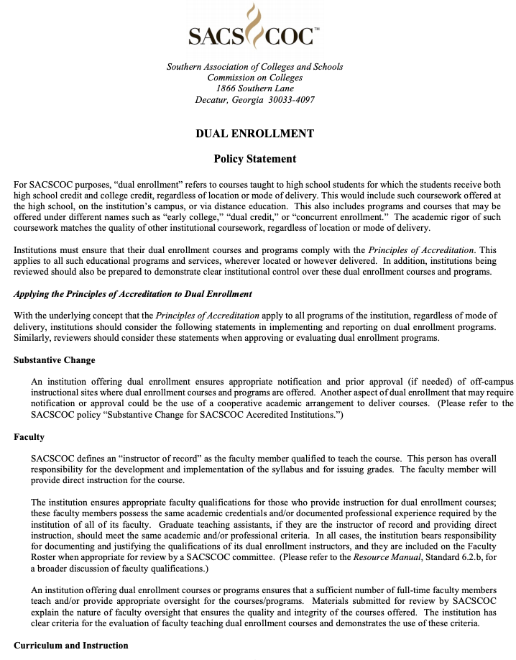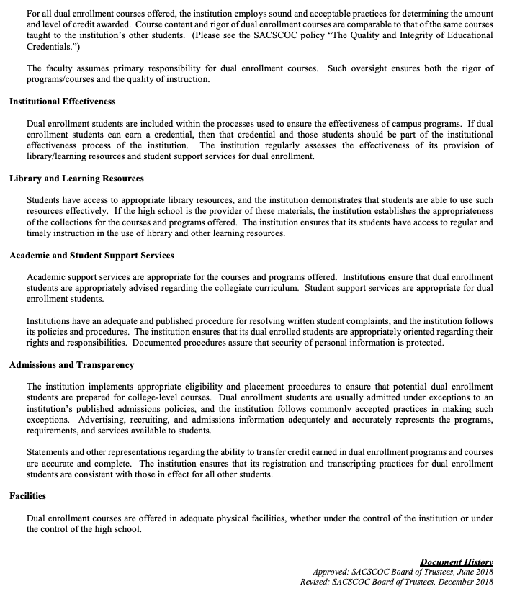

Appendix B - Professional Learning Network Fees, Structure & Benefits
Because all schools will be expected to make in-kind contributions to the overall operations and effectiveness of the Professional Learning Network (PLN), the chart below shows the discounted fee that a school will be charged to participate in the (PLN) each year during the pilot period.

 | School Size
 | 0-499 | 500-999 | 1,000-1,499 | 1,500 or greater
Discounted Professional Learning Fee for Contributing Network Members | $1,250 | $2,500 | $3,750 | $5,000
Dual Credit Student Access | unlimited based on qualifications and availability | unlimited based on qualifications and availability | unlimited based on qualifications and availability | unlimited based on qualifications and availability
Included Next Gen Leadership Academy Seats | 3 | 5 | 7 | 9
Seats for Next Gen Statewide Leadership Event | 5 | 8 | 11 | 14
Dual Credit Teacher Professional Development | unlimited for dual credit course partner teachers | unlimited for dual credit course partner teachers | unlimited for dual credit course partner teachers | unlimited for dual credit course partner teachers
Digital Tools Access (Short Courses, Resource Bank) | unlimited | unlimited | unlimited | unlimited

