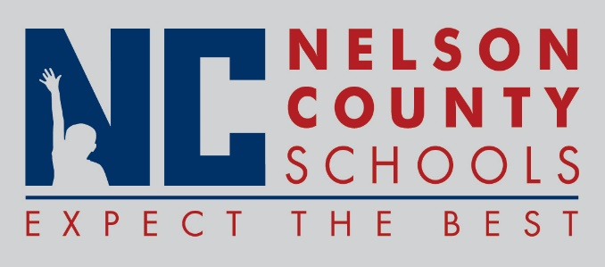

Decision Paper
To: | Nelson County Board of Education
From: | Tim Hockensmith, Chief Operating Officer
cc: | Dr. Anthony Orr, Superintendent
Date: | May 16, 2017
Re: | Audit contract for 2016-2017.

RECOMMENDATION: Approve the attached contract with Smith & Company CPA’s PLLC for auditing services for fiscal 2016-2017.

RECOMMENDED MOTION: I move that the Nelson County Board of Education approve as presented.

