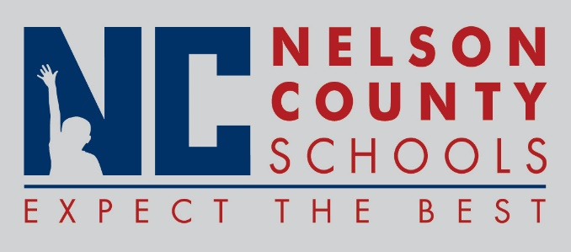

Decision Paper
To: | Nelson County Board of Education
From: | Ann Marie Williams
cc: | Dr. Anthony Orr, Superintendent
Date: | October 13, 2016
Re: | District Funding Assurances

ISSUE: Each year the district is required to review and assure that all funding received is allocated in compliance with the appropriate expectations. Areas of funding include, but not limited to Title I, Title II, Migrant, Neglected/Delinquent, ELL/Title III, Homeless, Career/Technical, Preschool, Wellness, Extended School, and Gifted and Talented.
RECOMMENDATION: Approve request for District FY 2017 Assurances.

RECOMMENDED MOTION: I move that the Nelson County Board of Education approve the District Funding Assurances completed in GMAP as presented.

