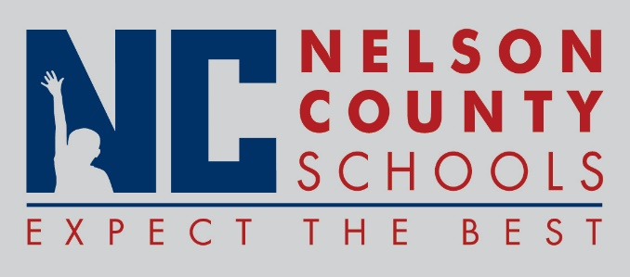

Decision Paper
To: | Nelson County Board of Education
From: | Tom Dekle
cc: | Tom Brown, Acting Superintendent
Date: | September 19, 2017
Re: | United Way Grant Applications

Team Up! FRYSC and Village FRYSC wish to apply individually for grant funding through Tri-County United Way. Team Up! FRYSC, representing Cox’s Creek, Foster Heights and Old Kentucky Home, wishes to apply for $2,500. The Village FRYSC, representing Boston, New Haven and the Early Learning Center, wishes to apply for funding totaling $2,100. Grant funding like this helps each center to provide services programs that go beyond the funding capacity typically expected through regular channels. Uses align well with the mission and vision of United Way, which has typically been very supportive of FRYSC requests for assistance. Matching funds are not required for these requests.
RECOMMENDATION: Approve request for Team Up! FRYSC, and The Village FRYSC to apply for grant funding through Tri-County United Way.
RECOMMENDED MOTION: I move that the Nelson County Board of Education ___________ as presented.

