Dayton High School

June 2018 Board Report from Principal Ryan Kellinghaus

- Summer school program (18 HS, 4 MS)
- Summer Novice Reduction program
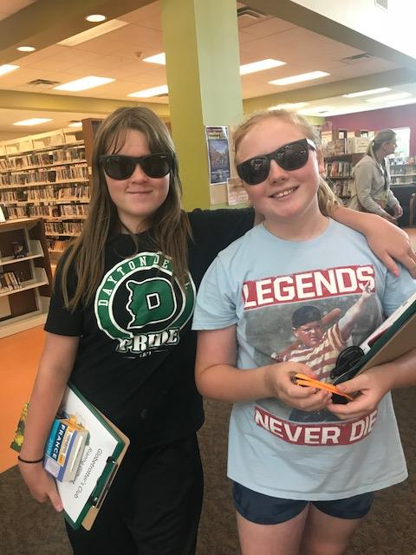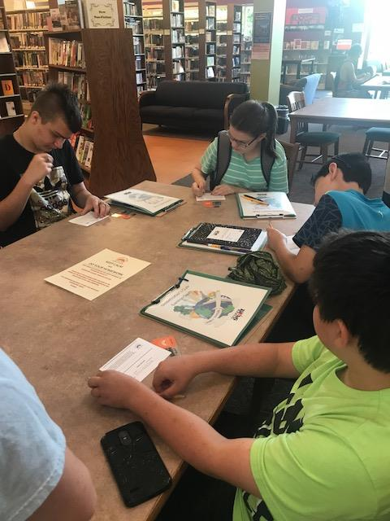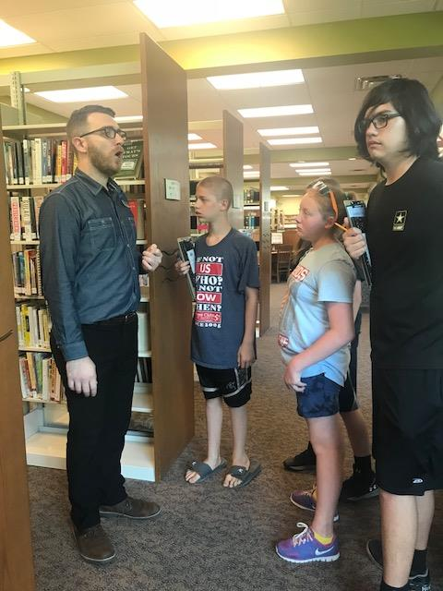
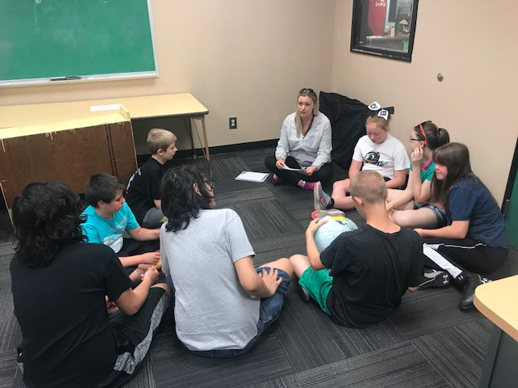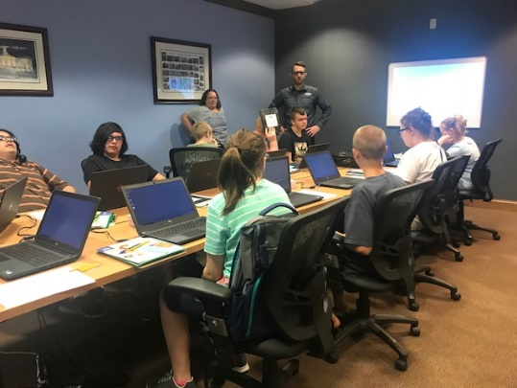
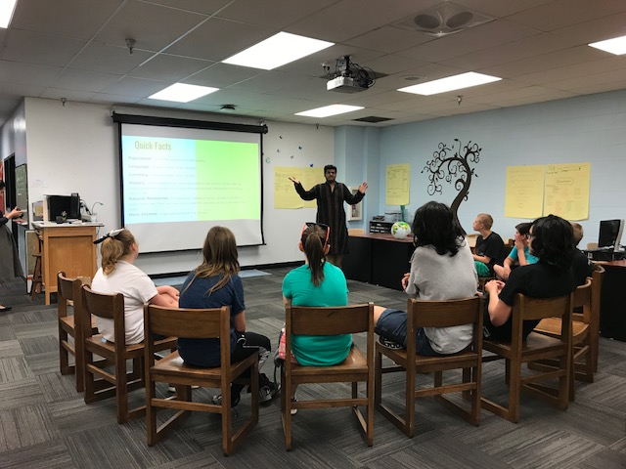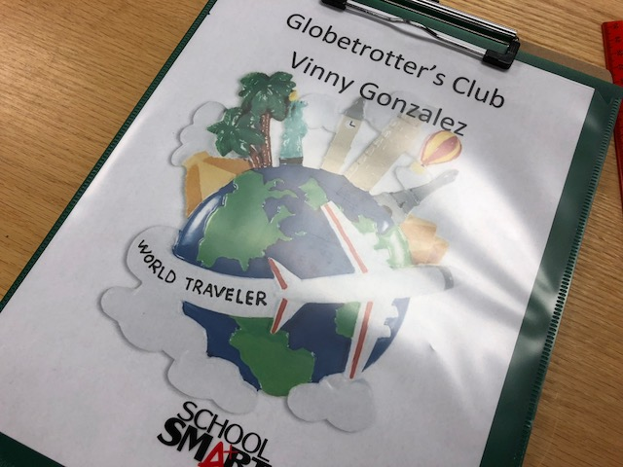
- One to one transition. Phase I complete. On to Phase II and Google Classroom!
- Recent professional learning in June… MasteryConnect, OLWEUS, KAGAN, Blended Learning/SAMR
- New/Transferred Certified and Classified Staff:
  - Dillon Mears - Digital Learning Coach
  - Matt Elrod - HS Social Studies
  - Sarah Setters - Spanish
  - Matt Sumpter - HS Math
  - Mallory Seidel - MS English
  - Mackenzie Culbertson - HS English
  - Jamie Woods - Instructional Aide (ISD)
  - Jen Erdman - Registrar

