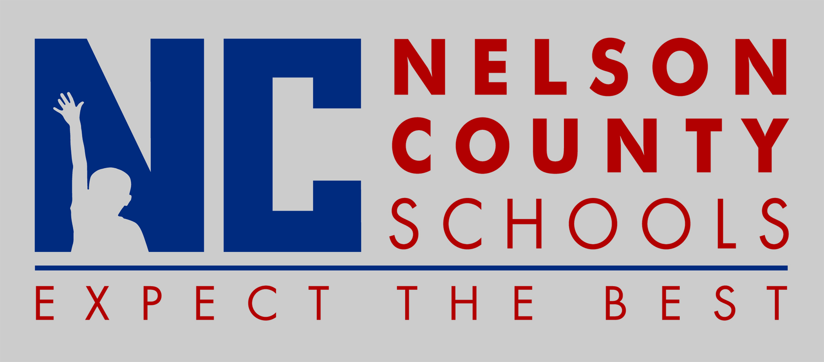

NELSON COUNTY SCHOOLS CODE OF ACCEPTABLE
BEHAVIOR AND DISCIPLINE

2015-2016

