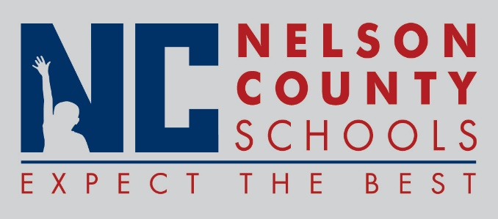

Decision Paper
To: | Nelson County Board of Education
From: | David Coffing, Chief Information Officer
cc: | Dr. Anthony Orr, Superintendent
Date: | May 16, 2017
Re: | 2017-2018 Technology Plan
ISSUE: Approval of the Technology Plan for 2017-2018.

RECOMMENDATION: I recommend the Nelson County Board of Education approve the Technology Plan for 2017-2018.

RECOMMENDED MOTION: I move that the Nelson County Board of Education approve the Technology Plan as submitted for 2017-2018.

