John Hardin SBDM Council
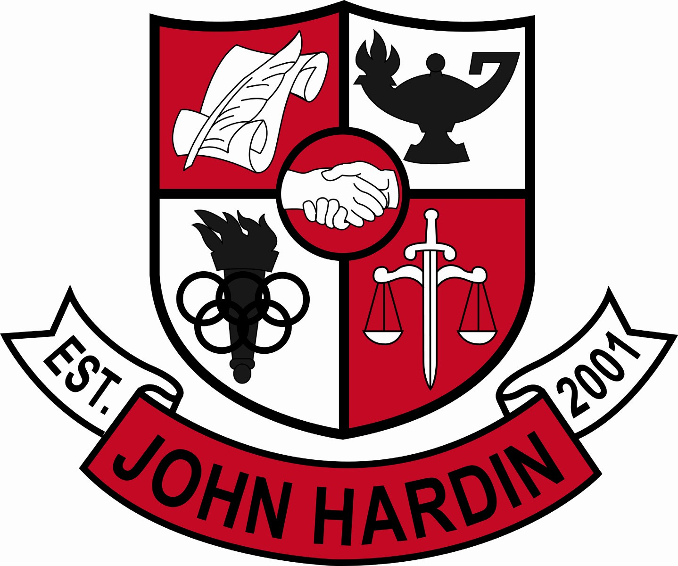
Meeting Minutes

January 12, 2017

No meeting was held in January due to lack of agenda items and/or no quorum.

