This is a decision paper.

TO: Members of the Hardin County Board of Education
FROM: Teresa Morgan, Superintendent
DATE: July 15, 2021
SUBJECT: American Rescue Plan (ARP) ESSER Assurances

FACT:
The Hardin County Board of Education must approve the American Rescue Plan Elementary and Secondary School Emergency Relief Fund (ARP ESSER) District Funding Assurances in order to participate and request funding through KDE.
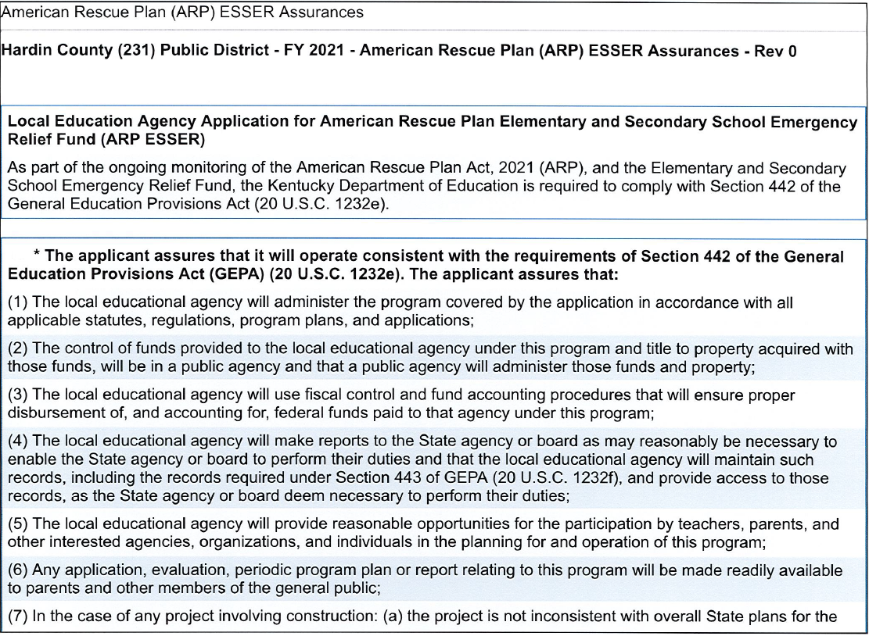

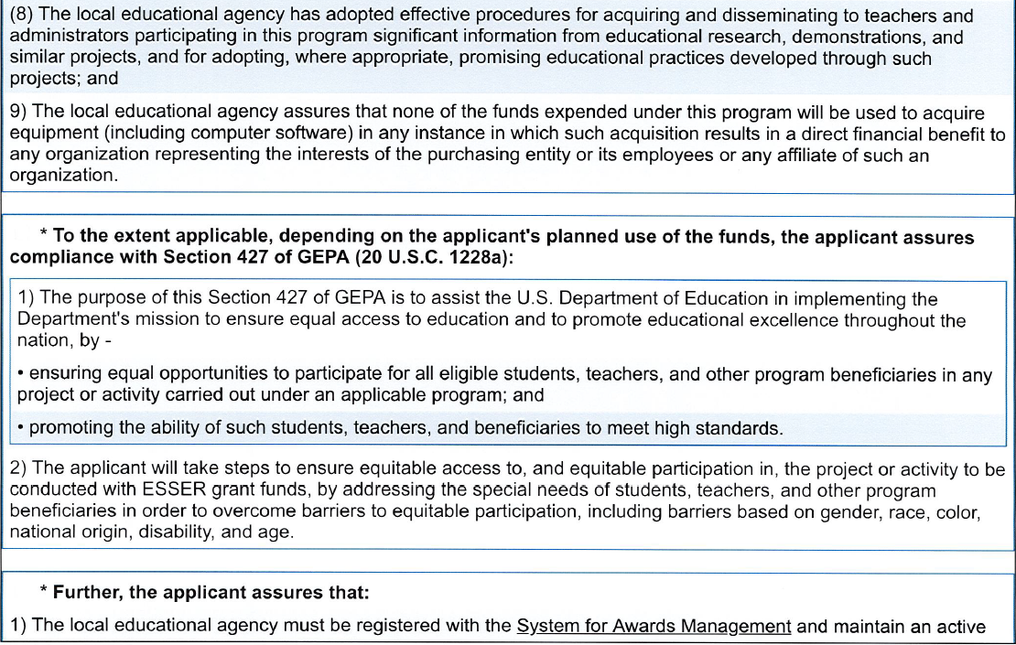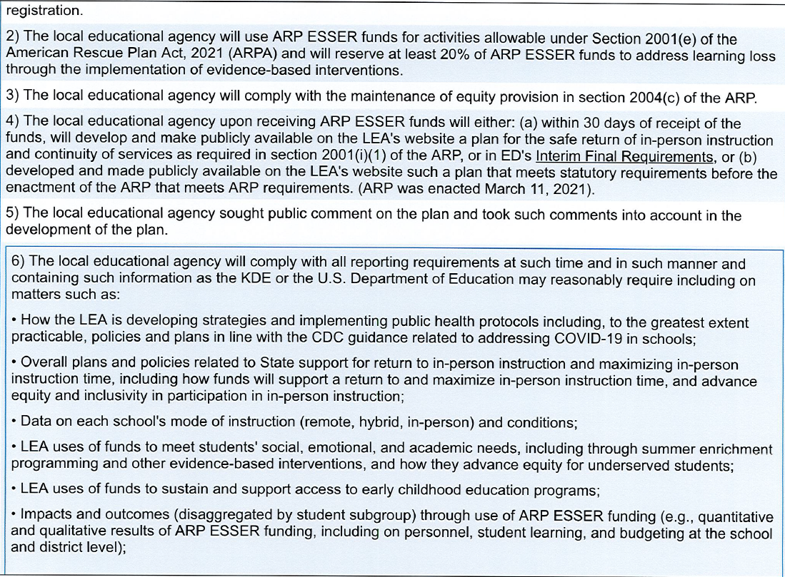
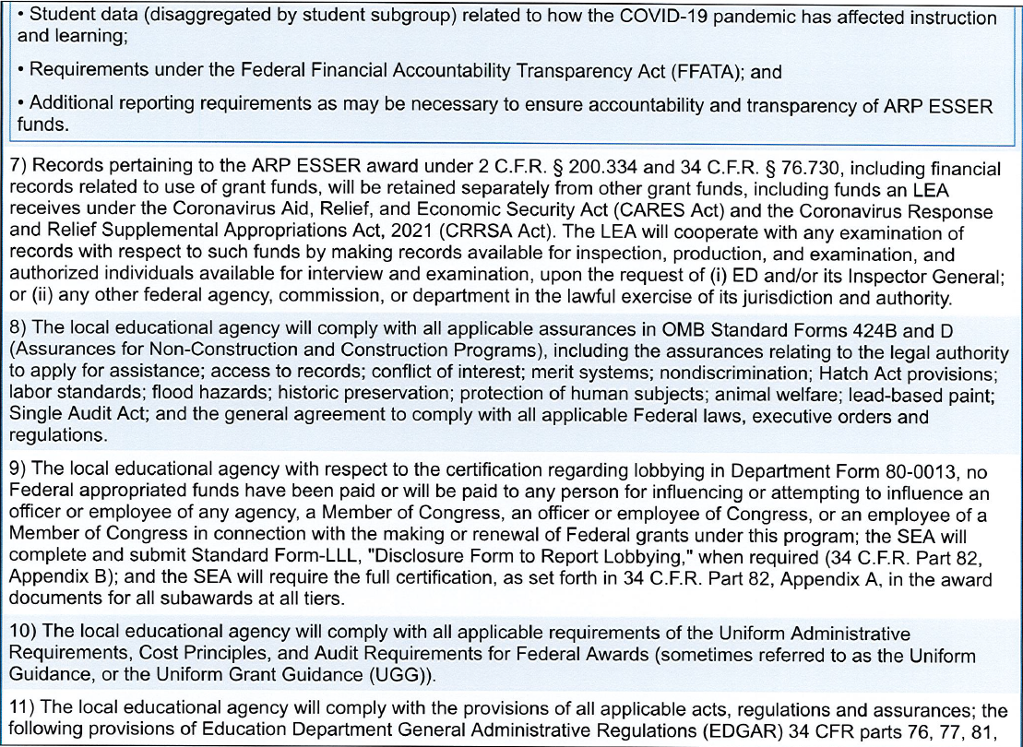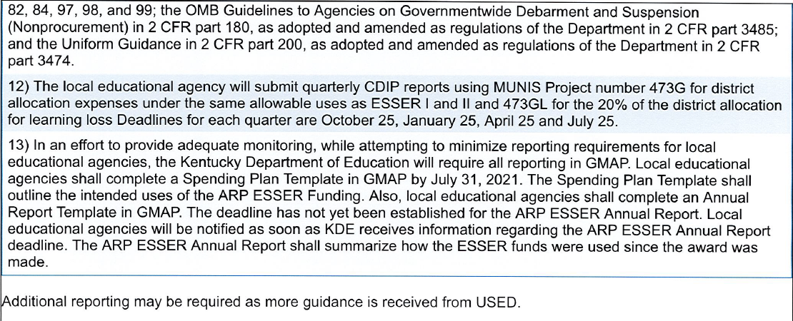
RECOMMENDATION: I recommend the Hardin County Board of Education approve the ARP ESSER District Funding Assurances.

RECOMMENDED MOTION: I move that the Hardin County Board of Education approve the ARP ESSER District Funding Assurances.

