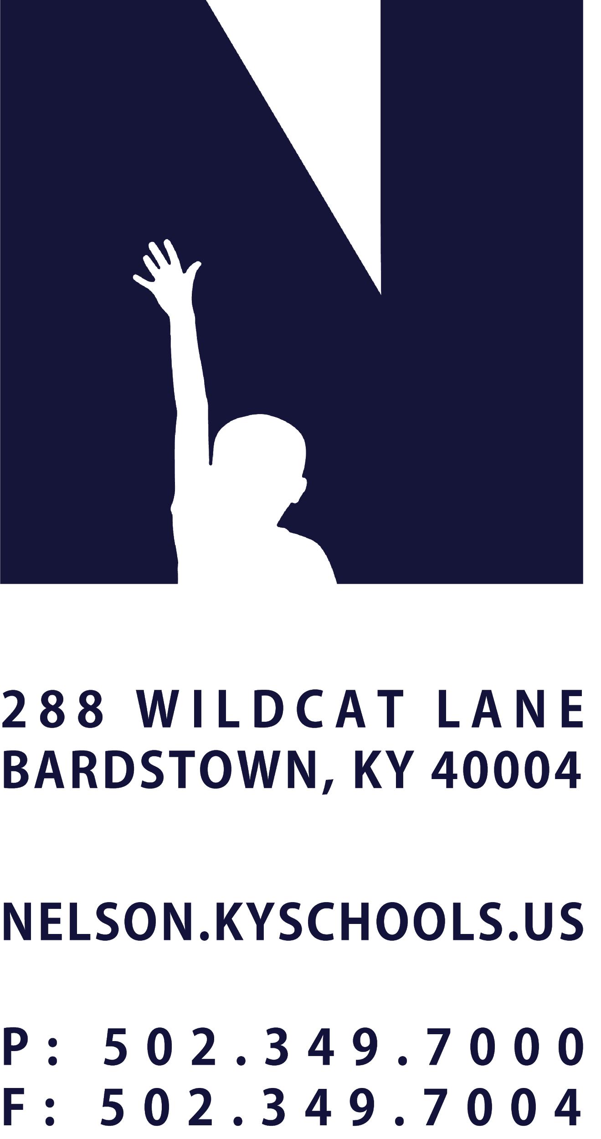 | JOB TITLE | SUPPORT TECHNICIAN
 | REPORTS TO | CHIEF INFORMATION OFFICER
 | SALARY SCHEDULE/GRADE | TECHNOLOGY SERVICES
 | CONTRACTED DAYS AND/OR HOURS | 260 DAYS, 7.5 HOURS PER DAY
 | EXEMPT STATUS | NON-EXEMPT
 | JOB CLASS CODE | 7525
 | POSITION CLASSIFICATION | CLASSIFIED PROFESSIONAL
 | DATE APPROVED

QUALIFICATIONS
Bachelor’s Degree from an accredited institution, including emphasis in computer science, information technology, business management, or a closely related field.
Two years of responsible information technology services preferred.

POSITION SUMMARY
Perform a variety of skilled and technical duties related to the installation, repair, alteration and maintenance of computers, printers and other peripheral equipment; Efficiently complete assigned tickets from the help desk queue; Communicate unresolved tickets to the Help Desk Coordinator; Assist with technology department projects.

DISTRICT AND SCHOOL PRIORITY ALIGNMENT
Align actions with district and school values and core priorities.
Evaluated based on the efficacy of aligned actions.

PERFORMANCE RESPONSIBILITIES
Provide phone and onsite support to users for a variety technical issues.
Complete help desk tickets as assigned.
Run AV and network cables.
Perform IOS troubleshooting.
Troubleshoot network connectivity issues.
Participate in the diagnosis, maintenance, and repair of District technology devices and equipment.
Collaborates with administrators at assigned locations regarding site technology matters including but not limited to budget, tickets, beginning and end of the year preparations and state of technology in the building.
Oversee student help desks at assigned locations.
Lead Student Technology Workers at assigned locations.
Observe legal and defensive driving practices.
Keep company vehicle clean and presentable, track service needs and report to Transportation Director.
Perform other duties as assigned by the Chief Information Officer or Superintendent.

KNOWLEDGE AND ABILITIES
Basic understanding of Active Directory.
Basic knowledge of Group Policy.
Ability to install and configure Windows 10.
Ability to install Microsoft Office.
DHCP and DNS.
Basic network and routing concepts.
Ability to prioritize help desk tickets.
Strong communication and organization skills.
Read, interpret and apply detailed and technical written and oral instructions.

PHYSICAL DEMANDS
Work is performed while standing, sitting and/or walking.
Requires bending, squatting, crawling, climbing, and, reaching.
Must have an adequate range of motion in the upper extremities.
Persons performing service in this position classification will exert 50 pounds of force frequently to lift, carry, push, pull, or otherwise move objects.
Requires the ability to communicate effectively using speech, vision and hearing.

